Release 0.9.4 🎉

# WHAT TO EXPECT?

The OpenBoxes team is excited to introduce to you the new Cycle Count feature! Use this new feature to regularly count a few products between your annual / bi-annual inventory counts and correct inventory regularly as needed.

This is the first release for Cycle Count, and we still have more exciting features that will be added to this workflow in the future release. See details below!

Since this is a brand-new feature, we are looking to our users to provide feedback and report any issues that you encounter. Please contact us at [openboxes@pih.org](mailto:openboxes@pih.org).

Table of Contents

WHAT TO EXPECT? 1

CYCLE COUNT FEATURE 2

1. Pick Products to Count 3

2. Perform the Count 4

3. Resolve Discrepancies 4

FUTURE ADDITIONS TO CYCLE COUNT! 5

Pick Products 5

Perform the Count 5

Resolve Discrepancies 5

Approving 6

Reporting 6

# CYCLE COUNT FEATURE

The new Cycle Count Feature will assist your warehouse team to check your inventory data, correct inventory as needed and get insights from your inventory accuracy. Per good warehousing standards, a few inventory items should be counted regularly between the annual / bi-annual counts. This feature will make your process easier!

The new Cycle Count Feature allows for a step-by-step process:

1. [Pick Products to Count](https://partnersinhealth.sharepoint.com/:w:/r/sites/Cross-SiteSupplyChain/Shared%20Documents/OpenBoxes/Release%20Documents/1%20English%20Versions/Release%20Notes%200.9.4.docx?d=w5d2436bfc9954398a36342724ed41b72&csf=1&web=1&e=l8jzg0&nav=eyJoIjoiMTc5MDQ2MTQzNyJ9)
2. [Perform the Count](https://partnersinhealth.sharepoint.com/:w:/r/sites/Cross-SiteSupplyChain/Shared%20Documents/OpenBoxes/Release%20Documents/1%20English%20Versions/Release%20Notes%200.9.4.docx?d=w5d2436bfc9954398a36342724ed41b72&csf=1&web=1&e=HbBhtz&nav=eyJoIjoiNzM5ODM1MTk5In0%3D)
3. [Resolve Discrepancies](https://partnersinhealth.sharepoint.com/:w:/r/sites/Cross-SiteSupplyChain/Shared%20Documents/OpenBoxes/Release%20Documents/1%20English%20Versions/Release%20Notes%200.9.4.docx?d=w5d2436bfc9954398a36342724ed41b72&csf=1&web=1&e=P3vEKC&nav=eyJoIjoiODU5ODA3MDEifQ%3D%3D)

Below you will find summarized information of each of the three steps.

For set-by-step instructions, please view this document: [Perform Cycle Count](https://help.openboxes.com/article/485-perform-cycle-count) in the OpenBoxes Knowledge Base.

## Pick Products to Count

Go to **Inventory** > **Manage Cycle Count** to load a list of ALL PRODUCTS available to count.

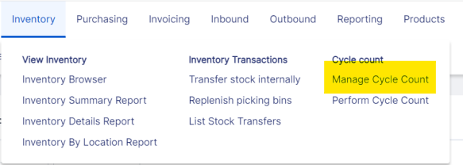

In the “ALL PRODUCTS” page, the items are sorted by which ones you should count the earliest. This sorting is done by looking at Last Counted Dateand ABC Classification. Users will make product selections on this page for counting.

ABC Classification: A Method of categorizing items into three groups: A, B, and C based on their consumption. Group A: high-consumption items that should be counted 4 times a year; Group B: should be counted 2 times a year; and Group C: should be counted once a year.

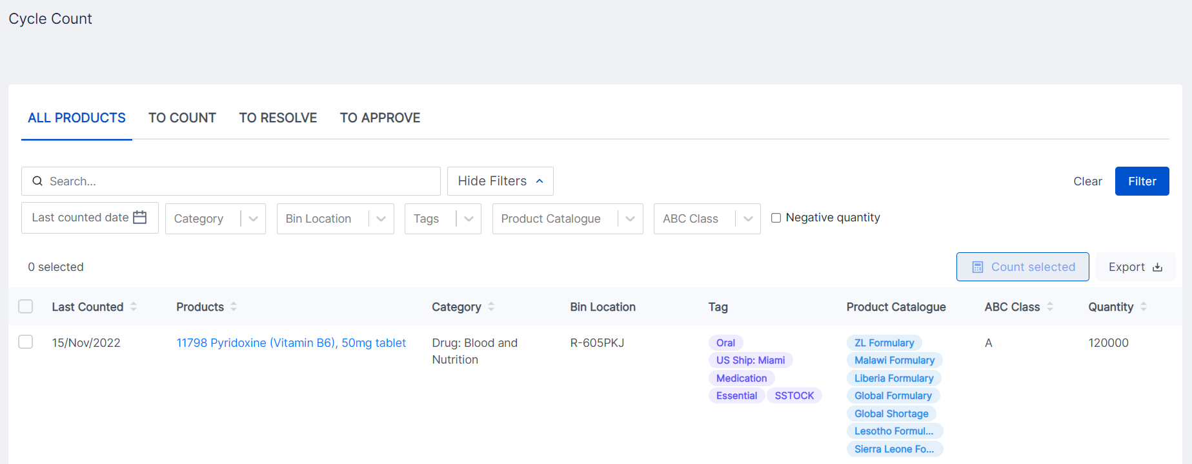

Users can also use the different available filters in the “ALL PRODUCTS” page to count items within a certain category, a certain bin, a certain tag etc.

## Perform the Count

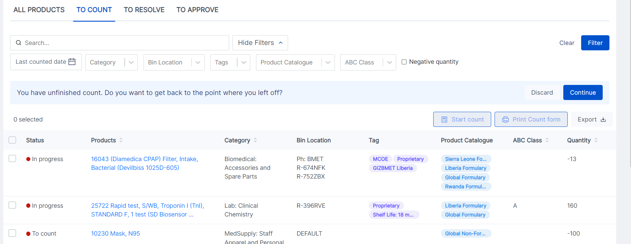

The “TO COUNT” tab displays the products you selected from “ALL PRODUCTS” page. This page also allows users to apply filters to start counting for a select number of products.

When you start counting for product(s), the first count is a blind count, meaning you will not see what the quantity for the product in OpenBoxes is. You can also print the count forms to make it easy for counting at the storage areas! Once you complete the blind count, OpenBoxes will then compare your entered data with OpenBoxes data.

## Resolve Discrepancies

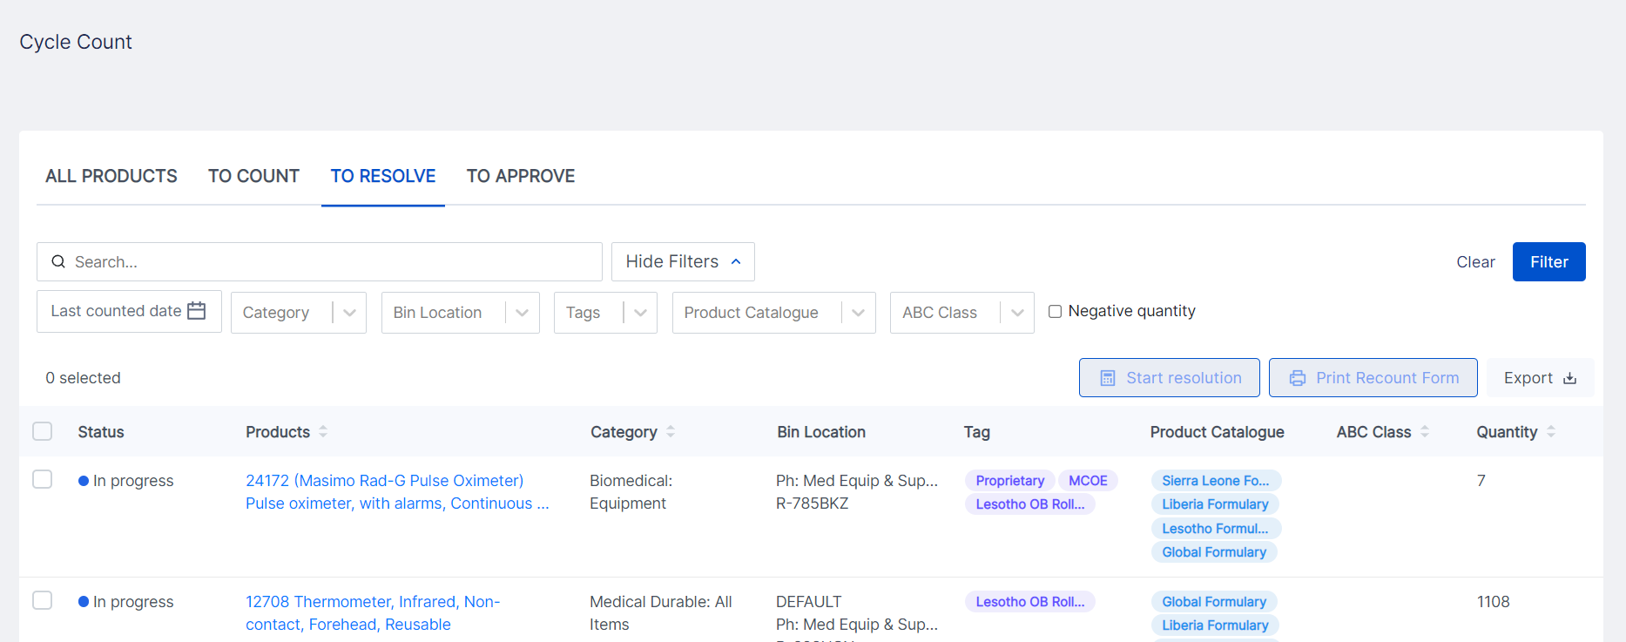

Based on the data from blind count and existing data in OpenBoxes, you can review a list of items with discrepancies. Here, you can print a recount form for another person to perform a second check.

To resolve discrepancies, users must enter the quantity recounted, the person who recounted, and root cause for each product.

# FUTURE ADDITIONS TO CYCLE COUNT!

This release builds the foundation for Cycle Count, but we have more functions coming for Cycle Count in the next release, including Reports! Please see below for upcoming additions to Cycle Count:

### Pick Products

* Indicate how many products you should be counting this period (period can be determined and configured).
* Allow a manager to assign products to count to specific personnel with a deadline to complete the count.
* Prevent starting a count on products in pending Outbound shipments.

### Perform the Count

* Indicate that an inventory item is “Not Counted” for scenarios where a product is in multiple bins, and you are counting products only in specific bins.
* Add a product inside the count workflow for scenarios where you are counting all items in a bin, and you find an item previously not recorded in that bin.
* Import of count.
* Full inventory count or long inventory count. Currently, the cycle count supports 50 products (release of this addition to be determined based on technical complexity).

### Resolve Discrepancies

* Summary view of inventory corrections (adjustments, quantity before the adjustment and quantity after the adjustment) before Saving.
* Update options available in the “Root Cause” field.
* Functionality to correct common mistakes such as wrong bin / lot /expiration date / missing transactions and detect root cause automatically!

### Approving

* Specific table for an Approver at the Warehouse to review all inventory changes that the cycle count workflow generates.
* Approve function for approver to confirm the review of inventory change.

### Reporting

* Inventory Accuracy Indicator based on cycle counts and number of discrepancies.
* Summary table of all inventory transactions ever created in the system, with filters for analysis, and audit records.
* A full reporting suite with a dashboard with other indicators to monitor cycle count work and inventory accuracy over time.
* Leadership report that shows how inventory and inventory value is affected by inventory discrepancies.