How to access the OpenBoxes training modules on the PIH learning hub
- Go to learning.pih.org
- If you have access to a pih.org email, click on “member login.” You can use your PIH email and password to sign in
  - On the sign in page, click “Sign in with Azure Active Directory.” You can enter your pih.org email and password to sign in
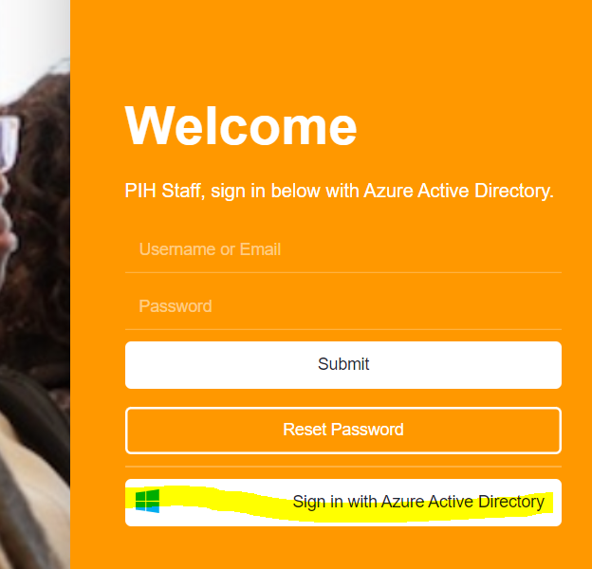
- If you do not have access to a pih.org email, click on “new member registration”
  - To create an account, enter your information and click submit
- You now have access to all publicly available courses in PIH’s learning portal
- Go to “collaborative offerings”
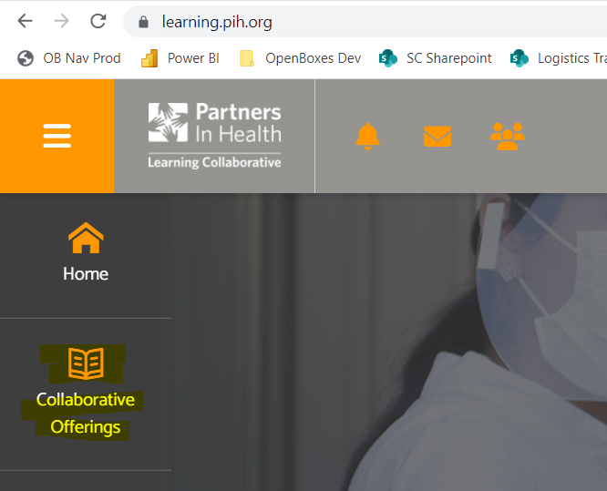
- Choose category “OpenBoxes” in the filter to bring up all OpenBoxes courses. You will see the completed basics, inbound shipments, outbound shipments, and inventory management courses
