RELEASE NOTES 0.9.6 🎉

WHAT TO EXPECT
The OpenBoxes team is excited to introduce to you the 0.9.6 release which brings several updates designed to make OpenBoxes easier and more intuitive to use.
In this release, we’ve introduced:
- Updates requested by the SCOps and Sourcing teams to improve workflows for Purchase Orders, shipments, and sources.
- Improvements to assist with better management of data like an improved product import and new validations
- Enhancements to the Cycle Count feature, including performance improvements to make counting and reconciliation more efficient.
- New and enhanced reports, originally developed for the Dominica project but useful for all sites looking to gain better visibility into their data.
We’ve also addressed a few migration-related bugs and made a few user interface updates to make OpenBoxes more intuitive and accurate. See the details below!
As always, we are looking to our users to provide feedback and report any issues that you encounter. Please contact us at openboxes@pih.org.

WHAT TO EXPECT 1
Purchasing Improvements 3
Filter Purchase Order by Supplier Code 3
Enhanced Audit Fields in the Product Source 3
Manually Clear Fixed Price Fields in Product Source 5
Cycle Count Improvements and Fixes 5
Improved Display of Expiration Date for Existing Lots in Cycle Count 5
Expanded Root Cause Options for Cycle Counts 6
Bug Fix: Screen Blank When Adding Expiration Date in Cycle Count 7
Bug Fix: Alignment of Cycle Count Information Bar 7
Data Management Improvements and Fixes 8
Refined Permissions for Managing Location Types 8
Bug Fix: Single-Word Organization Names Supported 8
Prevented Deactivation of Products on Stocklists 8
Ability to export and import product activation status 9
Bug Fix: Prevented Duplicate Inventory Counts from Double-Clicks 9
Expiration Management Improvements 9
More specific validation on expiration date change 9
Filter Stock Transfer for Expired Stock 10
New Reports and Report Upgrades 10
New Expiration History Report 10
Revamped Reorder Report 11
Run Request Detail Report for Multiple Locations 12
Filter Consumption and Transaction Reports for Multiple Products 12
E-Request Improvements 12
Save Requests with Removing 0 Quantity Rows 13
Other Bug Fixes 13

Purchasing Improvements

Filter Purchase Order by Supplier Code
When working with long Purchase Orders (POs), we know how important it is to quickly find what you’re looking for. Based on feedback from users from the Supply Chain Operations and Sourcing teams at the Coordination Site, we’ve added the ability to filter/search POs by the supplier’s code for the item.
You can now easily filter or search by supplier code across the Summary, Item Details, and Item Status tabs of the PO page. When you search using a supplier code, only the records associated with that supplier will appear—making it much faster to locate and review specific items. See the changes in the screenshot below!
Note: Screenshots included in this release highlight these updates in yellow, so you can easily spot where the changes appear in OpenBoxes.
PO Summary Tab: Before
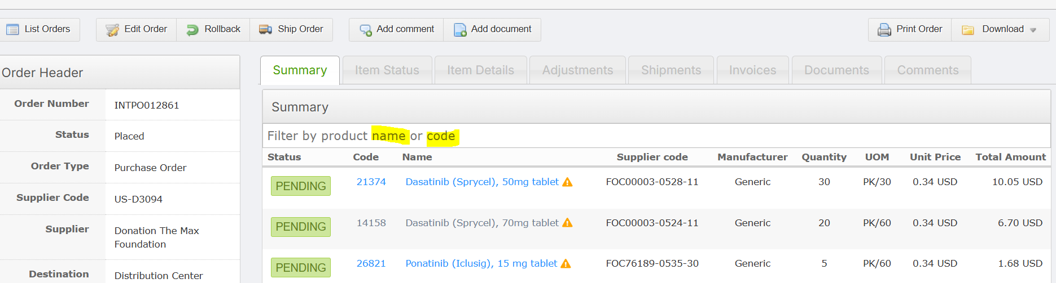
Summary Tab: Now
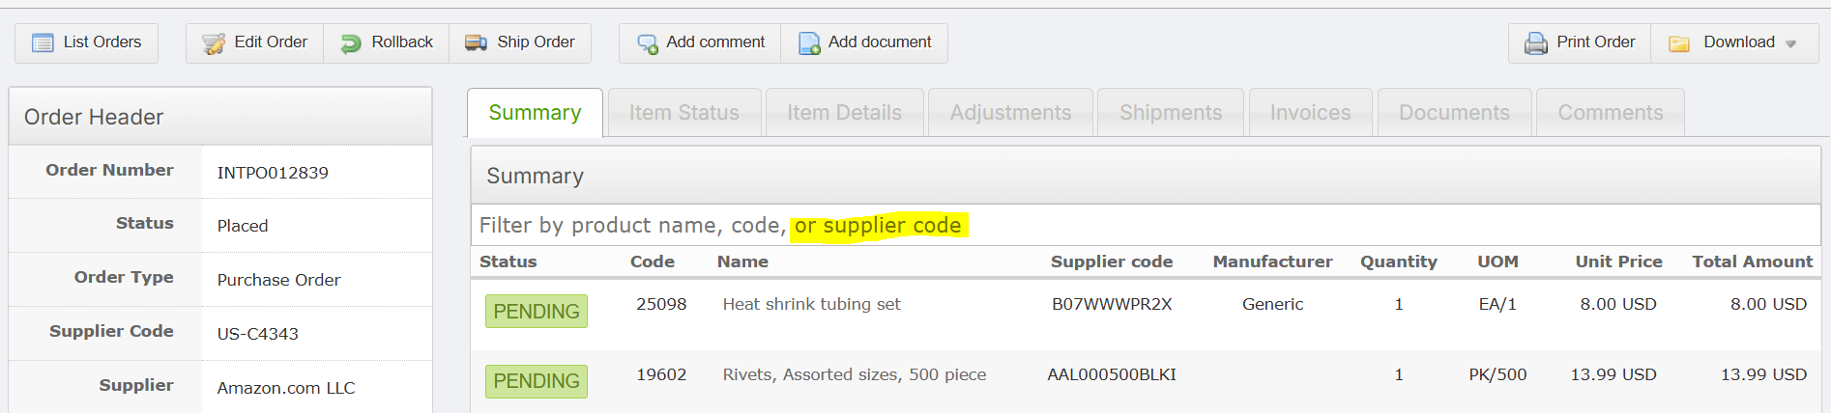

Enhanced Audit Fields in the Product Source
We’ve improved the audit fields of the Product Source Forms to give you better visibility into who created or updated a Product Source. In addition to showing the date a source was created or last updated, the form now also displays which user performed those actions. Now, you can easily see not just when a product source was created or updated, but also who made the change. To make this clearer and more intuitive, we’ve renamed the fields:
- “Source Creation Date” is now “Created”
- “Last Update” is now “Updated”
Each field now includes both pieces of information displayed in a friendly format like:
- Created: (date created), by (user who created it)
- Updated: (date updated), by (user who last modified it)
This gives you a complete audit trail right within the form, making it intuitive to trace the history of any product source.
Please note: Usernames will only appear for sources created or updated after this release (0.9.6), since earlier versions did not capture user information in this way.
Audit fields in Source Form: Before
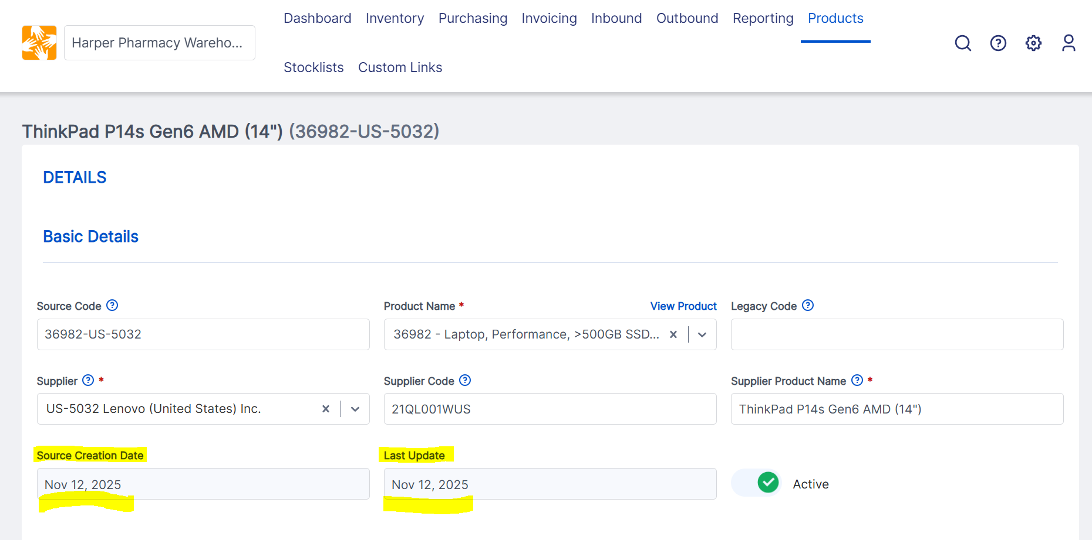
Audit fields in Source Form: Now
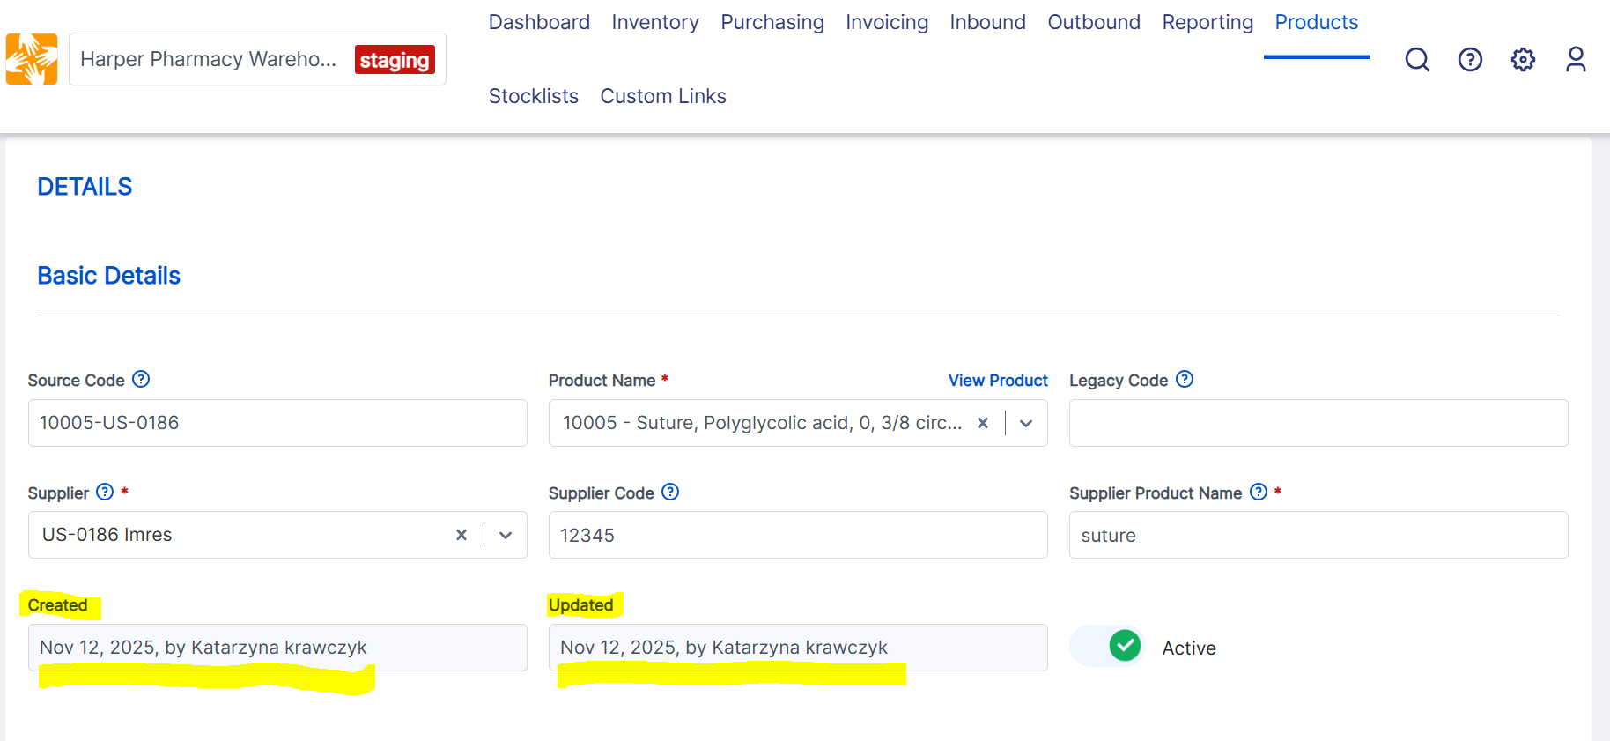

Manually Clear Fixed Price Fields in Product Source
Users from the Sourcing and SCOps teams have let us know that it wasn't possible to clear the Fixed Price field for existing sources—you could change the value - but not remove it entirely.
We're happy to share that we've changed this! You can now manually clear the Fixed Price field for any active or inactive source, giving you the flexibility you need to keep your data accurate. We've also added a helpful validation check: if you enter a detail like a price validity date, the system will now prompt/require you to provide the corresponding price. Hopefully, this small change helps ensure data consistency and prevents incomplete entries.
Price data validation check: Now
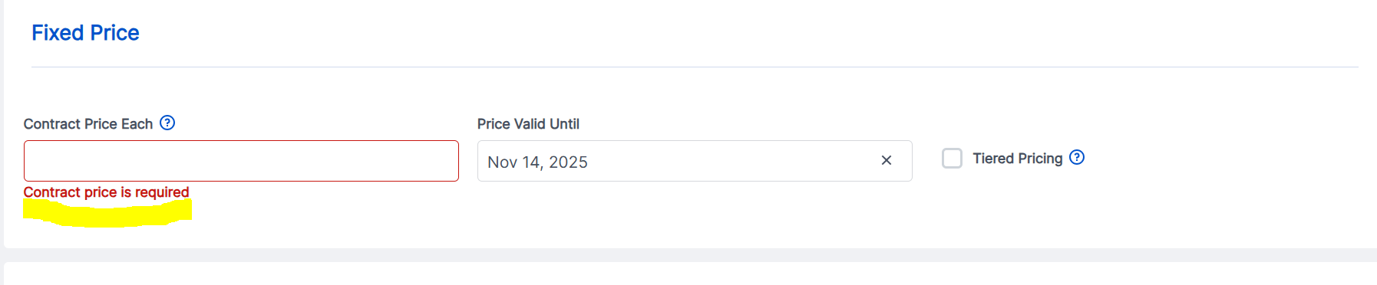

Cycle Count Improvements and Fixes

Improved Display of Expiration Date for Existing Lots in Cycle Count
We’ve made an important improvement to Cycle Count workflow to bring more clarity to how expiration dates behave when working with known Lots with Expiration Dates.
Previously, there was a confusing behavior in the Cycle Count workflow related to Lots that already have an expiration date recorded in the system. That is, when you added a new row and typed an existing lot number (that already has an expiration date recorded in the system) into the new row, the expiration date field didn’t populate. Instead, the field remained empty and allowed edits— but any changes you made did not persist.
With this release the behavior is clear and predictable:
- When you enter a lot number that already has an expiration date in the system, the expiration date is now automatically populated.
- The populated expiration date is read-only (you’ll see it is not clickable)
- This applies to both the counting and recounting phases of Cycle Count.
Note: If you do need to change the expiration date for an existing lot, please use the Manage Lot Numbers workflow.
Expiration date of known Lot in Cycle Count: Before
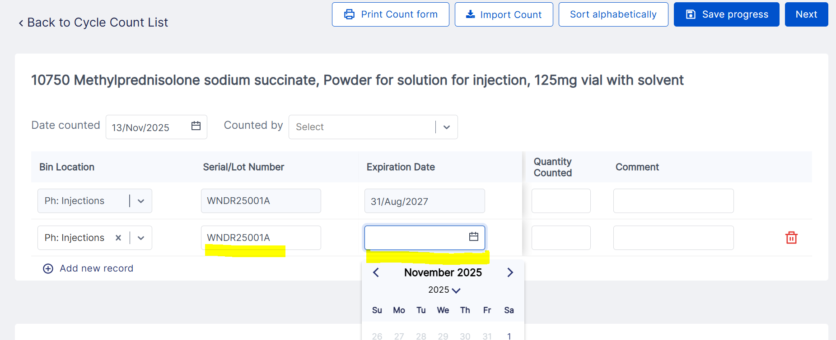
Expiration date of known Lot in Cycle Count: Now
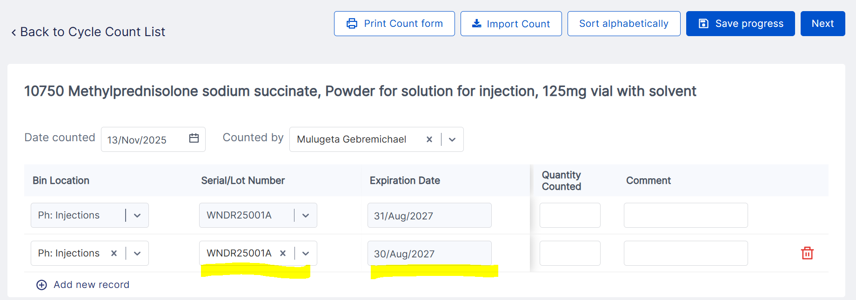

Expanded Root Cause Options for Cycle Counts
Based on valuable feedback from many of you—especially those who participated in the recent Cycle Count Training/Demo and Contest—we've expanded the list of available "Root Causes" when resolving inventory Discrepancies in Cycle Count.
You can now select from these new root causes:
- Lot Correction
- Bin Correction
- Incorrect Lot Picked
- Fix Negative Inventory
- Inbound Not Recorded
- Outbound Not Recorded
- Return Not Recorded
- Error in Inbound
- Error in Outbound
- Bin Location Missing
- Misplaced
These new options join the existing ones (like Damaged Product, Correction, Stolen, Missing, etc.) and your selections will also be clearly visible in the Stock History comments for a complete audit trail.
A quick tip: If you don't see these new options right away, please try clearing your browser cache and local storage. After that, they will appear and be ready to use!

Bug Fix: Screen Blank When Adding Expiration Date in Cycle Count
We've fixed a disruptive bug reported by some of our users. When performing a cycle count and adding a new line to input a Lot Number with an expiration date, the screen would unexpectedly go blank. The only way to continue was to refresh the page, which would cause the newly added lot information to be lost. This issue occurred on both the initial counting and recounting pages. This issue has now been fixed.

Bug Fix: Alignment of Cycle Count Information Bar
We've fixed a small visual glitch in the cycle count interface. Previously, the information bar displaying details for an inventory item updated by a cycle count could appear misaligned, which was a bit confusing to read. This has been straightened out!
Info Bar alignment of inventory updated using CC: Before
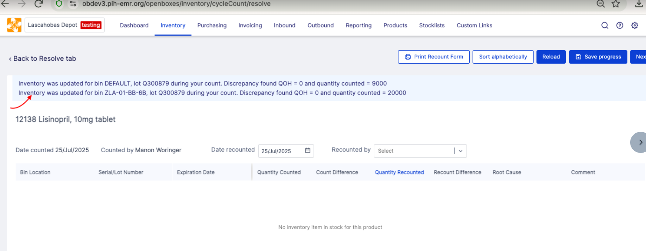

Info Bar alignment of inventory updated using CC: After
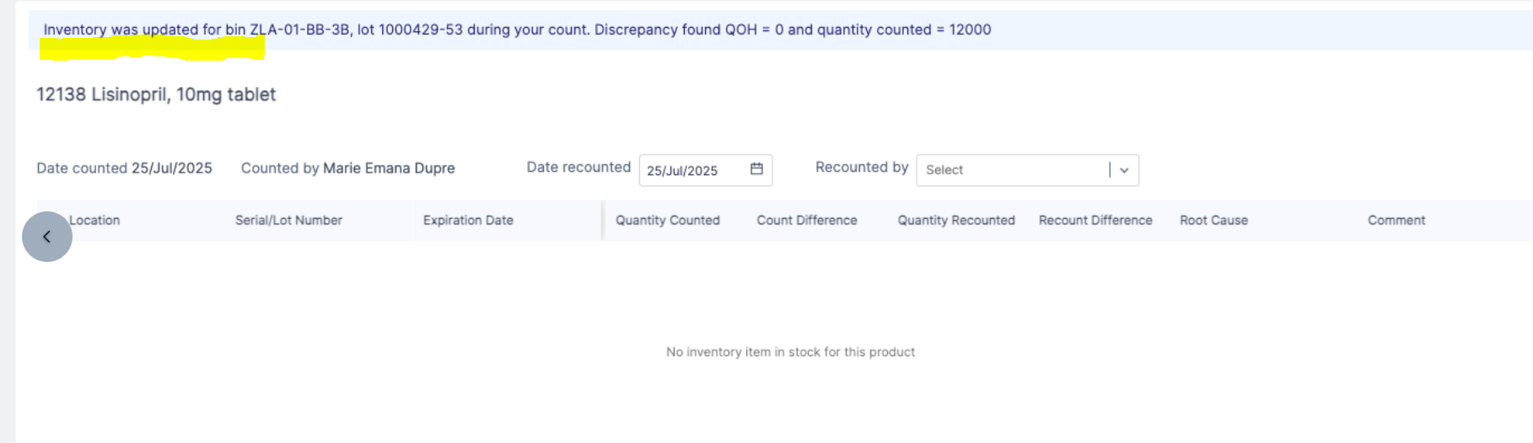

Data Management Improvements and Fixes

Refined Permissions for Managing Location Types
To help keep our data organized and accurate, we've made a small but important change to who can create and edit Location Types.
We noticed that some users occasionally created a new Location Type when they actually intended to create a new Location. Since these two concepts serve very different purposes, this sometimes led to confusion and data inconsistencies that were challenging to correct.
To ensure data integrity and prevent future mix-ups, we have now restricted the ability to create or edit Location Types to superusers. Please note that permission to view Location Types remains unchanged.
This change helps us maintain a clean and reliable system for everyone. If you need a new Location Type created, please reach out to your System Specialist or the OB team.

Bug Fix: Single-Word Organization Names Supported
We fixed a bug that prevented you from creating Organization with single-word names. If you encountered a validation error when trying to save a new Organization with a single word name like "SingleWordNameOrganization”, we apologize for the frustration this caused. It was a glitch related to the identifier generation logic and has now been fixed.

Prevented Deactivation of Products on Stocklists
It is now impossible to deactivate a product on a Stocklist. This change was made to ensure that all products on stocklists are active and available to use, and that all product deactivations are properly managed. To check if a product is on a stocklist, go to the Manage Stocklists button on the Stock Card. This will allow you to view and edit stocklists for a given product.

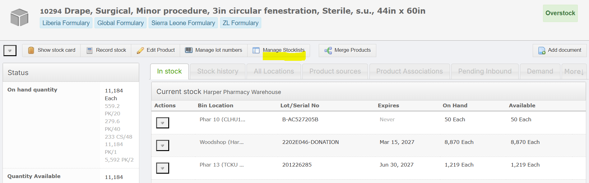

Ability to export and import product activation status
Users can now see in the product export and product list downloads whether a product is active or inactive. All product exports now have a field called Active in column B of the excel file. Products that are active will have a value of TRUE; products that have been deactivated will have a value of FALSE. This allows users to filter and sort based on the active value of the product. A column for Active status has also been added to the product import. Administrators can use the import to mass deactivate or reactivate products, by changing the value in the active column.

Bug Fix: Prevented Duplicate Inventory Counts from Double-Clicks
We've fixed a critical issue where double-clicking the "Save” button in Record Stock could create duplicate inventory transactions.
Here’s what was happening: If you accidentally double-clicked the button, the system would create two identical transactions at the exact same time. While the Stock History would show only the second one (as it should), the product availability (what informs calculation of quantity in stock) would incorrectly count both, effectively doubling the quantity. For example, if you recorded 10 items but double-clicked, the system might think you had 20 in stock. This could then lead to serious issues down the line, such as allowing distributing/issuing stock you didn't actually have, resulting in negative inventory.
We've now added validation to ensure that only one transaction is recorded per click. So even if you (or an impatient mouse!) click multiple times, the system will only create one correct transaction record.

Expiration Management Improvements

More specific validation on expiration date change
We have improved the validation that warns a user if they are updating an expiration date for a lot that is already entered into the system. Previously, there was a generic warning that the user was changing an expiration date, without specifying the particular product and lot affected. Now, the validation shows exactly which expiration date is being changed, and what the current system expiration is. If the user approves the change, they can click yes. If not, they can click no and update the expiration. This validation appears on the inbound and receiving workflows.
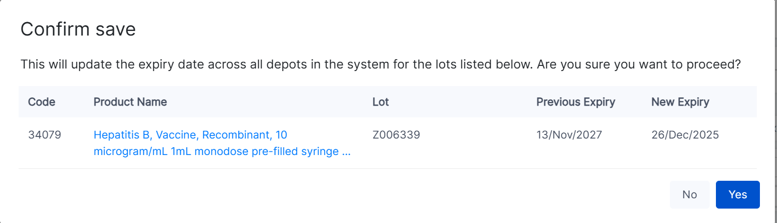

Filter Stock Transfer for Expired Stock
The stock transfer workflow now allows users to filter for all expired stock. This can facilitate moving expired stock into a hold bin to prevent it being picked. On the first page of the stock transfer workflow, click the expired stock button to filter for only expired stock. To transfer all expired stock, click the checkbox at the top of the table and then start transfer.
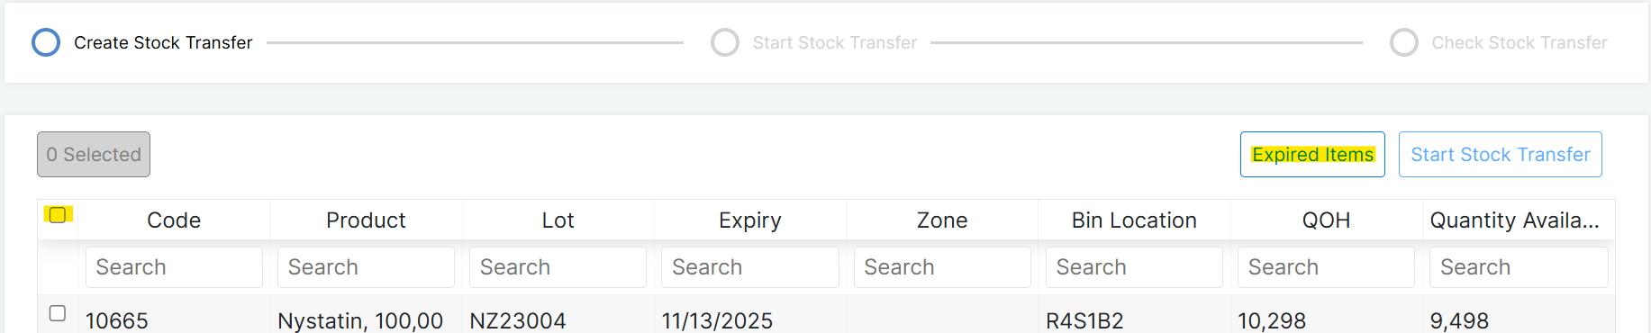

New Reports and Report Upgrades

New Expiration History Report
OpenBoxes can now report on products lost to expiration. To access this report, go to the reporting menu, and under Transaction Reports, find the entry for Expiration History Report
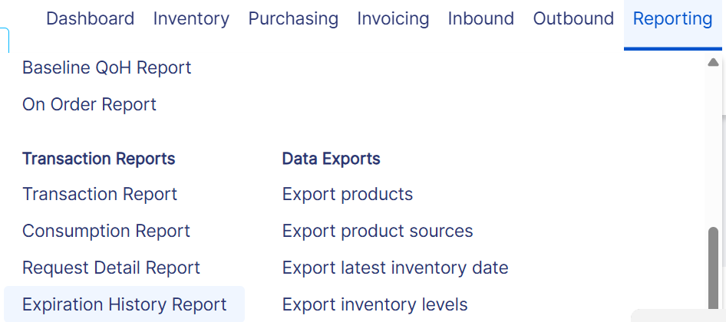
This report shows products that have been removed from stock due to expiry over a given period of time. Note that it does not show all products that have expired, only products that have been removed from inventory due to expiration. Products that are still in inventory will not be shown in this report, but can be seen in the expired products report.
To run the report, simply select a start date and end date and press load table. This will load a list of all lots removed from stock due to expiry during that period, and the associated cost. You can search within the report using the search bar, or download the report using the export button.
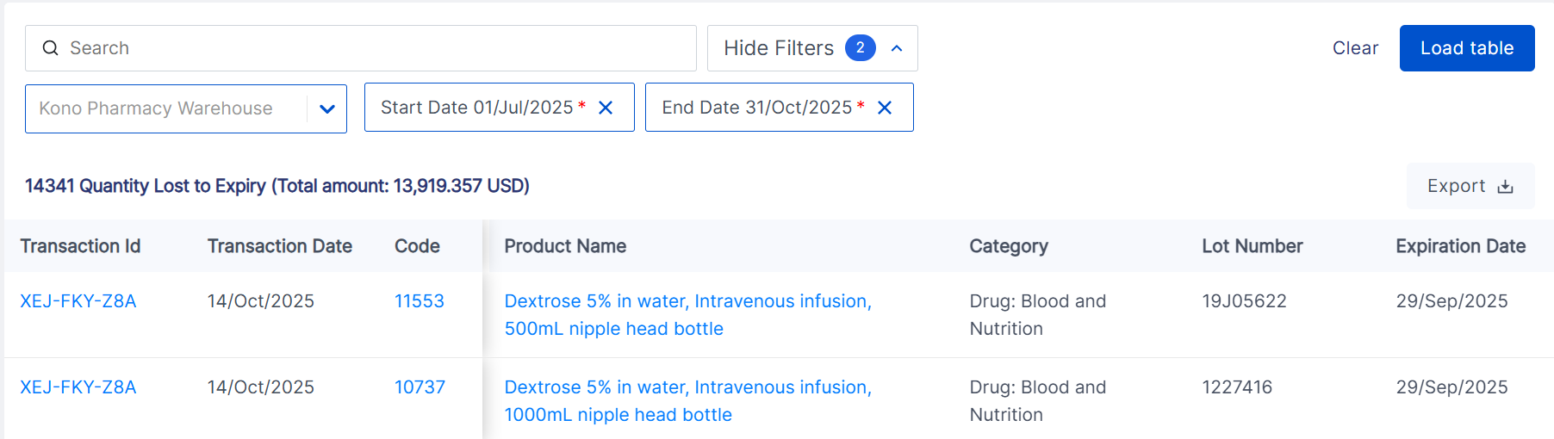

Revamped Reorder Report
The reorder report now has a new look and new filters. To access this report, go to Reporting>Order Reports>Reorder Report. The report now has several new options
- Additional inventory locations: Use this dropdown to select any additional locations that you would like to count in your total quantity available, The quantity available in the report will be summed across your location and any additional locations chosen.
- Expired stock: Use this dropdown to select whether you want expired and expiring stock to be subtracted from the quantity available in the report. The default is that expired stock will be subtracted, but that can be changed to include expired stock, or to subtract any stock expiring within a given number of days
- Show products filter: This filter dictates which products are shown in the report. The default options is to show all products, even if they do not need to be reordered. The user can also choose to show only products below the set maximum level, products below the set reorder level, or products below the set minimum level
- Category: This dropdown allows the user to show only products in a particular category
- Tag: This filter allows the user to only show products with a particular tag
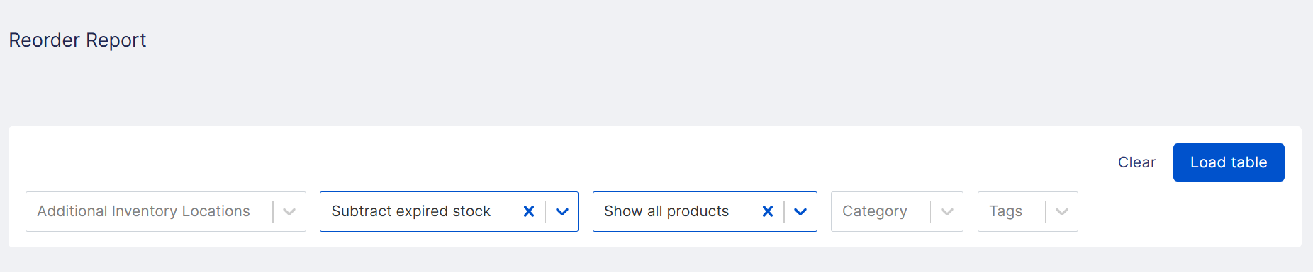

Run Request Detail Report for Multiple Locations
The Request Detail Report can now be run for multiple fulfilling locations at one time. Under report parameters, the fulfilling location will automatically appear as the location the user is logged into. Click into the box to view and add additional fulfilling locations. When multiple fulfilling locations are selected, the report will show all requests submitted to either location during the time period selected.
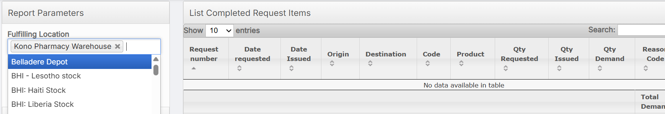

Filter Consumption and Transaction Reports for Multiple Products
A new filter has been added to both the consumption report and the transaction report. Users can now run this report for a custom list of products by entering more than one product into the product filter. The report will be run for all of the products entered.
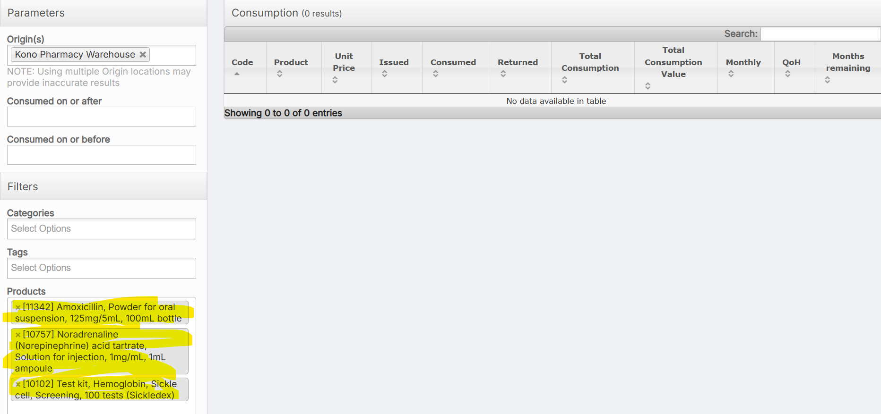
In addition, the consumption report csv download has been updated to show location names instead of location codes, for easier readability.

E-Request Improvements

Save Requests with Removing 0 Quantity Rows
We have changed the behavior of the e-request and outbound add items page so that users can save lines with a quantity of 0. Previously, all lines with a 0 quantity were removed every time the user pressed save, or moved forward in the workflow. This caused problems for requests based on long stocklists, where users could not save as they went without potentially erasing lines that they had not yet reviewed. Now, OpenBoxes will save all lines, including those with quantity 0. However, when the user submits the request or moves to the edit screen, lines with quantity zero will be deleted.

Other Bug Fixes
- Tooltips on "Add Items" Pages Restored: We've fixed an issue where the helpful tooltips that display product names were missing on the "Add Items" pages for outbound shipments, inbound shipments, and stock requests. What happened was that when users added items to a shipment or request, hovering over a product name would not show the expected tooltip. This made it harder to quickly verify items at a glance. Those handy little tooltips are back! You can now hover over product names on any "Add Items" page and see the full name displayed.
- User can easily remove reason code after deleting revised quantity: There was previously a bug where, if the user was on the outbound edit page and wanted to undo adding a revised quantity and reason code, they could not remove the revised quantity until after they had removed the reason code. This caused confusion and unnecessary clicks. Now, users can remove a revised quantity and reason code in any order.
- Full shipment number now visible on shipment list: On the shipment list page, the column for shipment number used to be slightly too narrow, cutting off the end of the number. The column has now been resized so that users can always see the full shipment number.
- Inventory Transaction Migration Fixes: After introducing a new structure for inventory transactions in 0.9.5, we also extensively tested the process of migrating old transactions to the new structure. In this release, we have fixed a few edge cases related to this process. The full migration process will be documented in the administrator guide.

