Release 0.9.3 🎉

# WHAT TO EXPECT?

This release covers quite a few different things, so you can pick what topic you want to excite you! If your focus is cleaning up duplicate products, check out the changes to Product Merge. There are also some updates to Shipment tracking. If you perform a lot of receiving in the system, then you should definitely read the fixes we have made in the Receiving workflow. Besides these big topics, we also have made some smaller changes as prioritized by the System Specialists and bugs that users have reported to us.

As always, if you encounter errors in the system or have any questions, please contact your System Specialist or the OpenBoxes team via email at [openboxes@pih.org](mailto:openboxes@pih.org).

Table of Contents

WHAT TO EXPECT? 1

New Features 1

A Reminder about the new Outbound Import Feature! 1

Improvements 1

Translations for our Spanish speaking users 1

More Detailed Shipment History 1

Easily Select Recipient for your Shipments 1

Add Desired Date of Delivery for Electronic Requests 1

Increased Unit of Measure Visibility through Transactions (PO to Receipt)! 1

Changes for Receiving Workflow 1

Ensure Quantity Matches the Original Shipped Quantity 1

‘Receiving Now’ Quantity Shifting Down 1

Status stays as ‘Receiving’ instead of ‘Received’ 1

Let’s Merge Duplicate Products! 1

Filter by Handling Requirement in Product List Page 1

Product Sources Import Improvements 1

Ensure Required Product Sources Data is not missing in your Import File 1

Delete and Edit via Import 1

Update to the Product Source Export File 1

See Product Sources in Various Pages 1

Product Source Hyperlink in Stock Card 1

What is Fixed? 1

Duplicate IDs assigned to Shipments and Purchase Orders 1

Performance for Very Long Receipts with Pack Levels 1

Issue with Splitting lines for Long PO Shipment 1

Line Saved Multiple Times During PO Creation 1

# New Features

### A Reminder about the new Outbound Import Feature!

As you may remember, we introduced the new [Full Outbound Import Feature](https://help.openboxes.com/article/478-import-outbound-shipment) in the previous 0.9.2.2 release. If you have not used it yet – we have added an information bar (in blue) in our regular Outbound workflow to remind you to try it out!

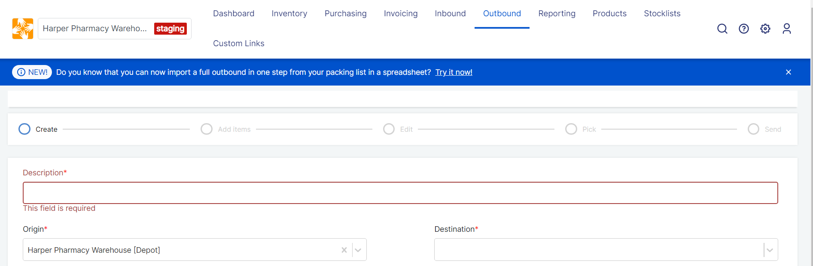

Information Bar about Full Outbound Import

# Improvements

## Translations for our Spanish speaking users

Thanks to the Compañeros En Salud team, we now have these printable documents in Spanish: Picklist, Transfer Order, Putaway Order, Packing List and Goods Receipt Note.

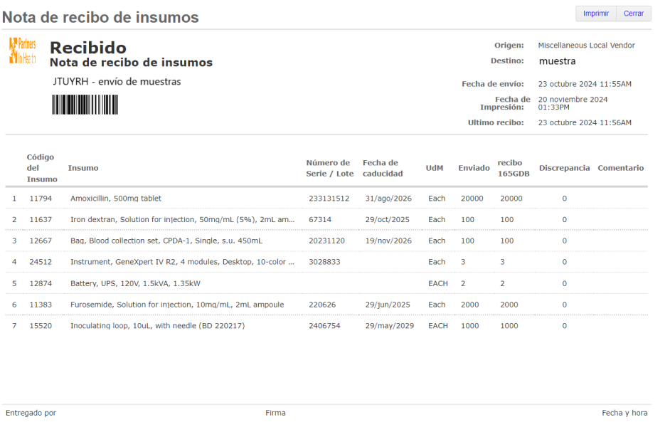

Sample Goods Receipt Note with Translations

## More Detailed Shipment History

OpenBoxes has always had specific statuses to track a shipment, for instance, users can see who shipped a shipment and when they shipped it. However, other events also happen to shipments. Therefore, we are bringing the ability to track other events to a shipment to help logistics users (or any type of user) to document and view shipment events, such as ‘Arrived at Port,’ or ‘Cleared from Customs.’

Simply click on the **Events** tab in the [Shipment Detail page](https://help.openboxes.com/article/304-outbound-shipment-detail-page). Here, you will see our regular shipment statuses (Created, Shipped, Partially Received, and Received) along with other custom event entries.

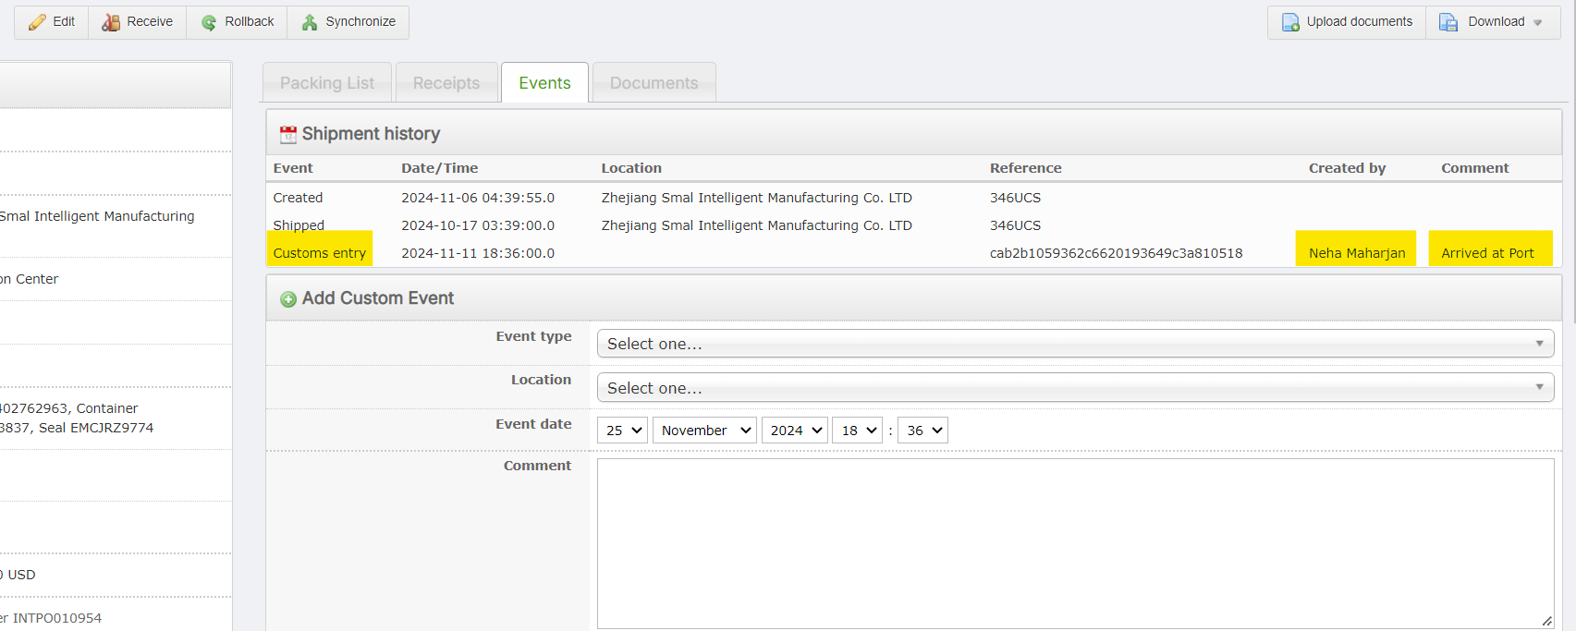

Events Tab in Shipment Details Page (International Vendor)

In addition to events, users can now also leave comments in a Stock Movement. Access additional information about a Stock Movement more easily!

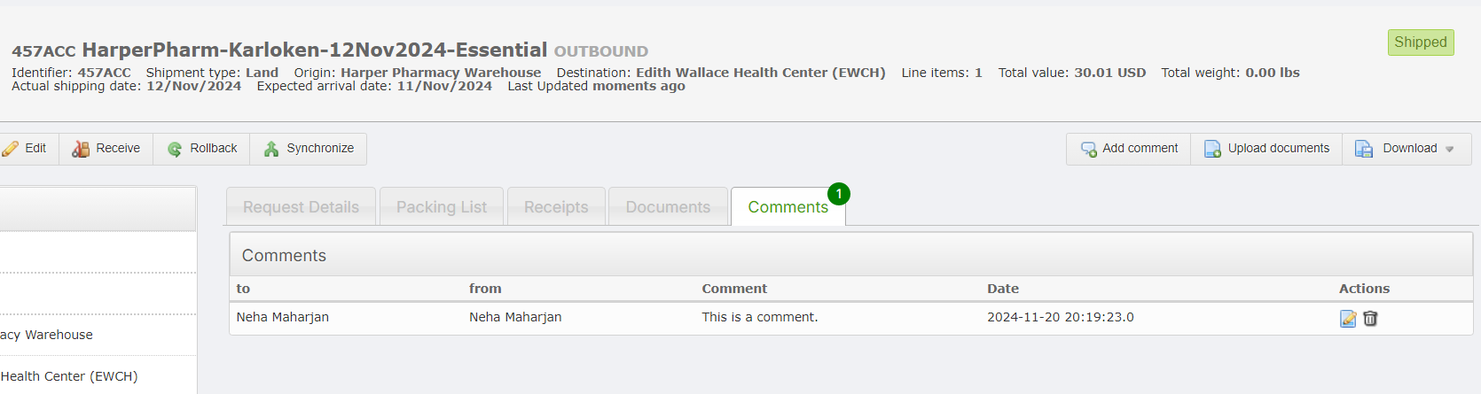

Comments Tab in the Shipment Detail Page (Depot to Depot)

## Easily Select Recipient for your Shipments

We are hoping this new change will save you some time in data entry! In Outbound Shipments, easily apply a recipient for all of the lines. This option is available in the [Add Items page](https://help.openboxes.com/article/72-outbound-shipment-page-by-page-add-items) and [Pack Page.](https://help.openboxes.com/article/75-outbound-shipment-page-by-page-pack)

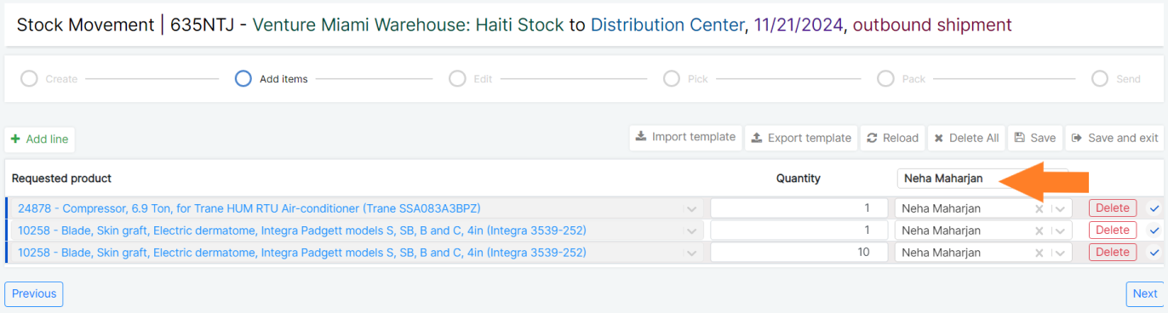

Apply a Recipient to all lines

## Add Desired Date of Delivery for Electronic Requests

A request we have received from Requestors is the ability to provide fulfilling warehouses with a desired date of delivery for better logistics and inventory management. Now they can!

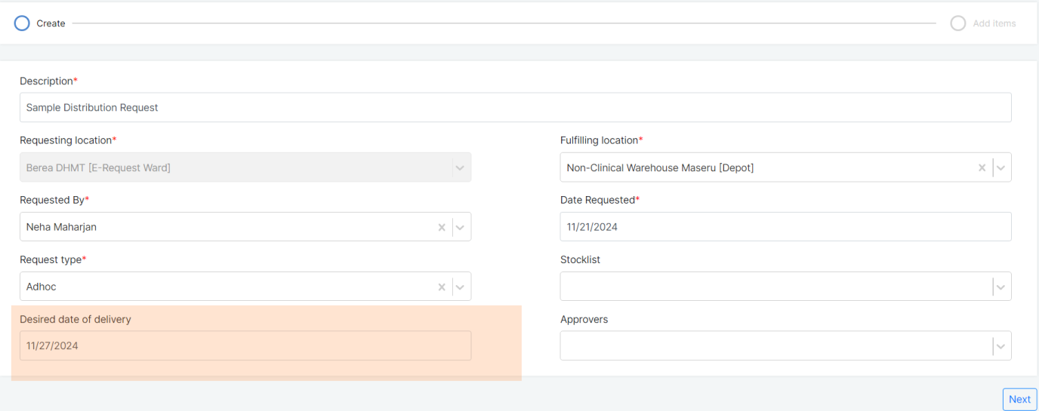

Desired date of delivery during E-Request Creation

The selected date will be available to fulfilling warehouse’s users in the request view page.

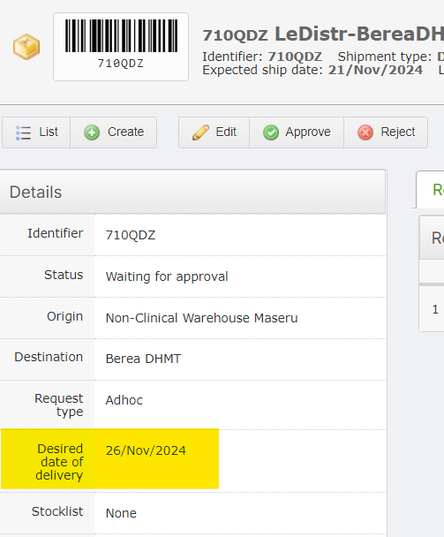

Desired date of delivery in Request View Page

## Increased Unit of Measure Visibility through Transactions (PO to Receipt)!

For International and Domestic Purchase Orders (PO), the flow of unit of measures (UoM) of items from POs to shipments to receipts can get confusing. Hence, we have made item UoM more visible as you move through shipments and receipts to make sure that the quantities between the PO and the shipments are consistent.

*Note: These changes are only visible for Shipments that are associated with a PO in the system.*

Regardless of what UoM items were ordered in (for example, 10 Boxes of 5, or 5 Packs of 2), OpenBoxes prompts users to receive the items in the smallest unit of measure (Each). Therefore, increased visibility of UoM across transactions should reduce confusion and data errors.

Please see screenshots below for example:

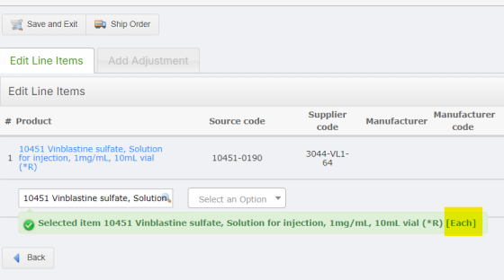

When selecting an item to add to a PO, you can see the default UoM of the product

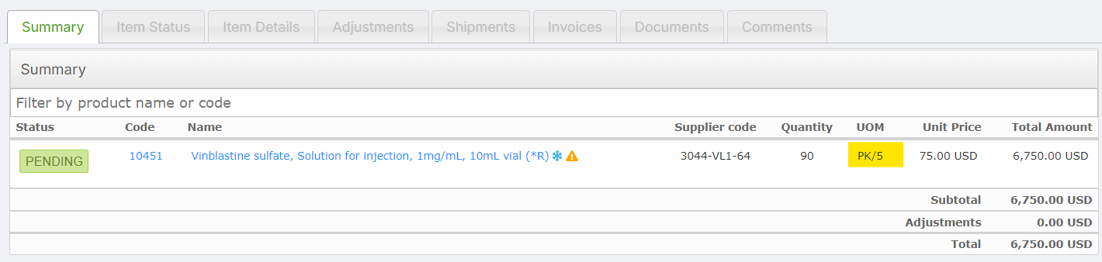

In the above screenshot, the PO consists of 90 Vinblastine sulfate ordered in Packs of 5

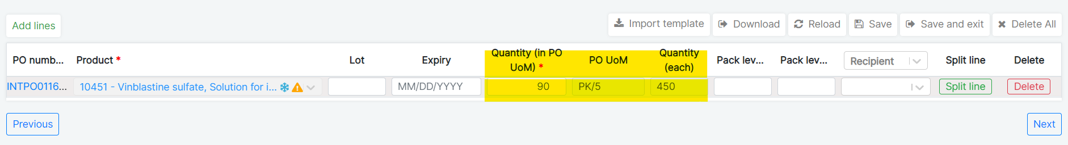

*Here, the PO is being shipped, and you can see the UoM that was entered in the PO: 90 PK/5 and a total of 450 vials of Vinblastine.*

*The supplier counts and invoices Vinblastine in Packs of 5, so this is how we define the product in the PO. But when counting in the inventory and issuing, the warehouse counts in each Vial, this is why they need to be able to receive 450 vials, and not 90 packs.*

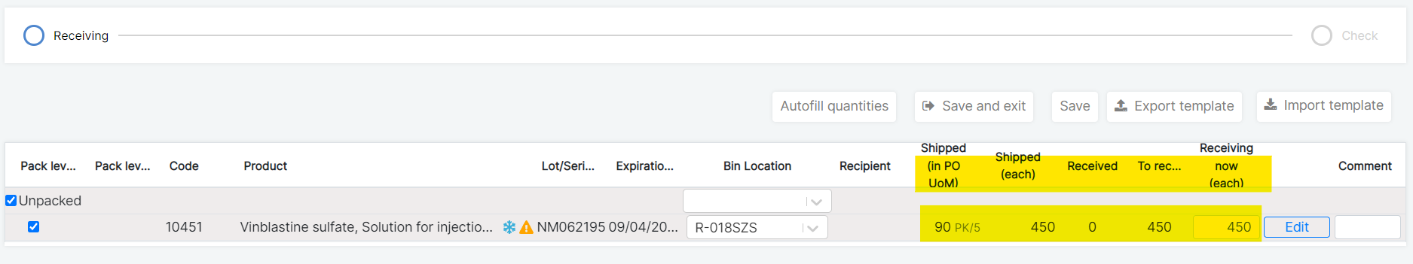

*During Receipt, you can ensure that the quantity you are receiving is consistent with what was ordered in the PO*

If you use the Edit function to change the Quantity shipped or add lines with multiple Lot #s, the Shipped (in PO UoM) and Shipped (each) columns will adjust quantities accordingly. In the screenshot below, I changed the Quantity shipped using the Edit modal from 450 to 400. This updated the Shipped (in PO UoM) from 90 to 80 PK/5 and the Shipped (each) from 450 to 400.

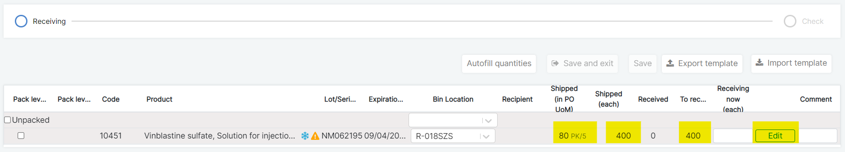

Edit function and New UoM fields during Receipt

Besides shipments from PO, Requestors who use E-Requests will also see Item UoM when placing their requests.

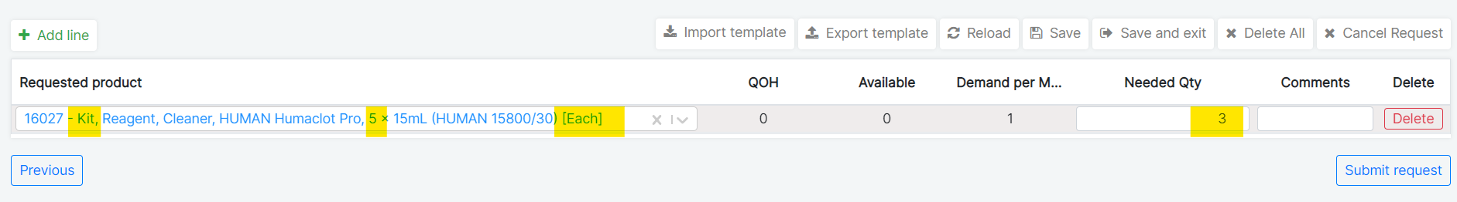

Here, the requestors can see that the Depot distributes Reagent Kit in Eaches, so they request 3 Kits.   
However, the name of the product also shows that the Kit comes with 5 cleaners. So, they’re requesting 15 total individual cleaners. The Requestors can now review the product name and the distribution UoM and request the appropriate quantity of items.

## Changes for Receiving Workflow

After multiple troubleshooting and screen sharing sessions with users, we have made multiple updates to the [Edit modal function in the Receiving workflow](https://help.openboxes.com/article/48-receiving) to support site processes. As always, we look forward to hearing your feedback on how these changes have helped your processes.

### Ensure Quantity Matches the Original Shipped Quantity

One of the ways that users use the Edit modal during Receiving is to correct the Lot # of the shipped item or add a line for Lot # not originally mentioned in the shipment. During this process, Openboxes will let you know if the quantities that you have entered/changed match the original shipped quantity for the item. This is to ensure that you are not receiving more or less, than the original shipped quantity.

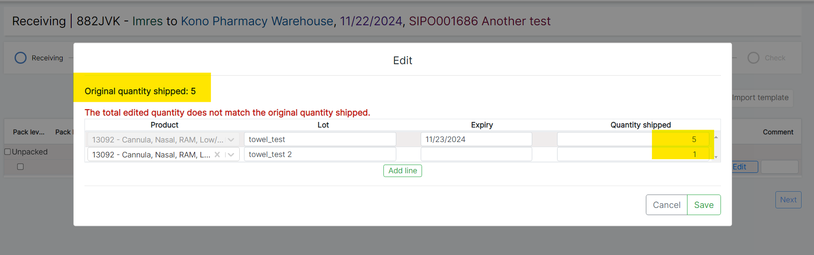

Original Quantity Shipped versus Edited Quantity Shipped

*In the screenshot above, you can see that the original quantity shipped is 5. I added the second line to add a missing Lot # with the quantity of 1. Since the quantities I entered do not match the original quantity shipped of 5, OB has displayed an error message.*

In addition to the above change, the ‘Receiving Now’ field will be empty if you made any change in the Edit modal. Users will have to add quantity in this field after they make any changes using the Edit modal to reduce the possibility of errors during receipt.

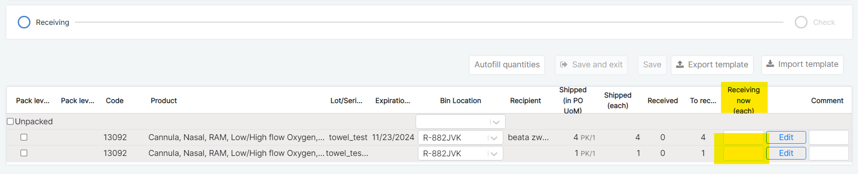

Blank ‘Receiving now’ field

### ‘Receiving Now’ Quantity Shifting Down

The Sierra Leone team reported another issue where the data entered in the ‘Receiving now’ field shifted down after using the Edit modal – we have resolved this.

### Status stays as ‘Receiving’ instead of ‘Received’

In some instances, users had to change the item code altogether during Receipt using the Edit modal, which made the shipment stay in Receiving status. This should no longer happen.

*Please note: Ideally, if the item that you physically received is not what is in the shipment in OpenBoxes, you should reach out to the depot who shipped it to update the code.*

## Let’s Merge Duplicate Products!

Introduced in 2023, the [Product Merge](https://help.openboxes.com/article/385-merge-products) feature allows the history and transactions of a product (obsolete) to be transferred to another product (the primary product). However, if the primary product was present in pending outbound shipment(s), the merge failed – we have now removed this restriction that will allow us to perform more merges.

*Note: All pending outbound shipment(s) for the to-be obsolete product still needs to be resolved for the* *merge to complete.*

If you have products that need to be merged, please report them to your System Specialist or email them to [openboxes@pih.org](mailto:openboxes@pih.org).

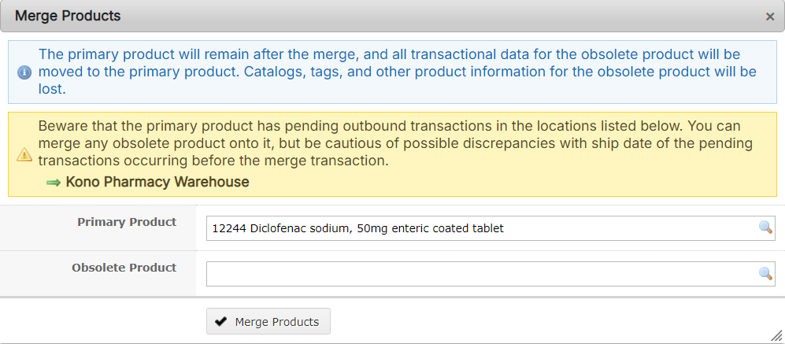

Product Merge Feature

## Filter by Handling Requirement in Product List Page

Do you need to see or download a list of products with a specific handling requirement? Now, do it easily from the [Products List Page](https://help.openboxes.com/article/65-intro-to-products). Filter for products by one or more handling requirements (Cold Chain, Controlled Substance, Hazardous Material, and Reconditioned).

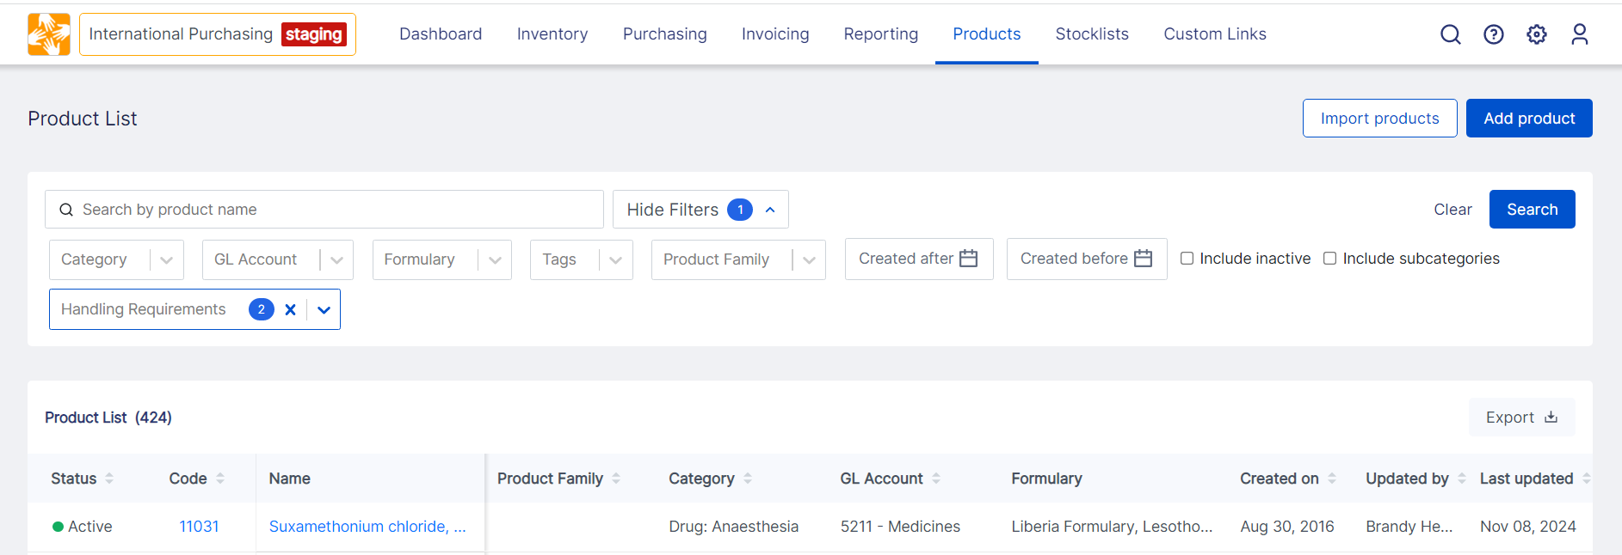

Product List Page Filters

## Product Sources Import Improvements

The ability to perform bulk edits for product sources management is a must! So, we have made several improvements to the [Product Sources Import](https://help.openboxes.com/article/468-import-product-sources) for better usability and accurate data keeping.

### Ensure Required Product Sources Data is not missing in your Import File

[Product Sources](https://help.openboxes.com/article/467-create-product-sources#Product-Source-List-Page-VrVUx) have various mandatory fields essential for good and accurate data. OpenBoxes will not notify you if the required data fields (Supplier, Default Source Package, and Package Size) are missing in your import file, or if the non-mandatory fields have errors.

### Delete and Edit via Import

You can now delete existing default preference types and deactivate an existing source tied to an inactive supplier via import.

In addition, OpenBoxes will assign the data entered in the following fields to the default package specifications to align with the manual creation process: Default Package Type, Quantity per Package, Package Price, and Minimum Order Quantity (Each). Previously, the data entered in these fields were linked to the “last updated” package specifications.

### Update to the Product Source Export File

As an update, the Product Source exports from OpenBoxes will display FALSE for inactive sources instead of blank fields in the Status column. The file shows TRUE for active sources. This will enable you to update both active and inactive sources via import without editing the file!

### See Product Sources in Various Pages

You can now also see the supplier product name on various pages: [Purchase Order View Page](https://help.openboxes.com/article/44-intro-to-purchase-orders), [shipment from a Purchase Order](https://help.openboxes.com/article/45-ship-a-purchase-order), and Packing List and Receipt tabs in [Shipment View Page](https://help.openboxes.com/article/304-outbound-shipment-detail-page).

This is intended to help the warehouse users when they are receiving a shipment in Openboxes with the help of a packing list that consists of supplier product names. Simply hover over the product.

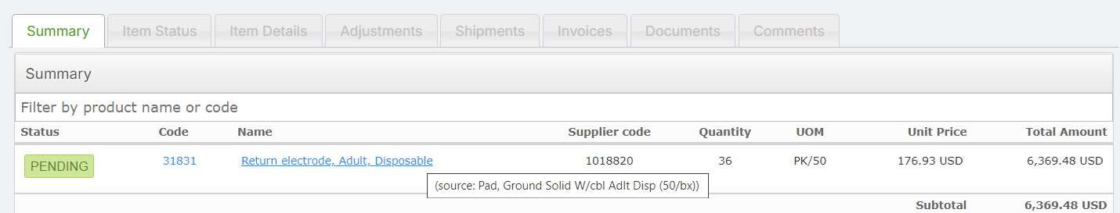

Product Source Tooltip in PO View Page

Besides the pages mentioned above, the Packing List export also displays the Supplier Product Name as entered in its associated Product Source.

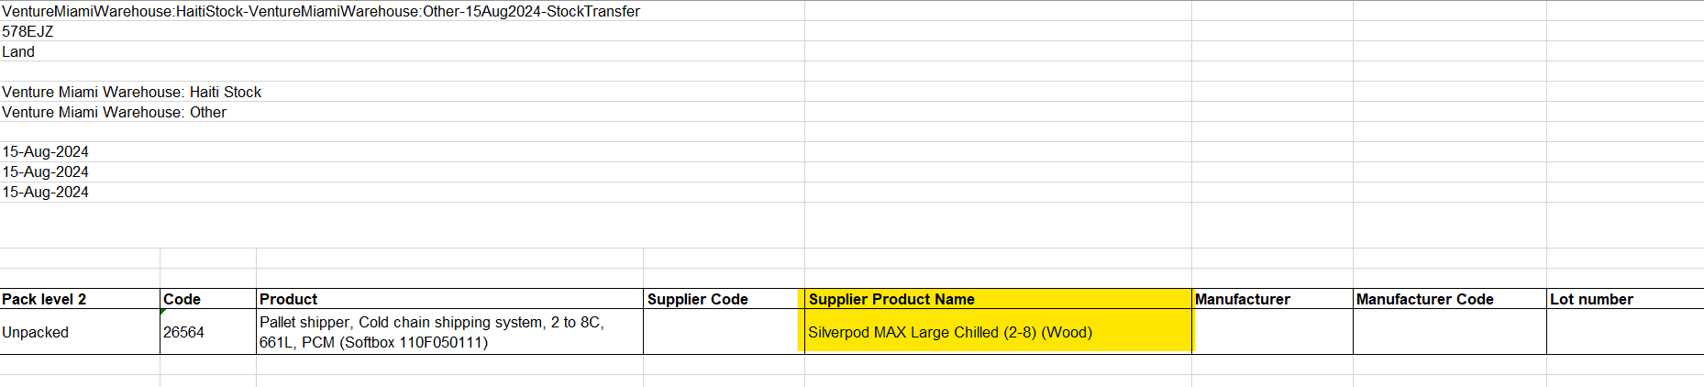

Supplier Product Name highlighted in Packing List Export

### Product Source Hyperlink in Stock Card

This one is not Import related but is still related to Sources. When editing a product in its stock card, the buttons in the Product Sources tab will now take you to the newly updated Product Source Page.

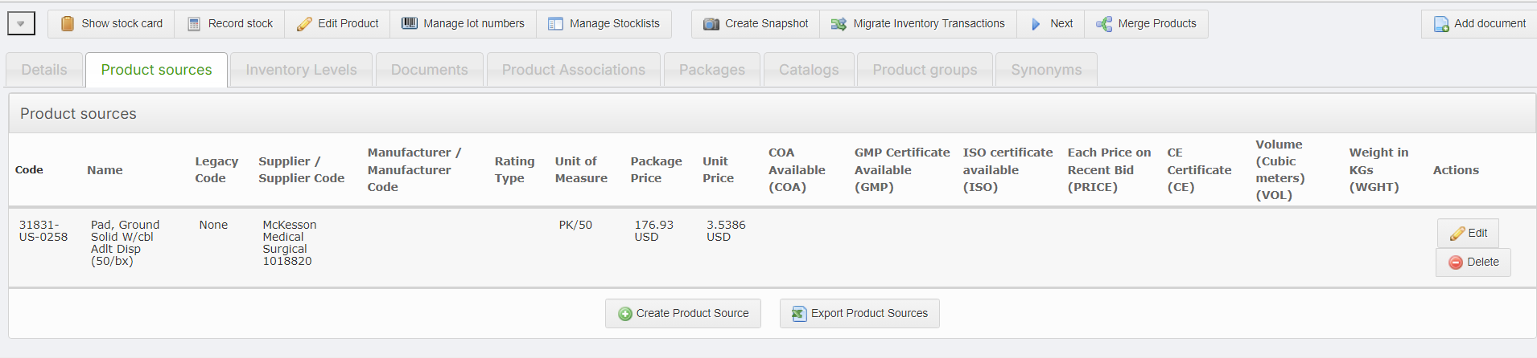

Product Sources Tab on Product Edit Page

# What is Fixed?

### Duplicate IDs assigned to Shipments and Purchase Orders

Multiple users have encountered this where two shipments have the same ID. This causes problems with locating the shipment using the global search bar. In more problematic cases, it prevents the user from receiving the shipment with this error:

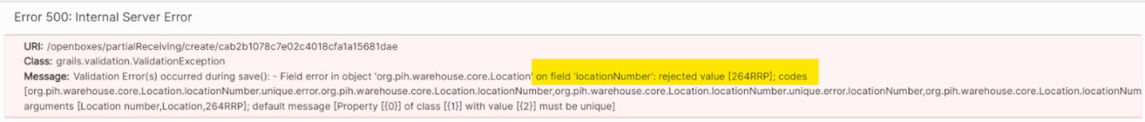

Receipt Error due to Duplicate ID

We have fixed this – now, OpenBoxes will check if the auto-generated shipment ID and PO number already exists. If yes, then it will assign another ID.

*If you see that a Shipment or Purchase Order does not have an ID, please contact your system specialist or OB admin.*

### Performance for Very Long Receipts with Pack Levels

For very long receipts divided into Pack levels, you should now see improved performance of all the components in the page, including checkboxes, bin levels, and inputting comments.

### Issue with Splitting lines for Long PO Shipment

When splitting lines during PO shipment (only with very long shipments), the additional line would disappear right after it appeared. This would happen if you were entering data very quickly before the page had fully loaded, but this should no longer happen.

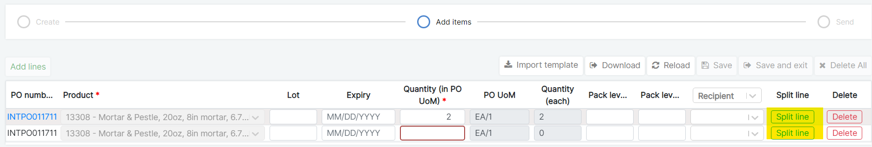

Split Line in PO Shipment

### Line Saved Multiple Times During PO Creation

When adding a product in a PO, users may click on the Save button multiple times because of slow response time or internet issues. This caused the same line to be saved and displayed multiple times in the PO. This issue has been fixed.