Release 0.9.0

# What to Expect

This OpenBoxes Release focuses mainly on the technical migration from Grails 1 to Grails 3. Therefore, while this release does not contain a lot of new features or improvements, it does include a lot of bugs that we have fixed.

Please review the Bug fixes and the few improvements included in this release.

In addition, since we are performing a technical migration of OpenBoxes, it requires more precautions than our usual releases. So, if you notice any issues, please report them to [openboxes@pih.org](mailto:openboxes@pih.org). It is very important that you report them to us immediately as they occur, and we thank you for your collaboration!

As always, you have the [OpenBoxes Knowledge Base](https://help.openboxes.com/collection/1-user-guide) and can request training through the [IOPS JIRA Helpdesk.](https://pihops.atlassian.net/servicedesk/customer/portal/3)

Table of Contents

What to Expect 1

Technical Migration 3

Improvements 3

Purchase Order Template: Order of Adjustment Line Items 3

What is Fixed? 4

Searching Products with Apostrophe 4

Missing Search Box on Purchase Order View Page 4

Invoicing more Qty than Shipped 4

Importing Items into a Purchase Order 5

Expiration Date Validation in Inbound Stock Movements 5

Expiration Date Validation when Lot does NOT Exist 5

Expiration Date Error caused by “Split Lines” during PO shipments 6

Duplication of Items during Inbound Stock Movements 6

Reload Button Issue during Bin Replenishment 6

Updates to Inventory Levels Import & Export 6

# Technical Migration

We are performing a technical migration for OpenBoxes from Grails 1 to Grails 3.

### What to expect?

This technical migration is a very important change to the version of OpenBoxes that our developers team started planning 5 years ago. We dedicated the majority of the last 9 months to this very crucial piece of work. From your side as users of OpenBoxes, you should not see any difference with the OpenBoxes you were using previously and the OpenBoxes you will be using now. OpenBoxes running on Grails 1 and OpenBoxes running on Grails 3 should be working in the same way for you. However, this change is very important for the upcoming changes you expect from OpenBoxes. The new version allows us to move forward on projects that were blocked when we were still using the old version of OpenBoxes: such as improving performance, improving our testing, some optimization topics, some security topics, etc. We are very happy to have you discover the new version of OpenBoxes after this long wait, and please bear with us as there could be some issues in the period following the go live.

It is very important that you report any issues you face before, during, or after the communicated maintenance time frame to the OpenBoxes team. Please email [openboxes@pih.org](mailto:openboxes@pih.org) to report any issues that you see.

# Improvements

### Purchase Order Template: Order of Adjustment Line Items

As requested by the Lesotho team, we have changed the way Adjustment line items are displayed in the PO Template. When adjustment items are entered, they are specifically entered in a way to have the tax amounts in the bottom, which the PO Template did not replicate.

Now, the PO template will display the adjustment line items in the same order that they are entered during [PO creation.](https://help.openboxes.com/article/42-create-a-purchase-order)

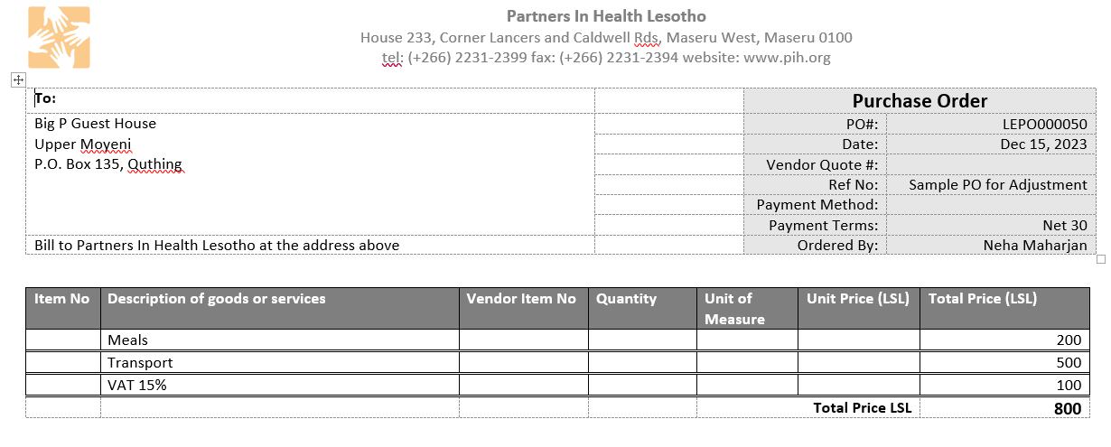

Purchase Order Template

# What is Fixed?

### Searching Products with Apostrophe

We have several products with apostrophe (‘) in the name. When [searching for the product](https://help.openboxes.com/category/6-openboxes-basics) by the name, if a user used Apostrophe, OpenBoxes threw an error.

Now, users will be able to use Apostrophe while searching using the product name.

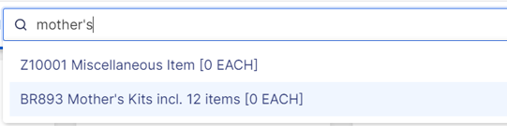

Searching with Apostrophe (')

### Missing Search Box on Purchase Order View Page

After the 0.8.23 release, the Boston team reported that the Search Box was missing on the Purchase Order View Page (Item Status Tab).

You will see the Search Box again and be able to search by Product Name and Code.

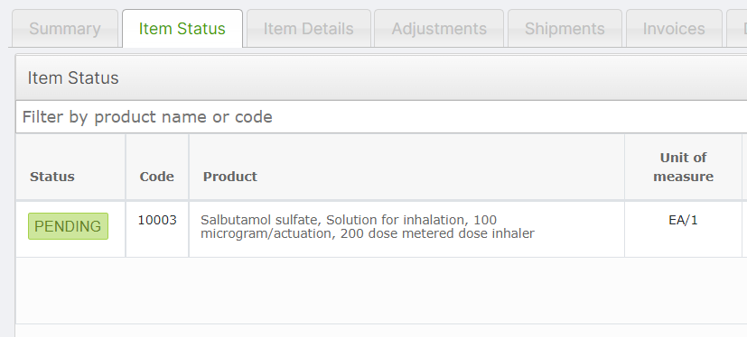

Search Box on Item Status Tab

### Invoicing more Qty than Shipped

The Boston Team reported of an error where users were able to invoice for quantities greater than what was ordered or shipped.

We have now resolved this issue, and users will see a validation error that will not allow them to invoice more than what was ordered or shipped

### Importing Items into a Purchase Order

During the implementation of OpenBoxes at Lesotho, we found that users without the Purchase Approval permissions were unable to add items into a Purchase Order via Import. This is now fixed and everyone with at least Manager permissions should be able to import items into a Purchase Order.

### Expiration Date Validation in Inbound Stock Movements

During an Inbound Stock Movement, if a user enters a lot number that already exists in the system, OpenBoxes checks if the corresponding expiration date for that lot matches. If the expiration date does not match, OpenBoxes shows a validation error that allows the user to update the expiration date for all existing inventory for that lot.

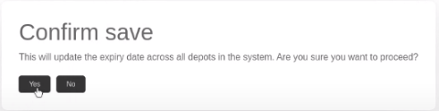

Expiration Validation

However, if the user saved and exited the shipment, and returned to it, they were able to pass to the final Send page without the validation error and did not update the expiration date.

This has now been resolved. Openboxes will display the validation error even if the user exits the page and returns to it.

### Expiration Date Validation when Lot does NOT Exist

When creating stock movements, Expiration Date validation should only be shown IF the Lot number already exists in the system. But, when shipping a Purchase Order, the validation was displayed even when the Lot number did not exist in the system.

Now, users should only see Expiration Validations if the corresponding lot number already exists in the system.



Expiration Validation

### Expiration Date Error caused by “Split Lines” during PO shipments

The Boston Supply Chain Team reported an issue during the shipment of PO items. During the shipment, if the user used the “Split lines” function, Expiration dates already entered for other line items were being duplicated on the newly created line item.

The duplication of expiration date on new lines should no longer happen.

### Duplication of Items during Inbound Stock Movements

The OpenBoxes team identified a bug where line items were duplicated during specific cases on the Send Page of [Inbound Stock Movements](https://help.openboxes.com/article/48-receiving).

During an Inbound Movement, if a user enters a lot number that already exists in the system with a different Expiration date, and tries to update the expiration date for all the existing stock of that lot number, the line item was duplicated in the Send page. This bug has been resolved.

### Reload Button Issue during Bin Replenishment

The Reload Button during the [Bin Replenishment](https://help.openboxes.com/article/102-replenish-bins-feature) process was not updating the inventory information on the page as expected, which has now been resolved.

### Updates to Inventory Levels Import & Export

To make the [Inventory levels](https://help.openboxes.com/article/299-manage-inventory-levels) more efficient, we have added the following columns to the Import and Export files.

* **Target Bin Location**: The location that the inventory level rules (min, max, reorder) apply to.
* **Preferred Putaway Location**: The Bin location used for picking of outbound shipments.
* **Default Replenishment Source**: An internal location like a Bulk location, an external Depot, or a Supplier