Release 0.9.7 🎉

WHAT TO EXPECT
This release focuses on improvements to existing features. While some of these improvements were directly proposed by OpenBoxes users, others were realized through user feedback and observations.
Please use the Table of Contents to find the section that relates to your work function to view the updates! You will find updates to the following areas: Product Management, Purchase Orders, Shipments, E-Request, Cycle Count, and Backdata Entry. As in every release, we have also addressed workflows and system-related Bugs.
Use the hyperlinks to learn more about the mentioned features!
As always, we are looking to our users for feedback and to report any issues you encounter. Please contact us at openboxes@pih.org.

Table of Contents
WHAT TO EXPECT 1
Inbound Refactor 4
Shipments Improvements 4
Updated Validation for Ship Date in the Past 4
Shipment Notification Email Now Includes Goods Receipt Note 5
E-Request Improvements 5
Bug Fix: Import Failure when using Stocklist 5
Use the Product Search Bar in E-Request! 6
E-Request Validation for Request Lines with 0 Needed Qty & Duplicate Request Lines 6
Cycle Count Improvements 7
Reporting: Selected Dates Saved across Cycle Count Reports! 7
Reporting: Export Inventory Changes Report 7
Import Recount Form 8
Bug Fix: Assignee not Visible during Recount if Product QoH was 0 8
Bug Fix: Assign Button not Visible 9
Performance Improvement: 9
Backdata Entry Improvements 9
See Inventory Information on the Confirmation Page 10
OpenBoxes to recognize Receiving Bins easily from the Import File 11
Removed Expiration Date Column 11
Purchase Order Improvements 12
Add Recipients using Email Address 12
Automatic Update of Actual Ready Date for New Lines in Placed POs 12
Update the Recipient for Lines in Different Purchase Orders at once! 12
Edit Purchase Order Line even if the Product Source is Inactive 13
Bug fix: Prevent reducing the Purchase Order Ordered Qty to be below the Shipped or Invoiced Quantity 14
Bug Fix: Purchase Order Placed for a Different Organization than the one the User is currently logged into 14
Product Management Improvements 15
Visual Alert for Duplicate Products in Stocklist 15
Search Box for Tags! 15
Disable Assignment of Products to Parent Categories 15
Restrictions on Product Deactivation 16
Avoid Duplicate Product Associations between Two Products 17
Product Sources Improvements 17
Easy Navigation: Product Source Hyperlink after Source Edits 17
Delete Product Source Data via Import 18
Bug Fix: Date Format for Product Source Import 18
Created By and Updated by Columns in Product Source List Page 19
Product Source Tab Updates on Electronic Stock Card 19
Bug Fix: Export Product Sources from Electronic Stock Card 20
Don’t Lose Product Source Updates 20
Delete Product Source with Associated Package 21
Other Updates 21
Baseline QOH Report Removed from Reporting Menu 21
Inventory Import for New Project Startups 22
Other Bug Fixes 22

Inbound Refactor
This is a technical upgrade to the system’s Inbound workflows to eventually enable autosave. Users will not see any change at this time.

Shipments Improvements

Updated Validation for Ship Date in the Past
When shipping an Outbound Shipment, the Ship Date may be in the past. In these cases, OpenBoxes displays a message asking whether you want to ship with the Past Ship Date or update it to today’s date, as shown below.
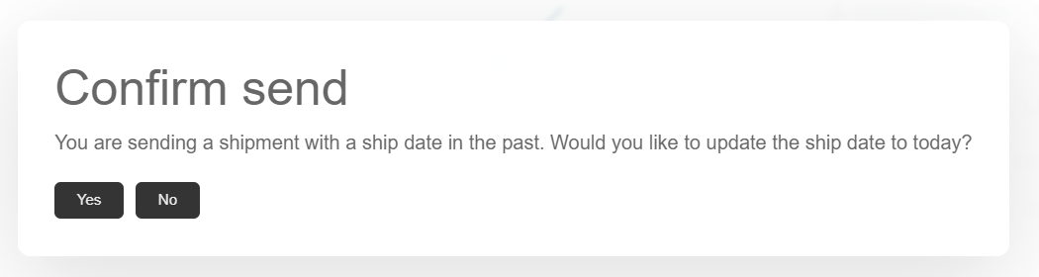
Ship Date Confirmation Modal before 0.9.7
This message has previously caused confusion, leading people to select the incorrect option. We have updated this confirmation message to prompt the user to actively select the correct Ship Date.
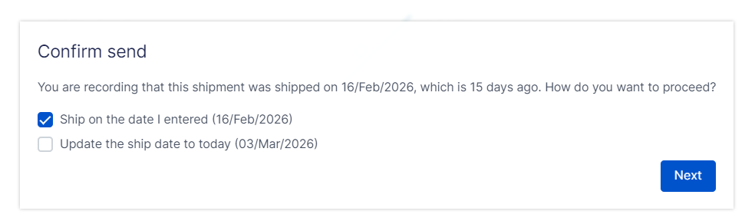
Ship Date Confirmation Modal after 0.9.7

Shipment Notification Email Now Includes Goods Receipt Note
OpenBoxes sends a notification to the selected Recipients when a Shipment is Received. This Receipt Notification will now also include the Goods Receipt Note, allowing the Recipient to obtain the necessary information about the receipt.
While the Recipients can still view the Receipt details in OpenBoxes, the attached GRN provides easier access.
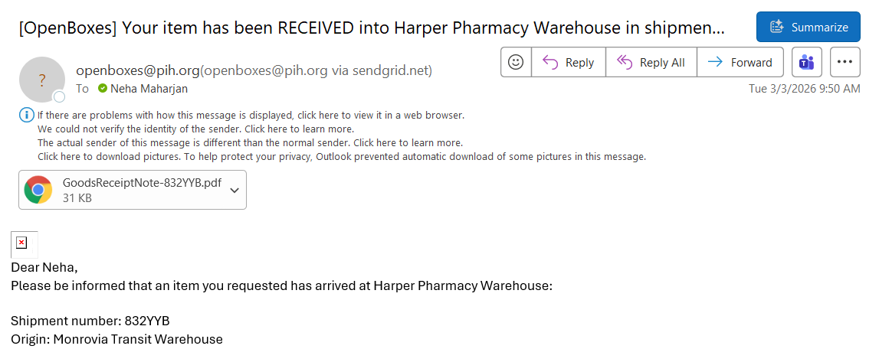
Receipt Notification with GRN attached

E-Request Improvements

Bug Fix: Import Failure when using Stocklist
If a user created an E-Request using a Stocklist and attempted to edit the Request lines via Import, the Import failed. This forced the user to manually edit the lines.
This is now fixed. The Import function in E-Request allows line updates and additions regardless of a stocklist being used.
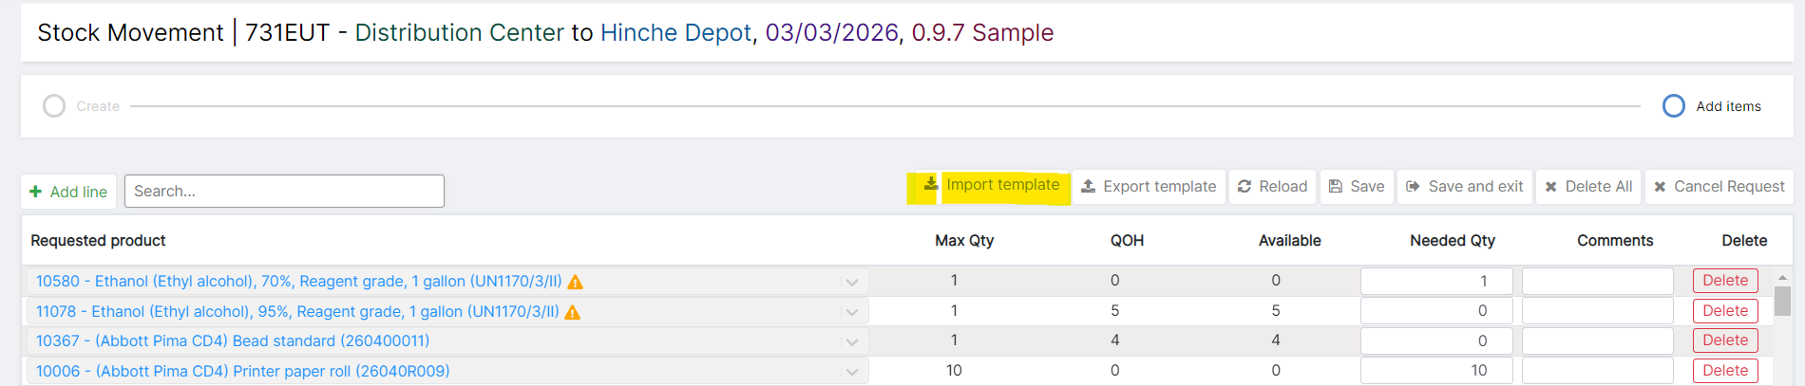
Import Template Button in E-Request

Use the Product Search Bar in E-Request!
Users no longer need to scroll through several lines in an E-Request to find a single line! Use the new Product Search Filter – simply enter the Product Name or the Product Code.
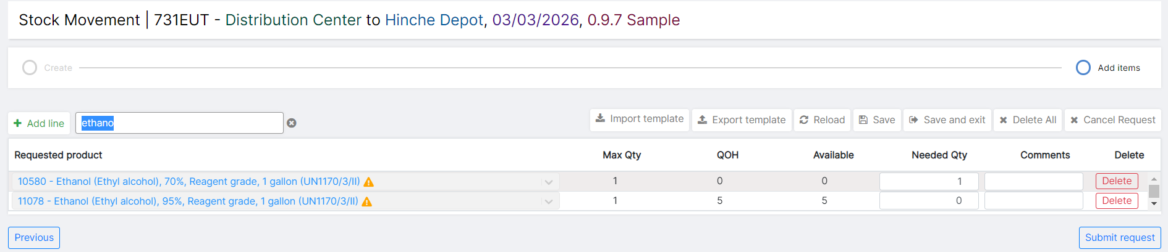
Filtered Products using Product Name

E-Request Validation for Request Lines with 0 Needed Qty & Duplicate Request Lines
A recent E-Request update we made to prevent the removal of 0 Needed Qty line items on Save introduced a complication.
In a scenario where an E-Request has 0 Needed Qty lines AND duplicate item lines, OpenBoxes was only validating the 0 Needed Qty lines and preventing the user from proceeding.
Now, in a case where both 0 Needed Qty lines AND duplicate item lines exist, OpenBoxes will first prompt users to combine ALL the duplicate lines. Once there are no duplicate lines, OpenBoxes will validate if the user wants to proceed with the 0 Needed Qty line items.
The 0 Needed Qty line items are removed when the E-Request is submitted.

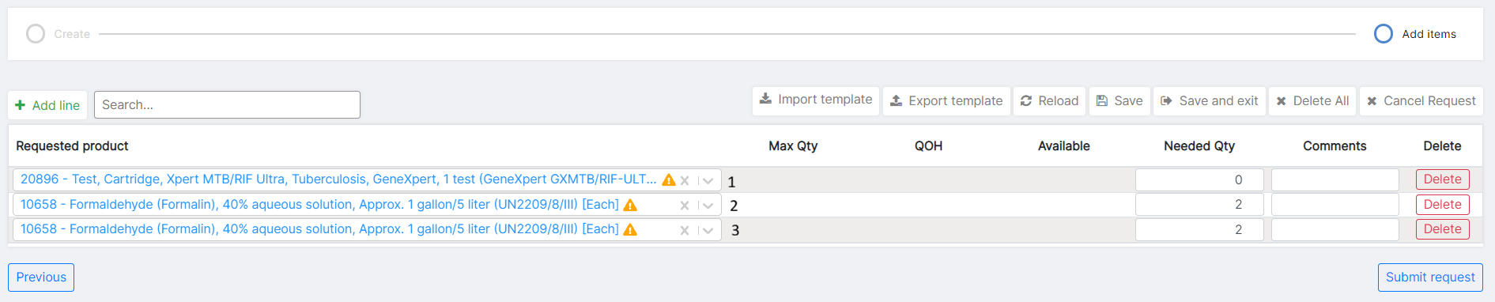Line 1 is an example of a 0 Needed Qty Line; Lines 2 and 3 are examples of Duplicate lines in an E-Request

Cycle Count Improvements

Reporting: Selected Dates Saved across Cycle Count Reports!
Many users suggested that the dates entered in the Inventory Changes Report should be saved when switching between the three reports.
Now, you no longer have to select dates each time you switch between the reports. Enter the dates in one of the reports and easily see the data for the dates under each reporting tab.
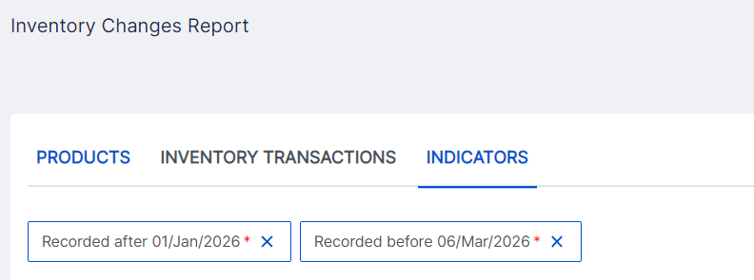
Inventory Changes Reports

Reporting: Export Inventory Changes Report
The Products and Inventory Transactions Reports provide users with information on the types of inventory transactions recorded in the system, along with details of each transaction. This data is crucial to understanding the accuracy of warehouse inventory and what is triggering inventory updates. While this data is already available on OpenBoxes, the ability to export it to Excel allows additional analysis and easier sharing.
Users can export the data under the Products and Inventory Transactions tabs. On the Right-hand side, click on Export > select either Export Full Report or Export Filtered Report.
Learn more about the reports here: Inventory Changes Report.
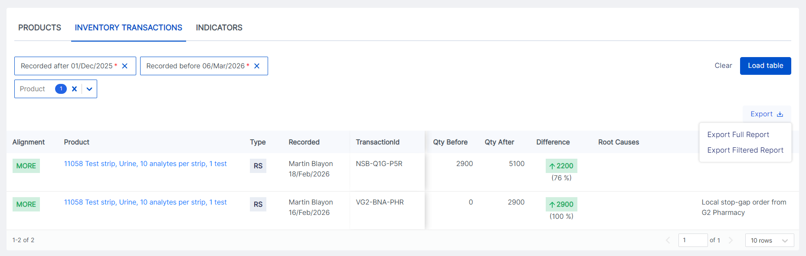

Import Recount Form
Users can now import Recount information in the Cycle Count Resolution workflow! The import feature was already available for the initial Count data, and it has now been extended to the Recount workflow for more efficient data entry.
In the Recount process, simply export the Recount Sheet > enter the Quantity Recounted information (column L) in the Excel file > and import the Recount.
For lines with recount difference, select the Root Cause in OpenBoxes.
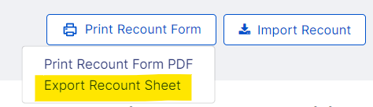

Bug Fix: Assignee not Visible during Recount if Product QoH was 0
In the Cycle Count Resolve workflow, if the product’s QoH was 0, the assignee was not visible. This is now fixed.
The assigned Assignee should always be visible during the Count and Recount workflows.

Bug Fix: Assign Button not Visible
Depending on the number of products selected, screen resolution, and zoom percentage, the Assign button was not visible on the screen when assigning products to count. The workaround was to zoom out on the browser.
This is now fixed. The Assign button is visible regardless of screen resolution and number of items selected to assign.
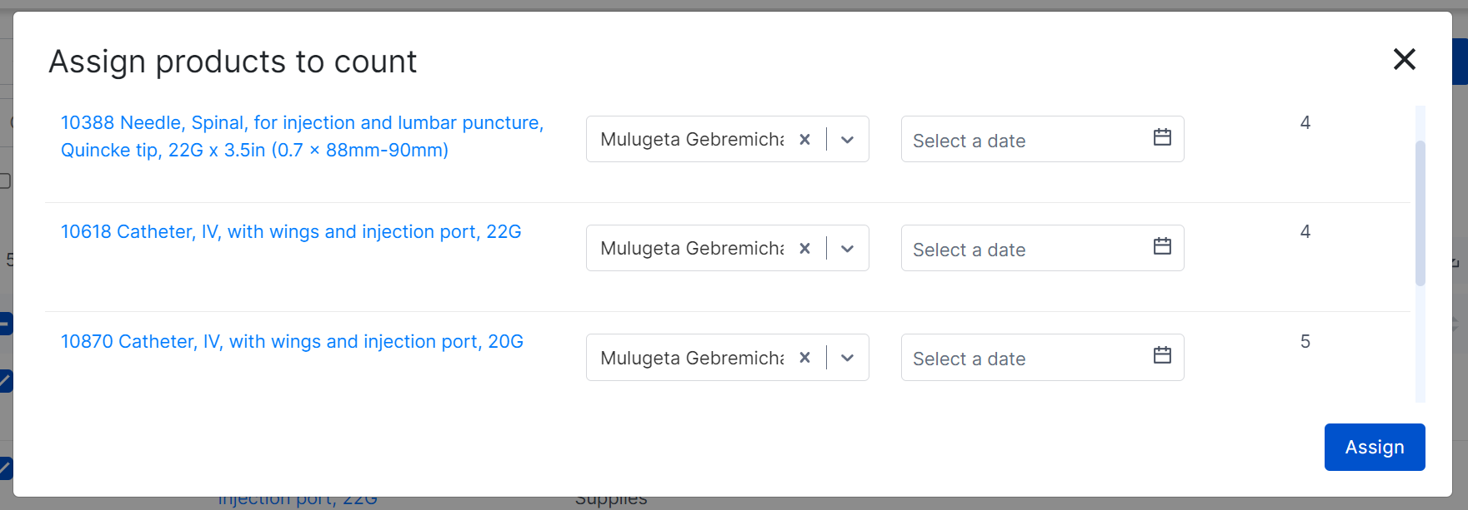
Assign Button during Product Count Assignment

Performance Improvement:
As a part of performance improvement, the OB Team has changed the validations that happen during Saving. Instead of validating saved changes against all the Cycle Count tables in the backend, the Save button will trigger validation for only the table that was edited. This allows for real-time validation without losing performance.

Backdata Entry Improvements
In 0.9.2.2. Release, we introduced a feature to Import Completed Outbound Shipments to assist with backdata entry. This feature has complemented ongoing processes at sites and supported accurate data entry. We have taken steps in this release to improve this feature.

See Inventory Information on the Confirmation Page
Once you have imported the Outbound Shipment Lines, OpenBoxes notifies you if any line has incorrect data and allows you to review all the information.
Now, on the Confirmation page, you can easily access Inventory information for shipment lines without having to open another tab in the browser.
In the Items table, click on the Magnifying Glass on the right-hand side to view the current Inventory information for the Item line. This easy access to the inventory information from the Confirm page will allow you to update your Import file with the correct information when needed.
For example: the Lot # you entered for a product in the Import file is incorrect -> Simply click on the Magnifying Glass icon to find the correct Lot number!
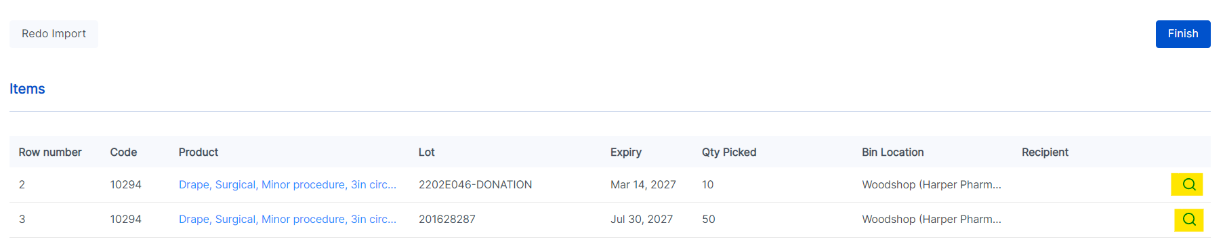
Highlighted Magnifying Glass in Confirmation Page

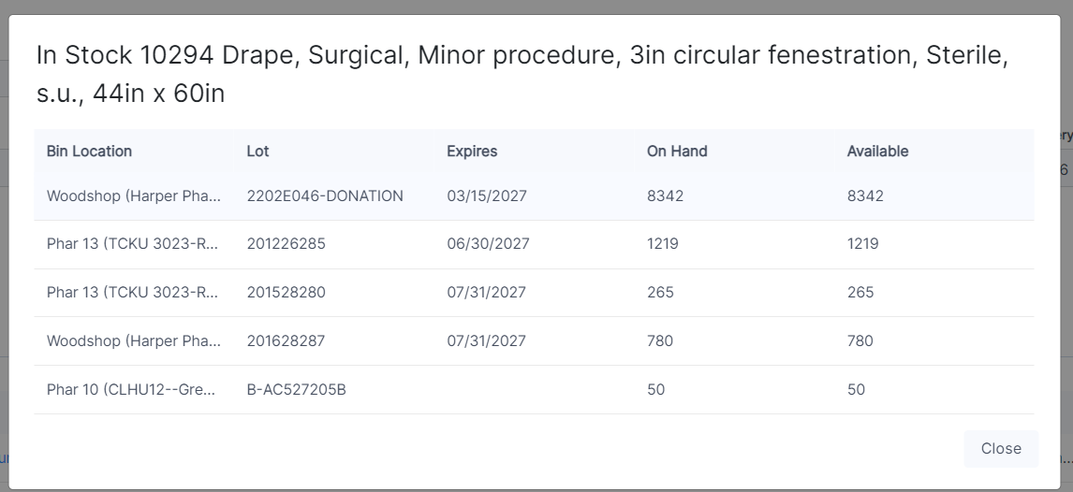
Product Inventory Information Modal

OpenBoxes to recognize Receiving Bins easily from the Import File
In the Import file, even if you forget to add “R-“ for a Receiving Bin, OpenBoxes will check if it is a Receiving Bin. For example, if you enter 123xyz for Bin Location, OpenBoxes will look for both 123xyz and R-123xyz.
This will reduce the number of corrections users have to make for a successful import.

Removed Expiration Date Column
During the “Import Completed Outbound” process, Openboxes uses the Lot number to pull the Expiration Date for that Lot. Hence, it is not necessary to enter the Expiration Date as well as the Lot Number. So, we have removed the Expiration Date column from the Import file.
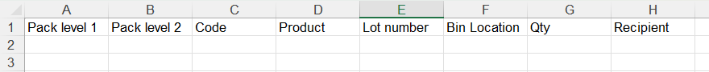
Import File without Expiration Date column

Purchase Order Improvements

Add Recipients using Email Address
During Purchase Order placement, users can now add Recipients using Recipient email addresses!

Automatic Update of Actual Ready Date for New Lines in Placed POs
Purchase Orders have two dates: the Expected Ready Date (entered initially during PO Placement) and the Actual Ready Date (copied from the Expected Ready Date and can be updated later per Vendor communication).
When a PO is initially placed, the Expected Ready Date copies over to the Actual Ready Date. However, the copy-over was not occurring when a new item was added to an already PLACED PO, resulting in empty Actual Ready Dates. This also affected the IOPs Encumbrance Reports. Users would have to manually enter the Actual Ready Date in these scenarios or use the Import option.
To remove this manual process, OpenBoxes now copies over the Expected Ready Date to the Actual Ready Date for new items, even if the PO is already placed. Simply click on the Save & Exit button to trigger the copy over. You can still update the Actual Ready Date as needed after the initial copy over.

Update the Recipient for Lines in Different Purchase Orders at once!
Users can now update the Recipient for Multiple PO lines from different Purchase Orders at the same time!
This will save a lot of time by avoiding manual updates to Recipients in each PO.
Use the PO Actual Ready Date and Recipient Import (previously, PO Actual Ready Date Import).
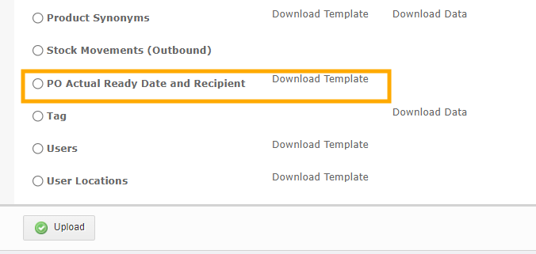
Updated “PO Actual Ready Date and Recipient” Import
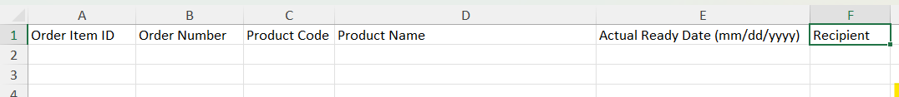
New Recipient Column in the “PO Actual Ready Date and Recipient” Import File

Edit Purchase Order Line even if the Product Source is Inactive
For an existing Purchase Order line, if the Product Source for that item is inactive, the following fields could not be edited: Recipient, Quoted Ship Date, and Expected Ship Date. However, even if the Product Source is not used for future POs, the PO line should remain editable.
Now, users can edit the Recipient, Expected Ship Date, and Quoted Ship Date for a PO Line item even if it uses a deactivated Product Source. This is possible through the User Interface (UI) and through Import.
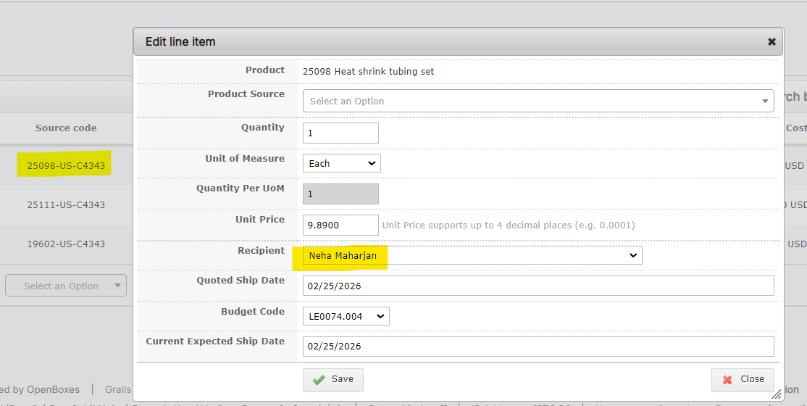
Editing the Recipient for a PO Line with an Inactive Product Source

Bug fix: Prevent reducing the Purchase Order Ordered Qty to be below the Shipped or Invoiced Quantity
There were previously two edge cases that allowed a user to reduce the ordered quantity on a PO below the shipped and/or invoiced quantity. First, if the user used the PO import feature to edit the quantity, OpenBoxes was not properly validating whether the new quantity was greater than or equal to the quantity shipped. Second, it is possible for a user to reduce the shipped quantity on a PO below the invoiced quantity if after completing the invoice, they roll back the shipment. In this case, the user could then lower the order quantity to less than the invoiced quantity as long as it was greater than or equal to the shipped quantity. Now, OpenBoxes has separate validations to ensure that the ordered quantity can never be below the shipped quantity or the invoiced quantity.

Bug Fix: Purchase Order Placed for a Different Organization than the one the User is currently logged into
A user noticed a strange behavior: a PO was created for one location, but the buyer organization was different from the Organization for the selected location. For example, a PO is created under the International Purchasing location (Boston), but the Buyer organization is APZU (Malawi). This prevented the Boston Finance team from invoicing the Boston PO.
This can occur when a user with access to multiple purchasing locations has multiple tabs open under different locations without refreshing them properly.
Now, if the Buyer Organization does not match the current open location’s Organization, OpenBoxes will reload the entire PO Creation page, and the user must start the PO over.
TIP: Do not leave multiple tabs open under different locations. Refresh your tabs before starting a new transaction.

Product Management Improvements

Visual Alert for Duplicate Products in Stocklist
As a Stocklist Manager, OpenBoxes will now alert you if a Product is already on the stocklist, preventing duplicate entries.
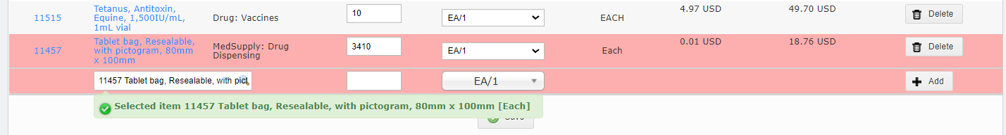
Red Highlight on duplicate Product Lines 1 during Stocklist Edit

Search Box for Tags!
Use the new Filters Box to look for Product Tags! You no longer have to skim through the several existing Tags in the Tags List Page.
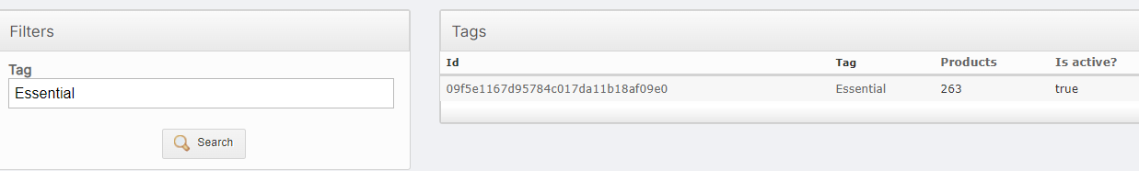
New Filters Box on Left-Hand Side

Disable Assignment of Products to Parent Categories
Superusers can now disable the assignment of Products into a Parent Category.
At the bottom of the Product Category Tree page, look for the button to “Disable assigning parent category to product.”
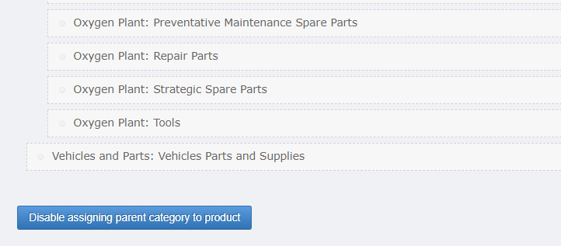
New Disable button in Product Category Tree Page
For example, in the categories shown below, Oxygen Plant is the Parent Category. When Parent Category assignment is disabled, a Product can be assigned to one of the Children Categories and not to the Parent Category.
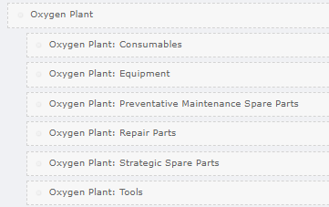
Parent Category with Children Categories
See this document for more information on Categories: Product Category.

Restrictions on Product Deactivation
For proper Product Management, we are adding additional restrictions on product deactivation.
In the cases below, a product CANNOT be deactivated.
- Product is in inventory at a Depot.
- Product is NOT in inventory but is in a SHIPPED shipment to an inventory managing Depot.
- Product is in a published stocklist (existing restriction).

Avoid Duplicate Product Associations between Two Products
Product Associations can be created as one-way or two-way. When investigating various duplicate associations between products of the same association type, we found we needed to limit the creation of the same association type from already-associated products.
If there is already a one-way substitution association from Product A -> Product B, and the association needs to be extended from Product B -> Product A, the existing one-way substitution should be updated to a two-way substitution. Adding another one-way or two-way association from Product B to Product A introduces redundancy and can cause duplicates.
To maintain clean associations, OpenBoxes will now validate if one-way associations of the same type already exist between two products when the user creates a two-way association. If yes, then the user must edit the existing one-way association.
This validation already exists for Association Import and is now extended to manual association entry from the Stock Card and the Associations List Page.
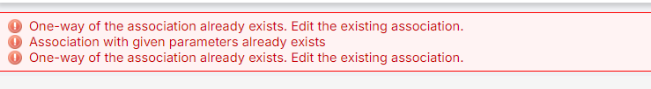
Error Message displayed when a One-Way Association already exists

Product Sources Improvements

Easy Navigation: Product Source Hyperlink after Source Edits
When you save any updates to a Product Source, the confirmation message includes a hyperlink to the Product Source, making it easy to navigate to the Source’s Edit Page.
You no longer must manually search for the Source you just edited!
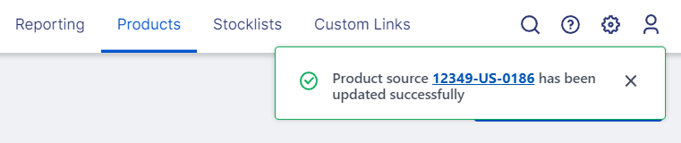
Product Source Hyperlink in the Edit Success Message

Delete Product Source Data via Import
With thousands of Product Sources to manage, it is important to be able to edit Source data easily. We’re happy to share that Product Managers can now remove existing data for the following fields via Product Source Import. Simply enter “null” in the Import file.
- Legacy Code
- Supplier Code
- Default Preference Type validity dates
- Default Preference Type bid name
- Package MOQ
- Package Price
- Contract Price (also removes validity and tiered pricing attribute)
- Manufacturer (also removes manufacturer code, rating, and brand)
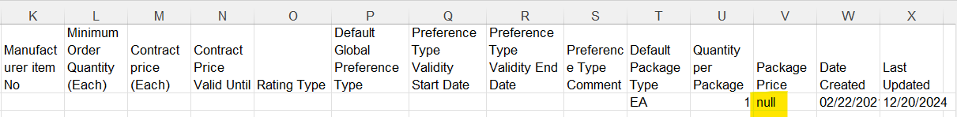
Deleting the existing Package Price by entering “null”

Bug Fix: Date Format for Product Source Import
We have fixed issues related to Date Format during Product Source Import. The Date Formats in the import file needed to be manually changed to Text format for a successful import – this manual fix is no longer required.

Created By and Updated by Columns in Product Source List Page
As requested by the Boston Sourcing team, we have now added columns for Created by and Updated by data in the Product Sources List Page.
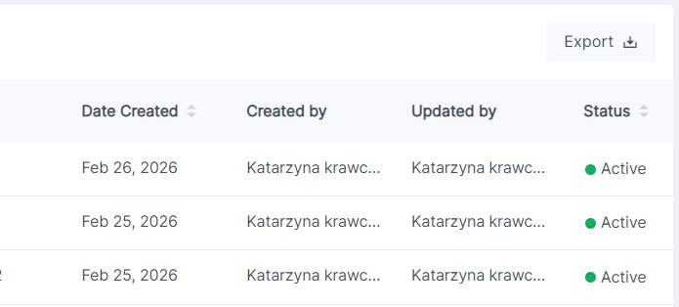
New Created by and Updated by Columns in Product Sources List Page

Product Source Tab Updates on Electronic Stock Card
As requested by the Boston Sourcing Team, we have made a few updates to the Product Sources tab in the Stock Card to display only relevant Source information.
- Removed the Contract Price and Contract End Date columns.
- Replaced Pack Size and Last Price with Default Source Package and Default Package Price, respectively.
- Added a Column for Each Price (Default Package Price / Pack Size), rounded to 4 decimal places.
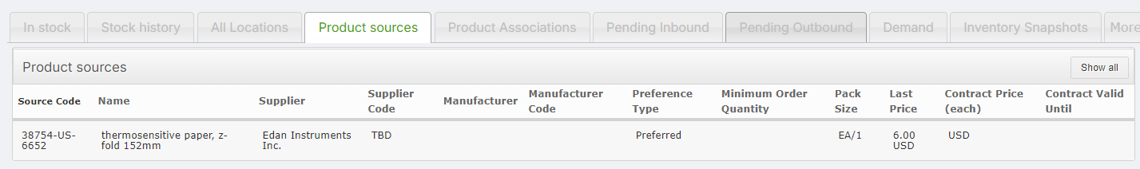
Product Sources Columns BEFORE 0.9.7

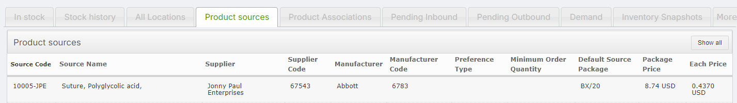
Product Sources Columns AFTER 0.9.7

Bug Fix: Export Product Sources from Electronic Stock Card
The Export Product Sources button in the Stock Card was exporting Product Sources for ALL products, rather than just the current Product’s Sources.
This has now been resolved. The button will only export the sources related to the Product the user is currently viewing.
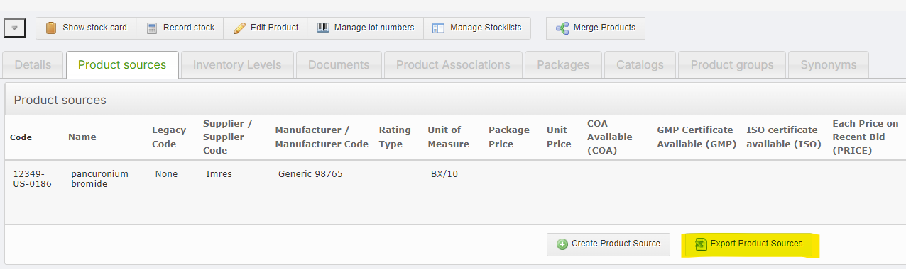
Export Product Sources Button in Electronic Stock Card

Don’t Lose Product Source Updates
After updating the Product Source, if you attempt to go back to another page without saving, OpenBoxes will display a warning that there are unsaved changes.
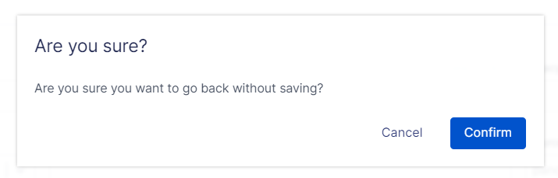
Warning Message for Unsaved Product Source Edits
Note: This warning is displayed only when users click the “Back to Product Source List” button at the top left of the screen, NOT when using the browser back arrow.
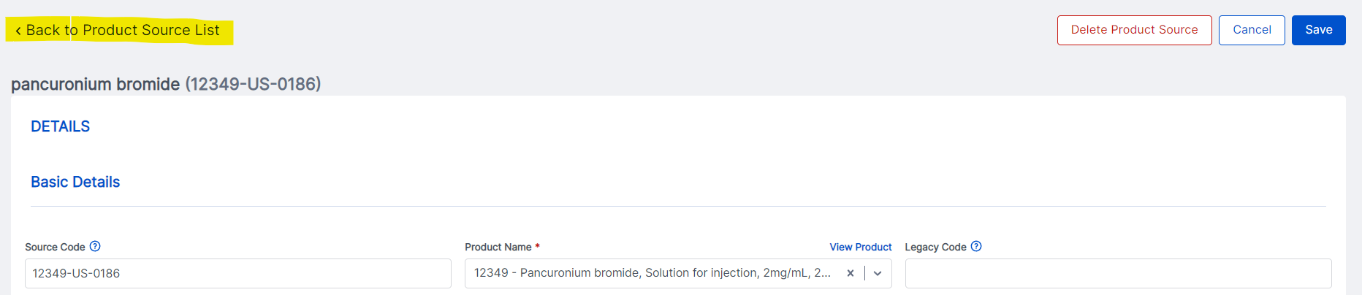
Highlighted “Back to Product Source List” Button

Delete Product Source with Associated Package
If a Product Source has an associated Package, OpenBoxes would not allow deletion of the Source, leaving virtually no way to delete it.
To allow the Sourcing team to maintain up-to-date data, users can now delete a Product Source even if it has an associated Package, which also deletes the associated product package records.
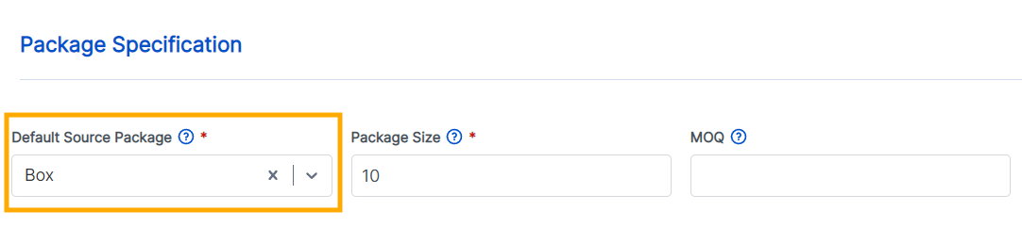
Default Source Package in Product Source

Other Updates

Baseline QOH Report Removed from Reporting Menu
You will no longer see the Baseline QOH Report under the Reporting Menu. This report is not functional; hence, we have removed this option.
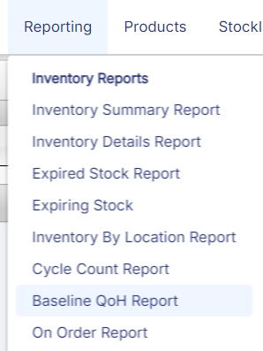 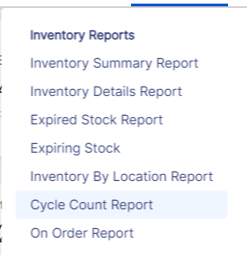
Previously Now

Inventory Import for New Project Startups
In an external project, the team found that the Inventory Import feature does not allow importing products that require Lot & Expiration Date with a 0 QoH. This is only relevant for new products that have never been in stock. Although this is most often seen during a new project's startup, we have addressed this.

Other Bug Fixes
- Edit Button during Receipt not Removing Bin Data: When receiving a shipment, using the Edit button would remove the selected Receiving Bins for all products and reset them to Receiving Bins. This has now been resolved.

- Transfer In function now working: The Electronic Stock Card has a Transfer In function; however, this function was not working. This is an alternative way of entering a credit transaction into the system and allows easy data entry for a single product. This is now fixed.
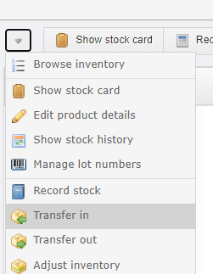

- Prevent shipment of items with 0 QATP: Users reported a bug where users were able to ship products even when the products had 0 QATP. This was occurring for products that had the QATP previously zeroed out using Record Stock.
However, OpenBoxes should not allow users to ship items that have no quantities in stock and should prompt the users to revise quantities in the EDIT page.
This bug has now been addressed and all items with QATP less than Qty Requested must be revised during the EDIT page before proceeding to PICK and SEND page.

- Cannot Rollback Receipt of Inbound Return when Receiving Bin has insufficient quantity: For an Inbound Return, users were able to rollback a Receipt even when there was insufficient quantity in the original receipt bin (example: when the received item has been putaway to another bin). This was possible through the Edit Page of the Return. This causes discrepancies in the QoH of the product.
This is no longer possible.

- Use Record Stock to enter the same Lots in different lines: Using Record Stock to entering multiple lines for the same Lot led to error – this is now resolved. This can happen when warehouse team notices the same Lot # is placed in different bins and attempts to update the inventory using Record Stock.
Now, users can use Record Stock to enter multiple lines with the same Lot Number.
- Rows now aligned in GRN: In the Goods Receipt Note, the Sierra Leone team found an issue with Rows alignment when products were received with multiple Lot #s.
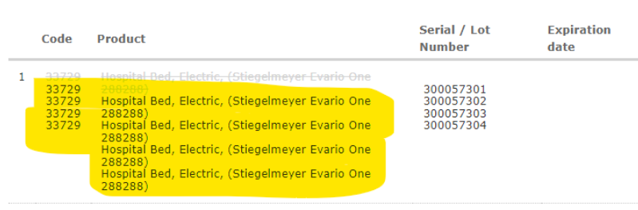
Previous unaligned Rows
This will no longer happen, and each row will be displayed properly.
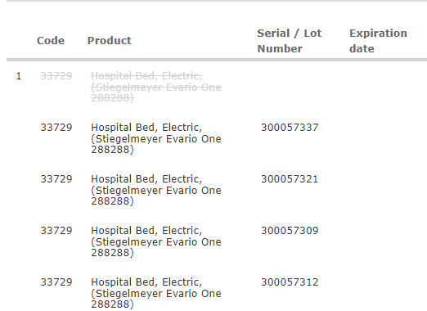
Aligned Rows after 0.9.7

