Release 0.9.5 🎉

WHAT TO EXPECT?
This release continues the work we started in 0.9.4 with the Cycle Count feature. Since the 0.9.4 release, many users have been waiting for Cycle Count Reports. You will be happy to see some introductory summary reports in this release. The Inventory Accuracy Indicators might become your favorite! In addition to the reports, we have done various updates to the Cycle Count workflows itself along with other improvements to existing documents (Picklist, Delivery Note & Goods Received Note) and bug fixes.
As always, please reach out to openboxes@pih.org for any feedback or any issues with the system.

Table of Contents
WHAT TO EXPECT? 1
REQUEST A PRODUCT MERGE 3
NEW INVENTORY CHANGES REPORTS! 3
Products (Cycle Count History by Product) 4
Inventory Transactions Report 5
Inventory Accuracy Dashboard 6
Product Inventories 6
Inventory Accuracy 7
Inventory Shrinkage 7
Inventory Transactions Refactor [Technical] 7
CYCLE COUNT IMPROVEMENTS 7
Different Inventory Adjustment Icon in Stock History 7
Uniform Date Formats 8
Do not See Inactive Products for Cycle Count 8
Cannot Access Cycle Count from a Different Location 8
Assign a Person and Deadline for a Count and Recount 8
See Zones in Cycle Count Tabs and Workflows 9
See if Products are already in the Process of Count / Resolution 10
Cannot Count Products PICKED for a Pending Outbound Shipment 10
Sort Products Alphabetically in Count and Recount Workflows 11
Introducing Import for TO COUNT Workflow 11
Select Receiving Bins during Cycle Count 12
OB Saves Drafts for RESOLVE Workflow 12
Improved Messaging after Cycle Count 12
IMPROVEMENTS 13
Export Filtered Results on Product Sources List Page 13
Download Picklist Sorted by Bins 13
Delivery Note: Improved Display of Separate Pack Levels 14
Goods Receipt Note: Wrapped Product Names 14
Page Numbers on Picklist & Delivery Note 15
Supplier Code Now Visible in the Shipment View Page 15
Bug Fixes 17
Product Import Causing Category and Tag Duplication 17
Product Associations List Page URLs 17

REQUEST A PRODUCT MERGE
The Product Merge feature has proven to be an essential tool for product management in OpenBoxes. And we are making it easy for users to suggest a Product Merge!
Use the IOPs Helpdesk Request a Merge ticket to report any duplicate products you come across. Our shared efforts will be crucial to maintaining our vast database of products.

NEW INVENTORY CHANGES REPORTS!
Long awaited, we are happy to release new reports for Cycle Count Results and inventory changes! With our new reports, users can view cycle counts performed for all products and the outcomes in one place. In addition, the new Inventory Transactions report considers inventory updates done through not only Cycle Count but also other inventory features!
Go to Inventory > Reporting (Under Cycle Count).
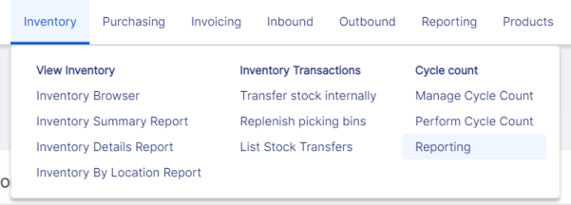
Reporting Option under Inventory Menu
See below for the report information. Here is the link to our Knowledge Base for these reports: Inventory Changes Reports.

Products (Cycle Count History by Product)
The PRODUCTS tab is a report of Cycle Counts performed within the designated period by products. Here, you can view all of the Cycle Counts performed at your site in one place!
The Cycle Counts performed after the release will automatically be included in the new report. The ones performed before the release will be available in the report within a few months after the release.
The OpenBoxes Team will notify sites when their old cycle counts are updated in the report.
Go to Inventory > Reporting (Under Cycle Count) > PRODUCTS tab.
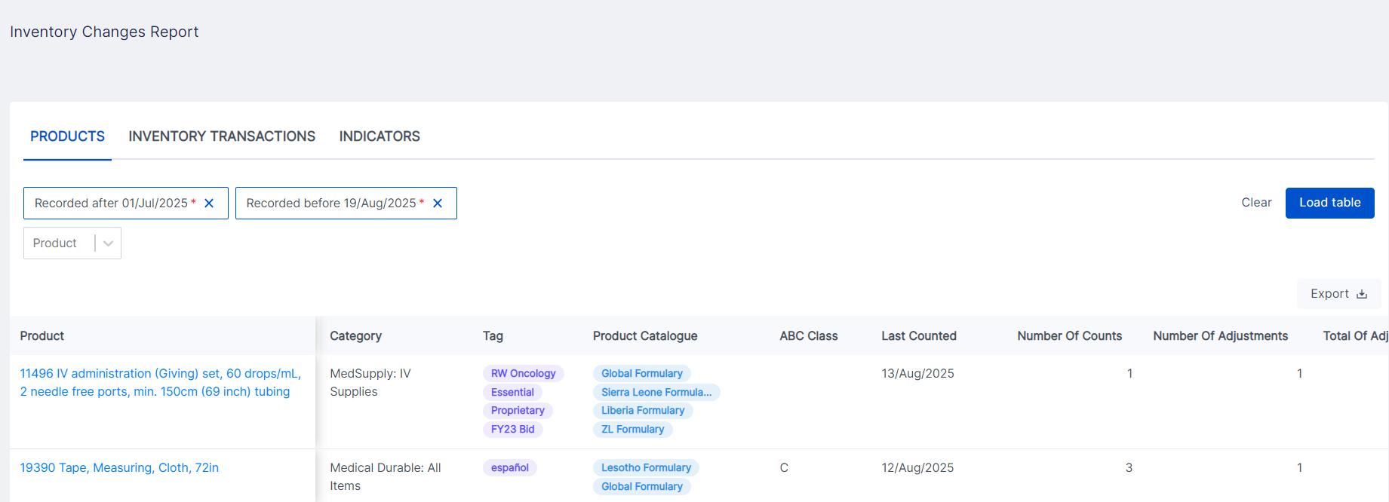
PRODUCTS Report
This report gives you a summary of the Cycle Counts performed with important data. Some important data available that people are interested to see are:
- When the product was last counted
- The number of counts performed for the product during the time period
- The number of adjustments resulting from those counts (i.e., how many Cycle Counts resulted in an inventory discrepancy)
- Total of adjustments
- Adjustment value (USD)
- How the adjustment affected the months of stock the product will be in inventory based on existing demand.
Product 19390 Cycle Count Data
For example, in the above screenshot, the number of cycle counts performed for the product 19390 is two for the period chosen. Out of the two cycle counts, one resulted in the need for an Inventory Adjustment. The total adjustment for the product in the chosen period due to Cycle Counts is an increase of 72. How does this change look in the stock history? See below.
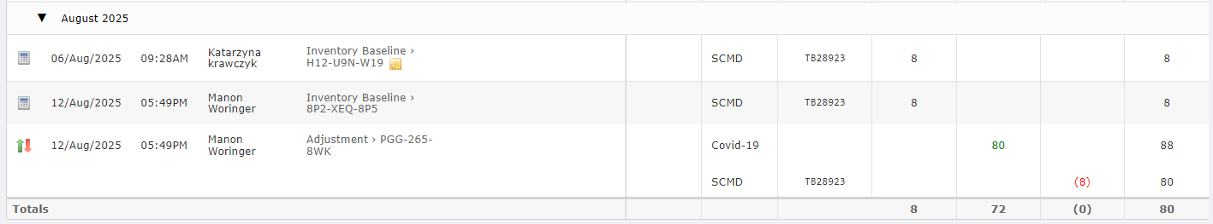
19390 Stock History displaying the Cycle Count & the resulting Adjustment of 72

Important: The Total of Adjustments displays the adjustments resulting from ALL the Cycle Counts performed for the period. If two cycle counts for a product resulted in two adjustments, the Total of Adjustments displays one value for the inventory changes that occurred due to both Cycle Counts.
example: If Cycle Count 1 resulted in an Adjustment of -6 and Cycle Count 2 resulted in an Adjustment of 100, the “total of adjustments” will display 94.

Inventory Transactions Report
With various ways to update product inventory, it would be nice to have a report that summarizes what inventory updates have occurred for a product and due to what transaction.
Such data gives us valuable insight into how our inventory is being handled and helps us identify opportunities for better inventory management.
That is why we created the INVENTORY TRANSACTIONS Report! This report shows product inventory transactions recorded via RECORD STOCK (RS), INVENTORY IMPORT (II), CYCLE COUNT (CC), and INVENTORY ADJUSTMENTS (IA) (via the Adjust Stock feature).
Go to Inventory > Reporting (Under Cycle Count) > INVENTORY TRANSACTIONS tab.
In this report, you will see the inventory update for each product by the type of inventory transaction. The Alignment and Difference columns display if the transaction resulted in an increase, a decrease, or no difference for the product inventory. Use the Transaction ID to easily locate the transaction in the product’s Stock History.
The Root Causes column is only applicable for Cycle Count Transactions. If multiple Root Causes exist, you will see them together in one row, separated by a comma.
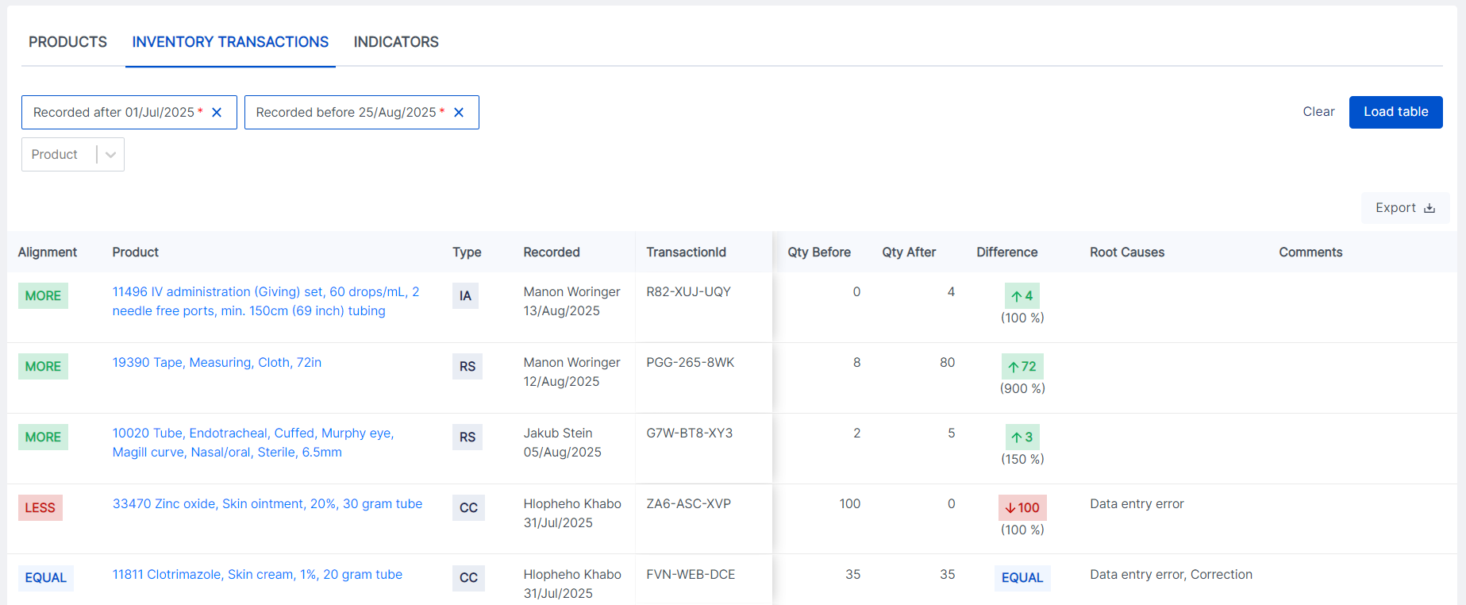
Inventory Transactions Report

Note: The Inventory Changes Report may not show accurate calculations for transactions recorded via the “Record Stock” feature and when the Qty before is zero (only when the zero is due to a debit transaction). This is due to a technical classification issue and will be addressed in 0.9.6.

Inventory Accuracy Dashboard
Another exciting development is the INDICATORS tab! These indicators are summarized Cycle Count Data. You can easily view Cycle Count Summaries for your desired period using these indicators.
Go to Inventory > Reporting (under Cycle Count) > Indicators tab.
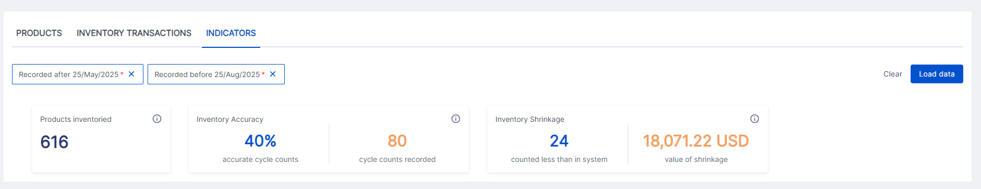
Inventory Accuracy Indicators

Product Inventories
This indicator displays the number of products counted at least once during the selected period.

Inventory Accuracy
This indicator displays the percentage of Cycle Counts that resulted in equal counts (the physical count matched OpenBoxes quantity). This represents the share of inventory for which OpenBoxes inventory accurately matched the physical inventory.

Inventory Shrinkage
This indicator presents the number of products for which the overall inventory adjustment for the selected period is negative; meaning if the total of all adjustments recorded is negative during the given period, that product is accounted for Inventory Shrinkage. The financial inventory shrinkage is the equivalent of the inventory decrease for these products in USD.

Inventory Transactions Refactor [Technical]
This technical change does not change the way stock and stock history are calculated.
The purpose of this change is to allow OpenBoxes to report on quantity before and after inventory transactions. You will see Record Stock transactions and Inventory Imports in the Stock History as inventory baselines for adjustments that represent inventory change.
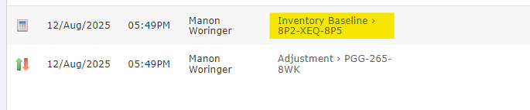
Inventory Baseline shown in Stock History

CYCLE COUNT IMPROVEMENTS
As a second iteration to the 0.9.4 Cycle Count release, this release contains various improvements to the Cycle Count workflow to make the process more efficient.
In this document, “Tabs” refer to the Cycle Count Menu (ALL PRODUCTS, PERFORM COUNT, AND RESOLVE COUNT) & “Workflows” refer to the process of performing the counts (entering the count information).

Different Inventory Adjustment Icon in Stock History
As part of the Cycle Count Improvements, we have changed the Inventory Adjustment icon. This icon now represents both positive and negative inventory adjustments.

Uniform Date Formats
We have applied the DD/MM/YYYY date format in all Cycle Count Tabs, Workflows, and Reports.

Do not See Inactive Products for Cycle Count
We should not be performing Cycle Counts for inactive products; hence, inactive products will no longer be visible in the ALL PRODUCTS tab.

Cannot Access Cycle Count from a Different Location
This applies to users with access to multiple depots in OpenBoxes.
If a user changes their location while performing Cycle Count to a different location, they cannot continue the workflow and must navigate back to the Cycle Count Menu tabs.
However, OpenBoxes will still save a draft of the count in the correct location!

Assign a Person and Deadline for a Count and Recount
For someone managing the Cycle Counts at the warehouse, OpenBoxes now offers the ability to assign products to count to specific team members with a deadline. The assignment is available for both the TO COUNT and TO RECOUNT tabs.
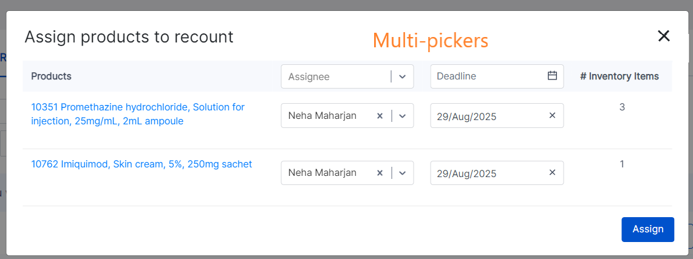
Assignment modal in the TO RECOUNT tab

To see count assignees, simply use the Assignee filter.
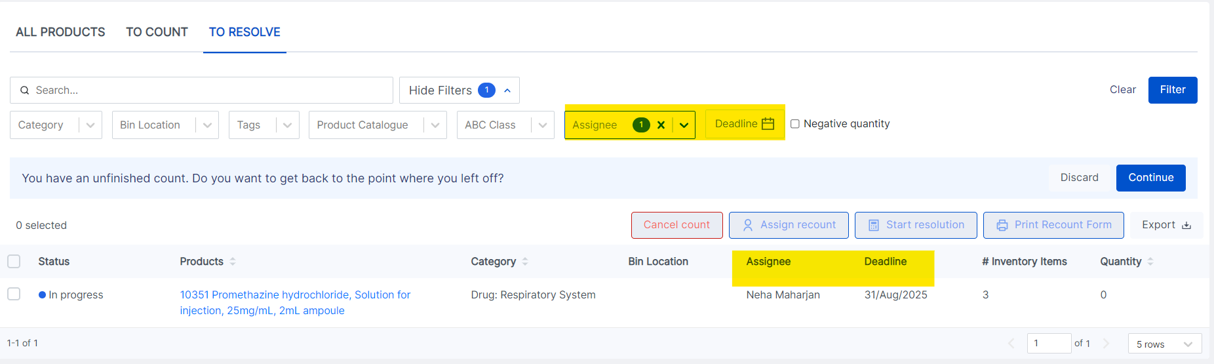
Assignee Filter in the TO COUNT tab

See Zones in Cycle Count Tabs and Workflows
Zones are important location identifiers and are extremely helpful in finding the physical locations of the products. That is why the Bin Location filter and Bin Location columns in Cycle Count Tabs now also display Zones along with the Bin Locations. The format in Bin Location columns is “Zone: Bin Location,” for example, “ROOM 1 – RIGHT WING (Zone): Section 1 (BIN).”
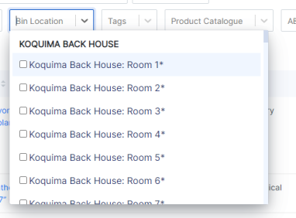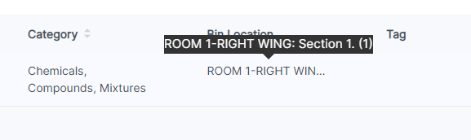
Bin Location Filter classified by Zones Tooltip with Zone and Bin Location

You will the same changes applied to Cycle Count Workflows “Zone: Bin Location.”
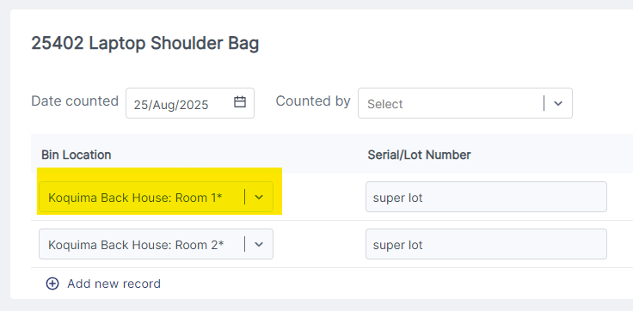
Bin Location with Zone in Cycle Count Workflow

See if Products are already in the Process of Count / Resolution
The ALL PRODUCTS tab shows all the products in inventory to count, even the ones that users have already selected to count. This can cause confusion.
To make it easy to distinguish which products are already in the Cycle Count process, these products are now gray in the ALL PRODUCTS tab. Although visible, users cannot take any action on such products in the tab.
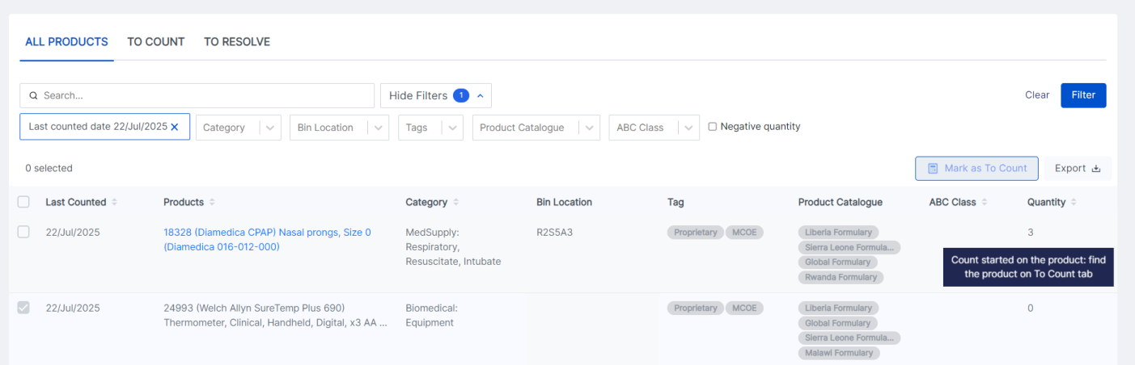
Grayed line with a message stating “Count started on the product, find the product on To Count tab”
In the screenshot above, you can see the row for the second product, 24993, is gray.
On the right-hand side, a message appears, “Count started on the product, find the product on the To Count tab.”

Cannot Count Products PICKED for a Pending Outbound Shipment
Performing a Cycle Count on a product PICKED for a pending Outbound Shipment can be a complicated process for the system as well as the warehouse team member. Capturing the correct quantity on hand can be tricky, as the picked quantity could be in a different location than stated in the system or already moved out of the warehouse. That is why only products not PICKED for a pending outbound shipment should be counted.
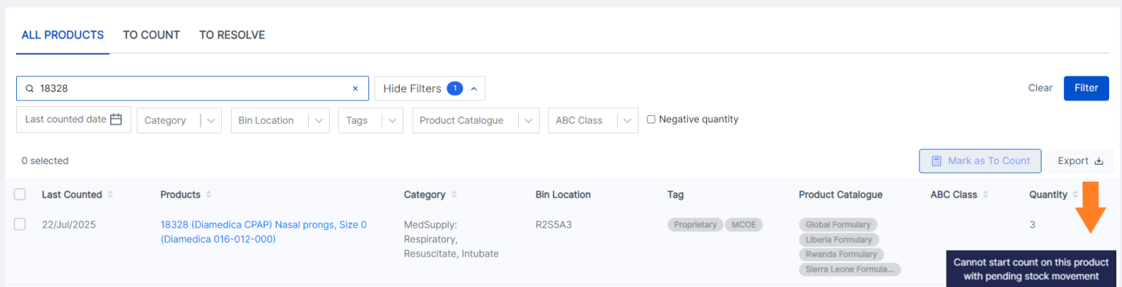
Row of product 18328 grayed out because the product is PICKED for a pending Outbound Shipment
OpenBoxes can now recognize in the Cycle Count Tabs whether a product is PICKED for a pending Outbound Shipment. If yes, the rows of the products are gray in the ALL PRODUCTS and TO COUNT tab and cannot be selected for counting.
On the other hand, if a user PICKS a product and it is already in the TO RESOLVE tab of Cycle Count, you can continue the resolution for the product, but OpenBoxes will display a warning message to be careful about the quantities.

Sort Products Alphabetically in Count and Recount Workflows
During the Count and Recount Workflows, you can now see a “Sort Alphabetically” option for easier navigation!
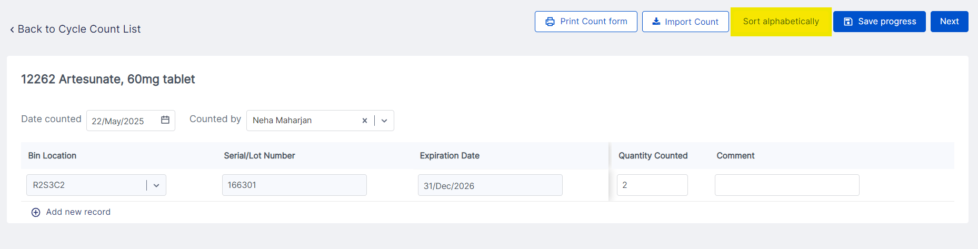
The new “Sort Alphabetically” option in Cycle Count Workflows

Introducing Import for TO COUNT Workflow
Imports always make data entry easier! Now, in the TO COUNT workflow, you can easily enter information in the exported Excel sheet and perform a quick Import.
The exported file will include any data you already entered on the page.
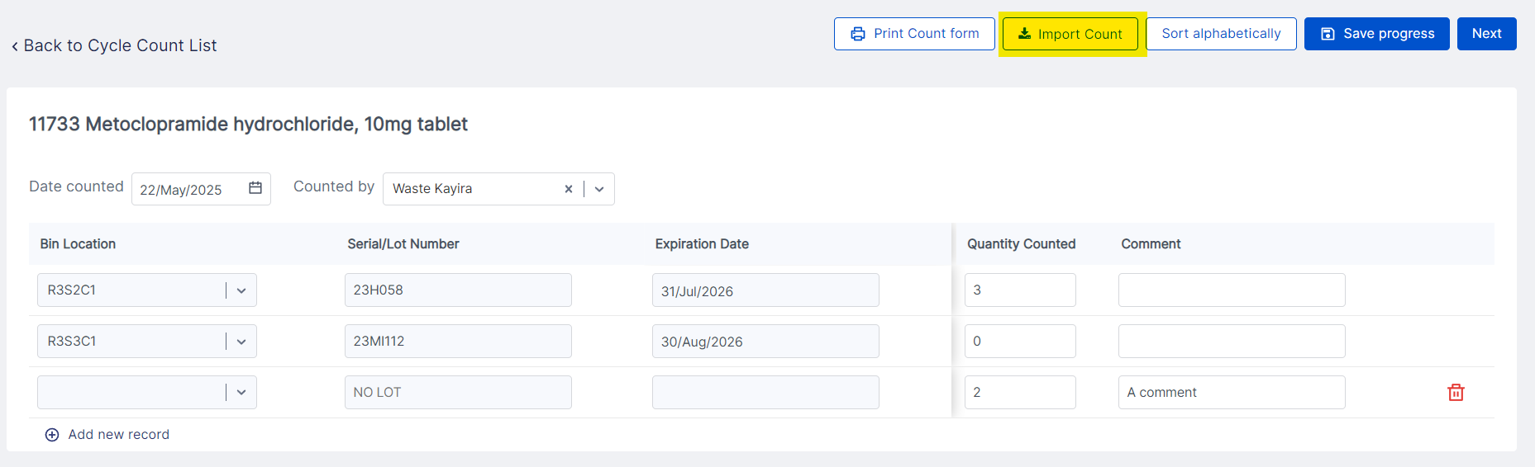
The new “Import Count” button

Select Receiving Bins during Cycle Count
The Receiving Bins format (R-Shipment ID) in OpenBoxes makes it easy for users to identify which shipment the item arrived in. Therefore, it is not surprising if a user wants to select a receiving bin for a new line during the Cycle Count workflow. Now you can!
You will find receiving bins at the end of the Bin Location list.
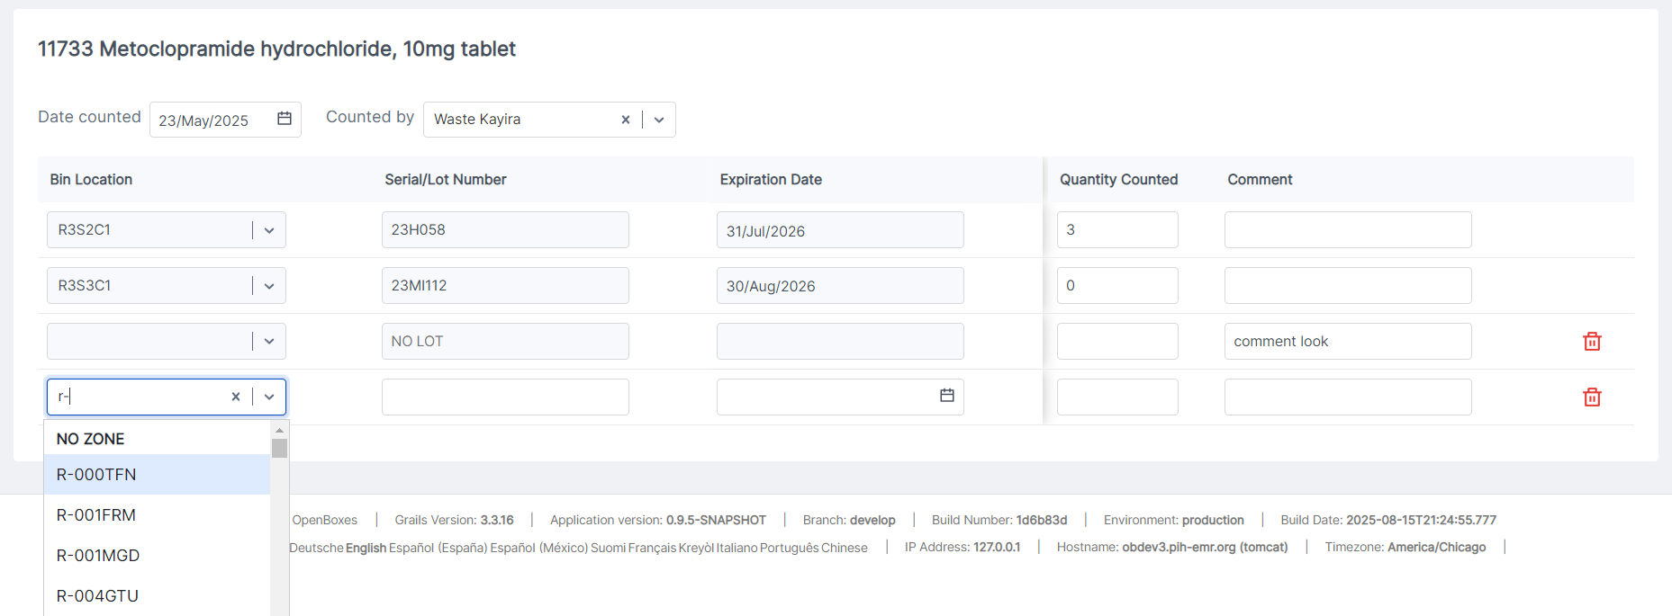
Receiving Bins selection available for New Lines

OB Saves Drafts for RESOLVE Workflow
If you are resolving discrepancies for a Cycle Count and have to stop the process for any reason, OpenBoxes will now save a draft for you to continue later. The draft consists of the batch of products you were working on.
If you choose to discard the draft, the information you entered for each product, such as root cause and comment, is still saved, but the batch of products is discarded.
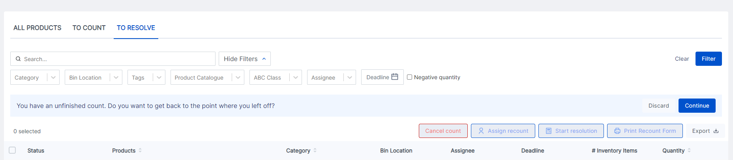
Message asking if the user wants to continue working on the saved draft in the TO RESOLVE tab

Improved Messaging after Cycle Count
For better messaging, OpenBoxes will now display success messages after the Cycle Count Workflow. The message will show the number of products for which the Cycle Count Workflow is complete and does not need discrepancy resolution.
In addition, if your count resulted in discrepancies, OB will automatically redirect you to the TO RESOLVE tab.
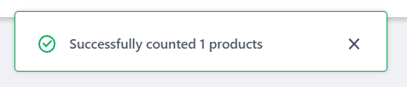
Success Message after Cycle Count

IMPROVEMENTS
This section is for improvements made outside of the Cycle Count feature.

Export Filtered Results on Product Sources List Page
As requested by the Boston Sourcing team, users can now export the filtered results on the Product Sources List page, allowing for easier data analysis and lookup.
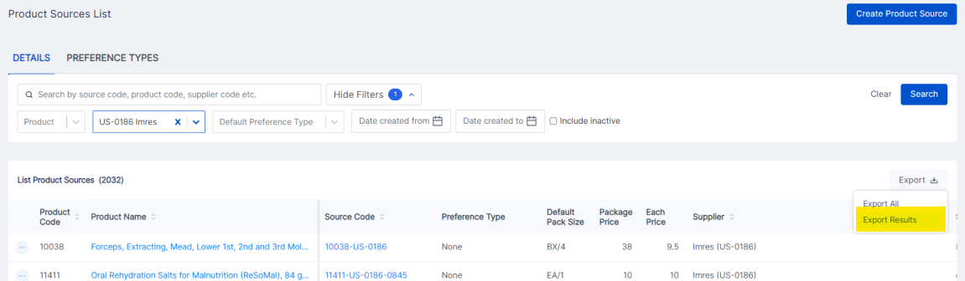
The New Export Results Option in the Product Sources List Page

Download Picklist Sorted by Bins
As suggested by the Compañeros en Salud team, we have created an additional option to download a Picklist sorted by bins. If your physical bins are arranged by alphabet or numbers, this picklist will make it easy to pick the items off the shelves. For example, if bins ABC 1 is next to ABC 2, then followed by ABC 3, the picklist will display the items in this order for easier picking.
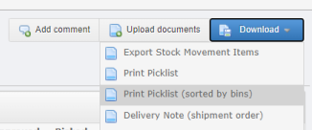
New Print Picklist (sorted by bins) option
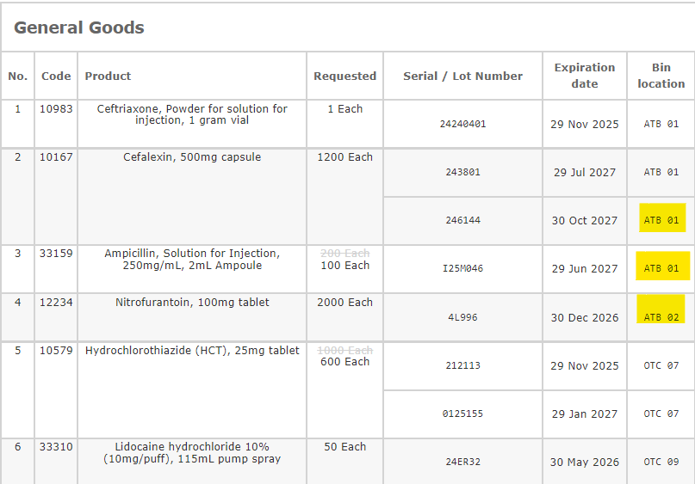
Picklist sorted by Bin Locations

Delivery Note: Improved Display of Separate Pack Levels
The Compañeros en Salud team noted that the display of different pack levels for the same product in the Delivery Note was confusing. The new changes to the Delivery Note will now clearly show the quantity of the products in different packs. This makes shipping and handling of the shipments easier!
Note: This is only applicable for Depots that have the “Pack” feature on.
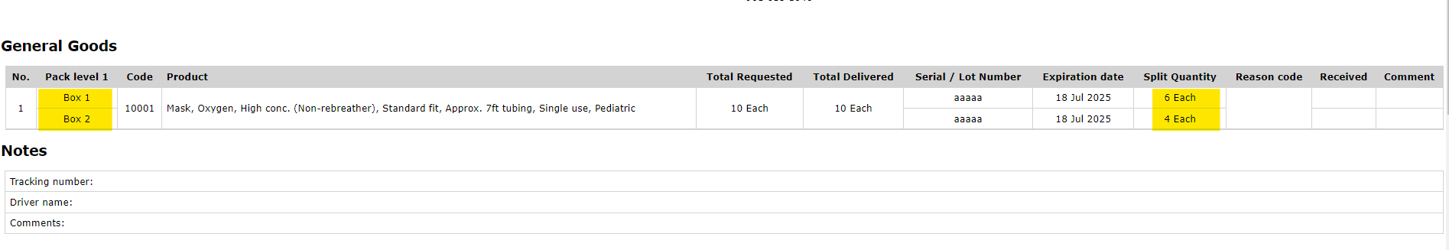
Delivery Note with Split Quantities for Different Pack Levels for Same Product

Goods Receipt Note: Wrapped Product Names
The Sierra Leone Team requested this.
Product Names in the Goods Receipt Note will now be wrapped so that the entire name is visible in the document. This is especially helpful for biomedical equipment and accessories.
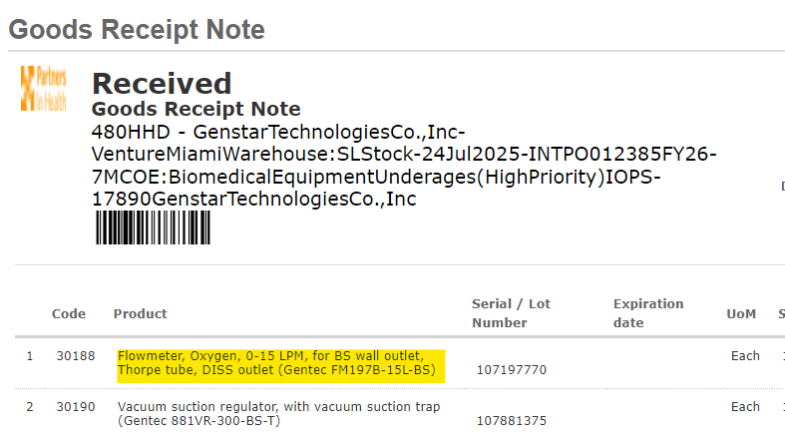
Wrapped Text for Product Name in GRN

Page Numbers on Picklist & Delivery Note
Another request by the Sierra Leone Team, now it will be easier to organize multiple pages of printed Picklist & Delivery with page numbers. No longer staring at multiple pages trying to figure out what page comes next!
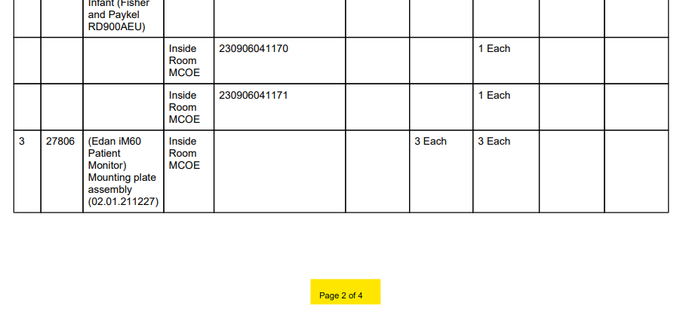
Page Numbers on Picklist

Supplier Code Now Visible in the Shipment View Page
Requested by the Boston Supply Chain Team, we can now see the Supplier Code in the Shipment View Page.
This is currently only applicable for shipments of internationally placed orders. The Boston Supply Chain team uses the Supplier Codes to report on the vendor’s services and document completeness. Having it visible on a page they visit often is a definite win!
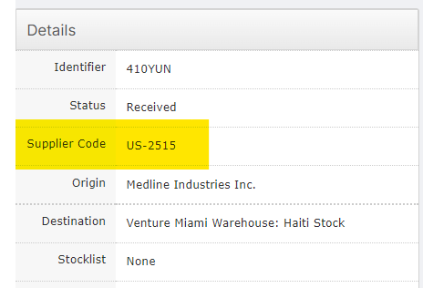
Supplier Code in the Shipment View Page

Bug Fixes

Product Import Causing Category and Tag Duplication
Instances of Product Imports with multiple lines containing the same categories and tags were causing duplication of those categories and tags by creating new IDs instead of matching them to existing IDs.
This is now resolved!

Product Associations List Page URLs
In the Product Associations List Page, the hyperlinks for the products under the Associated Products column were taking users to the incorrect stock card. This has been addressed. The hyperlinks will now take users to the correct stock cards of the products.
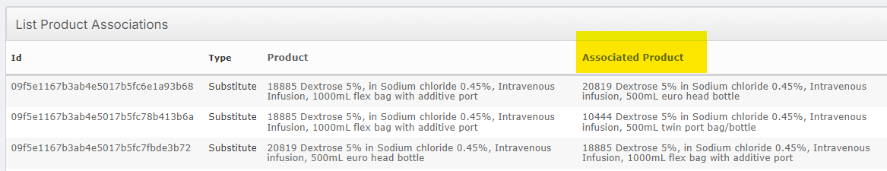
List Product Associations

