Release 0.9.1

# WHAT TO EXPECT?

After the much-anticipated technical migration in the last release, I hope you are all looking forward to returning to the regular release cycle of OpenBoxes! In this release, you will find various improvements in OpenBoxes features and workflows. We have intended to focus on highly impactful features and improvements to improve user workflows, processes, and understanding of the existing features. Many of these improvements have been informed by input from OpenBoxes System Specialists and Experts!

You will find Inventory Reports and transaction changes, such as Receiving and E-Requests. In addition to these changes, guided by user requests and activities, we have also redesigned the Product Sources-related functions and pages in OpenBoxes to reduce the occurrence of bad data.

----------

Since this release note would be extremely long if we included all the change details, please follow the attached hyperlinks to read more detailed information in the [OpenBoxes Knowledge Base](https://help.openboxes.com/collection/1-user-guide).

As always, if you encounter errors in the system, please contact the OpenBoxes team via email at [openboxes@pih.org](mailto:openboxes@pih.org). You can also request training for you and your team members through the [IOPS JIRA Helpdesk.](https://pihops.atlassian.net/servicedesk/customer/portal/3)

Table of Contents

WHAT TO EXPECT? 1

PRODUCTS DEACTIVATED 2

IMPROVEMENTS 3

Transactions: Renamed 3

Receiving Workflow: Improvements 4

E-Request: Filter by relevant STATUS on the Request List Page 5

E-Request: Editing E-Requests (Requestors) 5

E-Request: Comments on Rejected E-Requests 6

Average Unit Price: Changed to “Unit Price.” 6

Electronic Stock Card: Icon Color changed for Putaway Transactions 6

Electronic Stock Card: New Icons for Inventory Adjustments 7

Transaction: Expiration Date Validation in Inbound Returns 7

Invoice List Page: Vendor List sorted alphabetically 8

Invoice List Page: Export Invoice List Details on the Invoices List Page 8

Purchase Orders: Import Actual Ready Date 9

REPORTING 9

Inventory Reports Redesigned! 9

Sub-Menus under Inventory Menu 10

Information Bar on Inventory Reports 11

Expiration Reports: Bin Location Data added 11

Expiration Reports: Date Range Filter 11

PRODUCT SOURCES REDESIGN 12

Supplier Code after Product Source Creation 12

Product Sources List Page 12

Header 12

Product Sources List Table 13

Create Product Source 13

What is fixed? 14

Cannot import invalid UoMs in a PO 14

Users with Browser permissions can now change their password 14

Prevent editing Completed Putaway Transactions 14

Product Sources Export Fixed 14

Error during Receiving Workflow resolved 14

Documents can now be attached to E-Requests 15

# PRODUCTS DEACTIVATED

There are many products in OpenBoxes that we do not have in stock anymore or that we do not refer to anymore. But the existence of these products can be a source of confusion for users.

Hence, we have done a bulk deactivation of **3150** such products. We applied the following logic to determine if a product should be deactivated.

* Not in Purchase Order (PO) or have never been in POs.
* Not currently in inventory in ANY location.
* Not in Open shipments (shipments that have been shipped but not been fully received).
* Not in a stocklist.
* Created over one year ago
* Has not been in a transaction in 18 months
* Not on any catalogs EXCEPT non-formulary catalogs
* Does not have any source with source preference type
* Not in the following categories
  + IT & Communications, Oxygen Plant, and Facilities: Medical Gas
* Does not have any tags
* Does not have associations used for equipment and spare parts (any association type not substitution)

For [Miscellaneous Products](https://help.openboxes.com/article/37-create-a-product)

* Not on Open POs (would not appear in encumbrance report)
* Not currently in inventory
* Not in Open shipments (shipped but not fully received)
* Created over 1 month ago

For a complete list of deactivated products, please refer to the excel list attached to the Release email.

# IMPROVEMENTS

## Transactions: Renamed

We have renamed inventory transactions to better identify the process involved.

* **Create Stock Transfer**, now called [Transfer Stock Internally](https://help.openboxes.com/article/68-stock-transfers)
* **Create Replenishment**, now called [Replenish picking bins](https://help.openboxes.com/article/102-replenish-bins-feature)

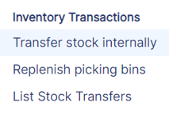

Inventory Transactions Menu

Along with the renaming, you will also find an information bar when performing these transactions.

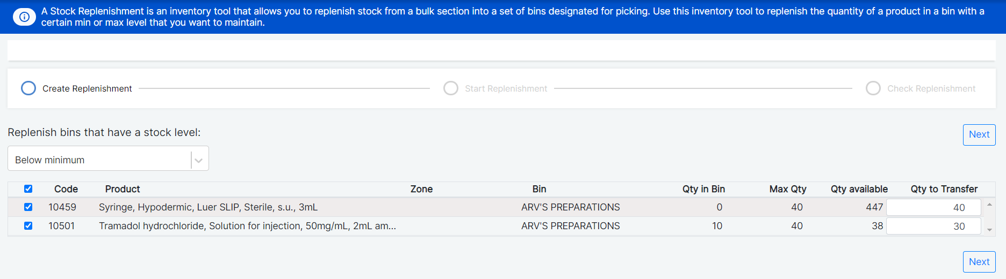

Info Bar for “Transfer Stock Internally”

## Receiving Workflow: Improvements

We have made improvements to the [Receiving workflow](https://help.openboxes.com/article/48-receiving) realized through troubleshooting sessions with the Sierra Leone team! During the receiving process, users can use the EDIT button to change the Lot# or Expiry date of line items. Previously, when using this EDIT button, all the Receiving quantities entered for other line items would be lost. This will no longer happen!

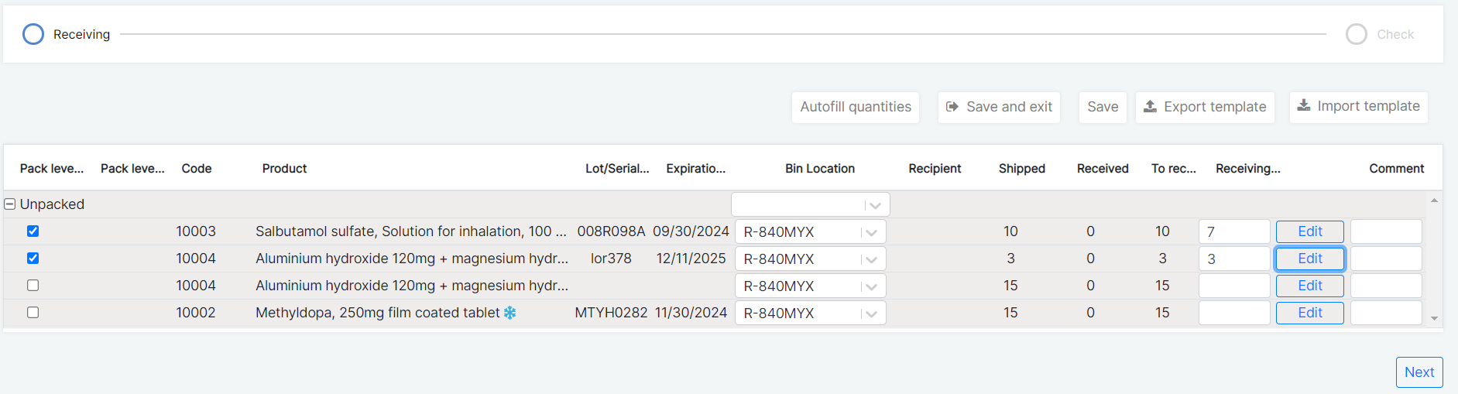

Receiving Workflow Snapshot

## E-Request: Filter by relevant STATUS on the Request List Page

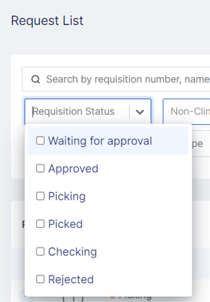For Depots that use [Electronic Requests (E-Requests)](https://help.openboxes.com/article/417-view-electronic-requests) and require approvals for them, you will see only relevant statuses can be selected in the Request List Page, which are:

* WAITING FOR APPROVAL,
* APPROVED,
* PICKING,
* PICKED,
* CHECKING, and
* REJECTED

This will make it easier to select the correct status and avoid confusion by removing the extra statuses that do not apply to E-requests.

If your Depot *does not* require approvals, the statuses you will see on the Requests List Page are APPROVED, PICKING, PICKED, and CHECKIN G.

Once Requisitions have been ISSUED, you will find them on the Outbound Stock Movement List Page.

## E-Request: Editing E-Requests (Requestors)

*For users who submit E-Requests with the Approval feature.*

After Requestors submit an e-request for approval, they can [rollback the e-request and edit](https://help.openboxes.com/article/94-submit-requests-from-non-depot-locations#Updating-an-E-Request-Rejected-by-the-Approver-fjWjj) if needed. When Requestors rollback and edit, currently, OpenBoxes directs them to the Fulfilling Location’s view. Now, after Requestors roll back and edit, they will be directed to the “Add Items” step of the process to make the editing process simpler and easier.

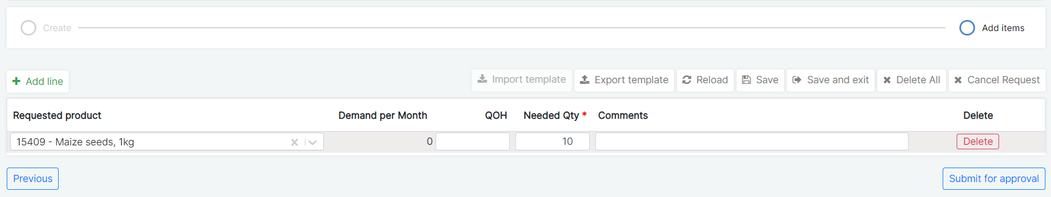

Add Items Page of E-Request Workflow

## E-Request: Comments on Rejected E-Requests

*This is for non-Depot users who submit E-Requests with the Approval feature.*

When [Approvers reject an e-request](https://help.openboxes.com/article/414-approve-electronic-requests), OpenBoxes prompts them to add a comment to explain why. Now, OpenBoxes will display the Rejection comments in the Requestors’ E-Request Dashboard.

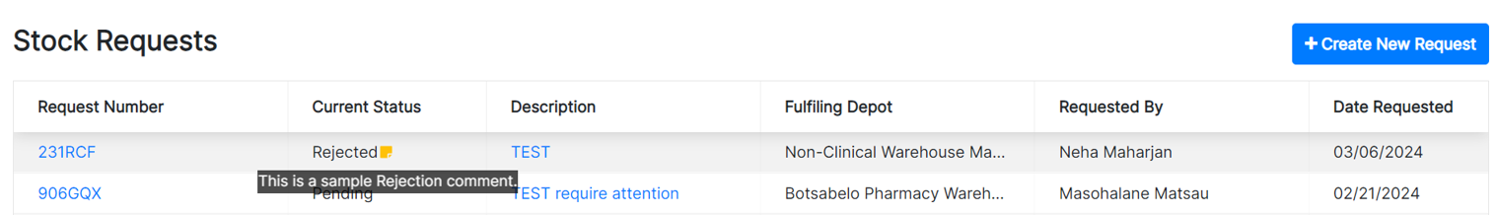

Hover over the Rejection Comment

Average Unit Price: Changed to “Unit Price.”

You may have noticed the field “Average Unit Price” is multiple pages in OpenBoxes, including the Electronic Stock Card, Create Product page, Inventory Summary Report (In Stock Report), and Product Sources tab in the Electronic Stock Card. This field shows the last price paid for the product.

Hence, we have changed the field’s name to display the actual value: Unit Price. You can hover over the field to show that this value is for the Last Paid price.

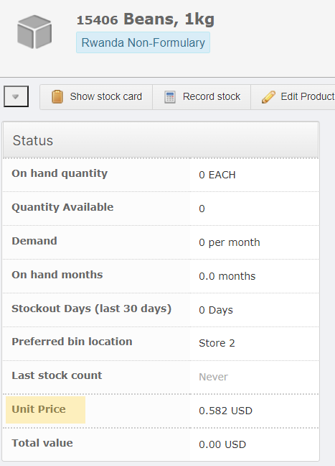

Status Tab on Electronic Stock Card

## Electronic Stock Card: Icon Color changed for Putaway Transactions

Under the Stock History in the Electronic Stock Card, you will notice different icons for different transaction types, each with a color.

For [Putaway](https://help.openboxes.com/article/297-receiving-putaway) transactions, we have changed the icon color to **Blue** from Green to distinguish it from Transfer In transactions.

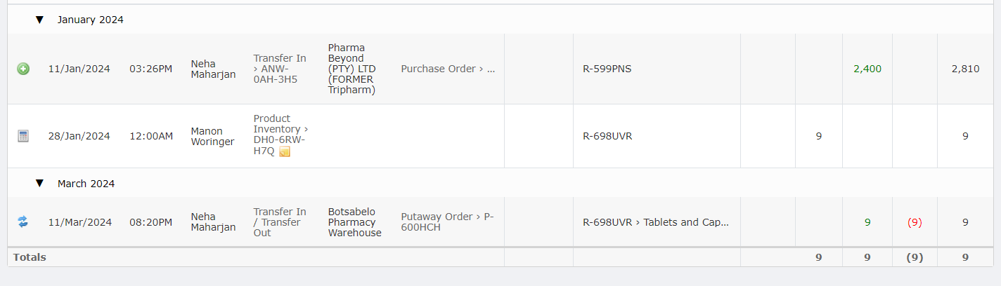

Transaction Icon Colors

## Electronic Stock Card: New Icons for Inventory Adjustments

Previously, when users made negative or positive adjustments (using [Adjust Stock](https://help.openboxes.com/article/41-inventory-adjustments-and-stock-counts)) to their inventory, OpenBoxes displayed both the negatives and positives with a green icon in the Stock History. This is not straightforward and can be confusing.

So, we have changed the icons for Adjustments to Red (negative) and Green (positive) arrows. See below.

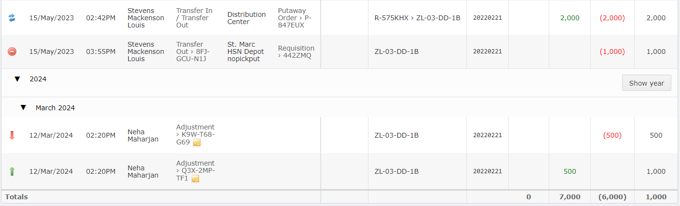

New Icons for Inventory Adjustments

## Transaction: Expiration Date Validation in Inbound Returns

We have added validations for the expiration date for [Inbound Returns](https://help.openboxes.com/article/465-inbound-returns). Validations will appear when a user enters a lot number that already exists in the system but has a different expiration date than that which exists in the system for that lot number.

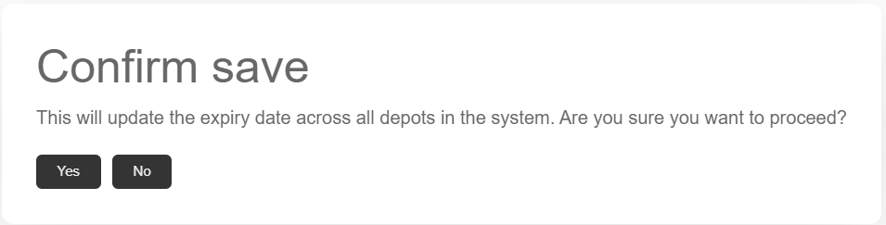

Validation message for Expiration Date

## Invoice List Page: Vendor List sorted alphabetically

On the [Invoice List Page](https://help.openboxes.com/article/78-invoicing), you will find that the vendors under the Vendor filter are now alphabetically sorted.

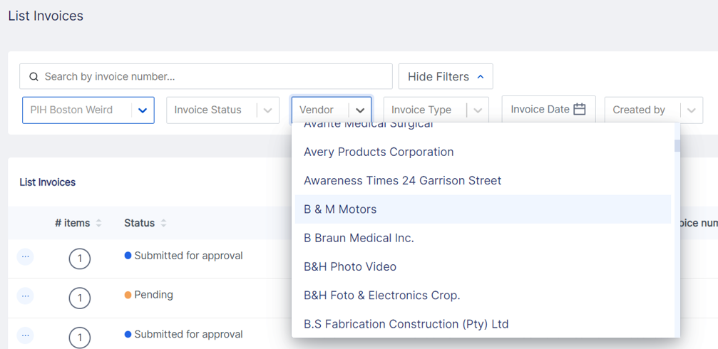

Vendor List Page with Filters

## Invoice List Page: Export Invoice List Details on the Invoices List Page

In the previous release (0.9.0 Hotfix), we introduced [exporting Invoice](https://help.openboxes.com/article/78-invoicing) Lines from the Invoice List Page.

Now, you can also export Invoice details.



Invoice Details Export

## Purchase Orders: Import Actual Ready Date

This was a highly requested feature from the Boston Sourcing and Supply Chain Team to implement a more robust system for monitoring ship dates. This feature will ease the pain point of manually editing multiple Actual Ready Dates on multiple POs once the vendor confirms the order with the correct dates.

Now, users with Admin permissions can import multiple Actual Ready Dates for multiple POs at the same time. To learn more about this import, please see this document: [Import Actual Ready Date on PO(s).](https://help.openboxes.com/article/469-import-actual-ready-date-on-pos)

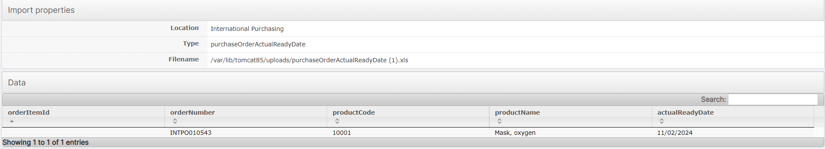

Import Review Page

# REPORTING

## Inventory Reports Redesigned!

We have made some helpful changes to the Inventory Reports! To start, we have renamed these Inventory Reports:

* **Browse Inventory**, now called [Inventory Browser](https://help.openboxes.com/article/395-inventory-browser)
* **In Stock Report**, now called [Inventory Summary Report](https://help.openboxes.com/article/310-inventory-reports)
* **Bin Location Report**, now called [Inventory Details Report](https://help.openboxes.com/article/310-inventory-reports)

In addition to renaming these reports, we have also made this accessible under the **Inventory Menu** along with the **Reporting Menu**.

### Sub-Menus under Inventory Menu

The OpenBoxes team realized that many users prefer the **Inventory Menu** option to look at inventory information. Hence, we have added a sub-menus under the Inventory Menu.

We have also removed the “Manage Inventory” option because no functionalities were available on this page. We have also removed “Import Inventory”. Admins can still import inventory through the Import page under the Configuration menu.

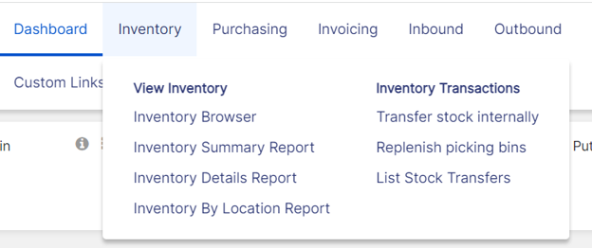

Inventory Menu Options

You will find two sub-menu under the Inventory Menu: **View Inventory** and **Inventory Transactions.**

* Under [View Inventory](https://help.openboxes.com/article/310-inventory-reports), you will find:
  + [Inventory Browser](https://help.openboxes.com/article/395-inventory-browser) (previously: Browse Inventory)
  + [Inventory Summary Report](https://help.openboxes.com/article/310-inventory-reports) (previously: In Stock Report)
  + [Inventory Details Report](https://help.openboxes.com/article/310-inventory-reports) (previously: Bin Location Report)
  + [Inventory by Location Report](https://help.openboxes.com/article/313-inventory-by-location)
* Under Inventory Transactions, you will find:
  + [Transfer Stock Internally](https://help.openboxes.com/article/68-stock-transfers) (previously: Create Stock Transfer)
  + [Replenish picking bins](https://help.openboxes.com/article/102-replenish-bins-feature) (previously: Create Replenishment)
  + List Stock Transfers

## Information Bar on Inventory Reports

Since we have renamed most of the Inventory Reports, we have also added information bars on related pages to guide all the users on the actions they can take with them.

You will find information bars on all the Inventory Reports.

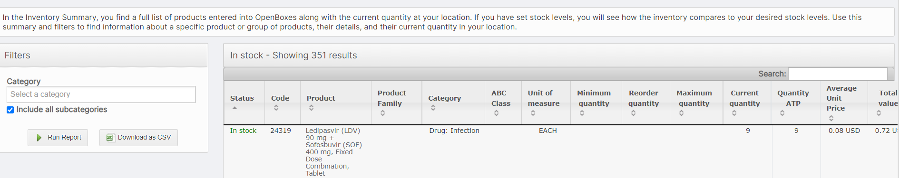

Info Bar for **Inventory Summary Report**

## Expiration Reports: Bin Location Data added

As requested by our Sierra Leone team members, we have added Bin Location information to [Expiration Reports](https://help.openboxes.com/article/311-expired-stock-report). This will facilitate the removal of expired stock from shelves without having to look for Bin Location information in another report.

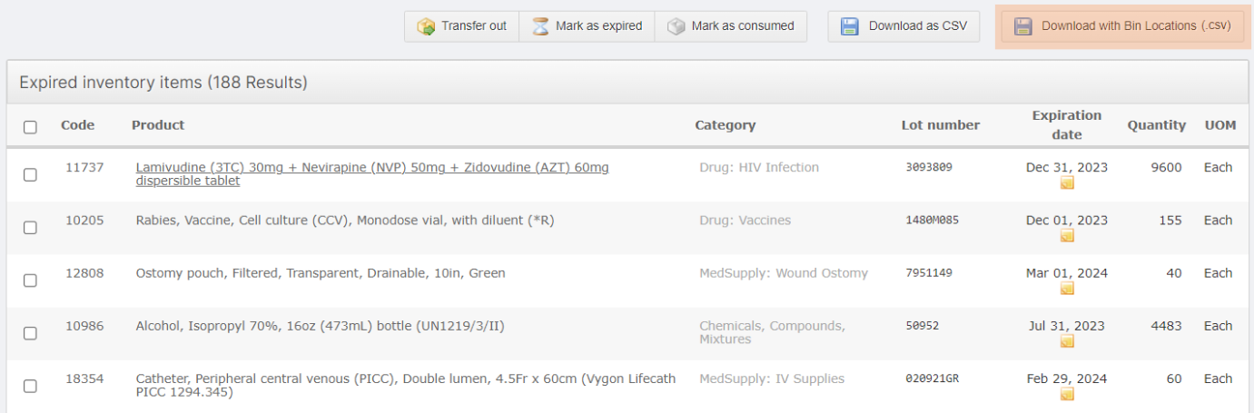

Download with Bin Location

## Expiration Reports: Date Range Filter

As requested by our APZU team member, we have added the ability to filter the Expiration Report by Date Range. This will help our warehouse users take action quickly on products with a specific expiration date range.

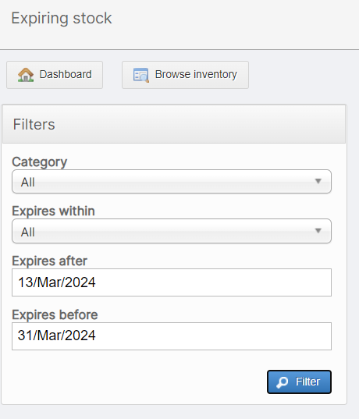

Date Range Filter for Expiration Reports

# PRODUCT SOURCES REDESIGN

## Supplier Code after Product Source Creation

There are different ways that an Item Master can create Product Sources in OpenBoxes: when creating a PO, through the Product Sources Page, through Source Import, and the Stock Card.

When an Item Master creates Product Sources, regardless of their method, the Source Code format will be consistent.

* When we have a product code and organization code, the format is <product code> - <organization code>. If this combination already exists, 4 random digits are added: <product code>-<organization code>-<NNNN>.
  + The Organization code here refers to the supplier information. You may see this for U.S. suppliers.
* When we only have a product code, then 4 random digits are added to the product code: <product code>-<NNNN>.
* When we don’t have product code and organization code, then the source code is just <NNNN>.

## Product Sources List Page

In this release, we have made many improvements to the Product Sources List Page to make it more usable for the users responsible for sourcing and improve source data quality.

You will find that the Sources List Page is similar to the other transaction List Pages, such as the Inbound or Outbound List Page.

### Header

The List Page features two tabs: **Details** and **Preference Type**. You can use the Details tab to filter and view the list of Product Sources. The Preference Type tab will be coming soon.

You can also [Create Product Source](https://help.openboxes.com/article/467-create-product-sources) from the List Page.

You can filter the product sources list using the available six data points.

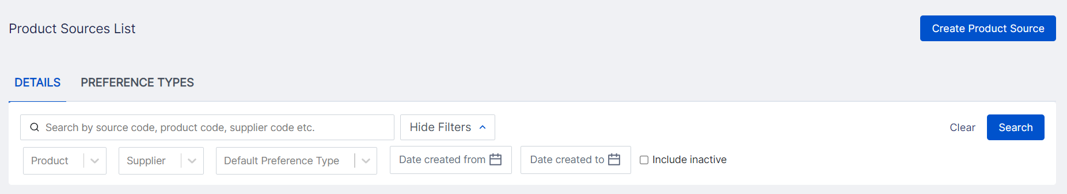

Product Sources List Page Header

### Product Sources List Table

The Product Source table displays product source information in various columns. You can sort the columns by clicking on the Headers. You can also **export** the Product Sources.

For a complete list of the different columns, please see this document: [Product Sources List Page.](https://help.openboxes.com/article/466-product-sources)

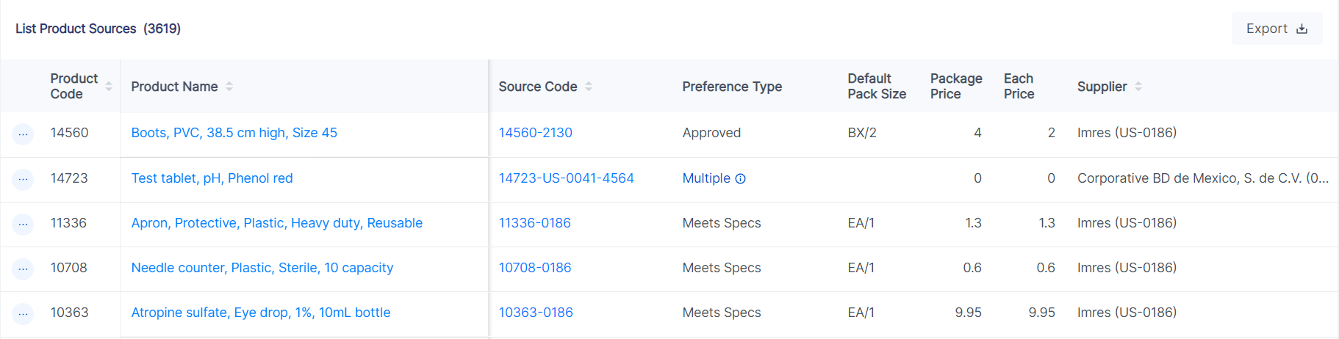

Product Sources List Table

## Create Product Source

As mentioned earlier, you can create a single Product Source through the Product Source List Page and the Electronic Stock Card.

To view detailed information on the Product Source Creation redesign, please see this document on the Knowledge Base: [Creating Product Source.](https://help.openboxes.com/article/467-create-product-sources)

# What is fixed?

### Cannot import invalid UoMs in a PO

We recently identified an error where users were able to import invalid variations of the UoM EA/1, such as EA/2, EA/3. This causes issues when receiving the shipments related to the PO. This will no longer occur. If the import template includes such invalid UoMs, the import will fail and OpenBoxes will show an error message.

### Users with Browser permissions can now change their password

Users with Browser permissions can now change their passwords. To learn how to change your password, please see this document: [Basic Navigation.](https://help.openboxes.com/article/4-basic-navigation)

### Prevent editing Completed Putaway Transactions

Users should be unable to edit completed [Putaway](https://help.openboxes.com/article/297-receiving-putaway) transactions, which causes receipt and inventory discrepancies.

To prevent this, we added a validation error that signals the user that the transaction is already complete and cannot be edited.

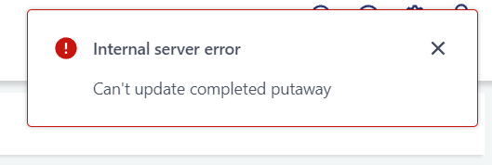

Internal Server Error

### Product Sources Export Fixed

In the Product Sources Export, the Supplier Name was missing. We have now resolved this, and it will allow for easier data analysis.

### Error during Receiving Workflow resolved

When performing the Receiving workflow, users can use the EDIT button to edit Lot # and Expiration Date and add additional lines for line items. The teams have been working around an error where the user adds another line using the EDIT function, THEN zeroes shipped Qty in the original line, and the original Qty in the original line is saved instead of zero. This causes receipt discrepancy.

This is now resolved.

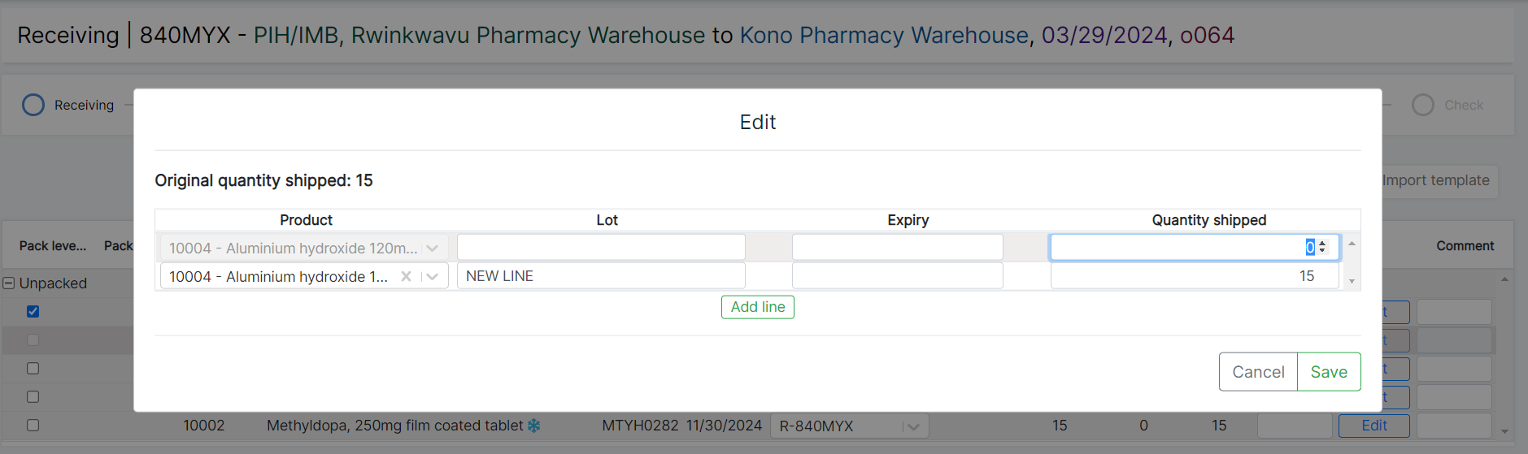

Edit Modal on Receiving Workflow

### Documents can now be attached to E-Requests

A bug identified during e-request implementation in IMB sites has now been resolved. Users could not attach documents to e-requests once the requestor had submitted the e-request for approval. There should be no errors in attaching documents to an e-request, regardless of the status.