Release 0.9.8 🎉

WHAT TO EXPECT
For release 0.9.8, the OpenBoxes team paused most new feature work to focus on fixing aspects of the system that don’t work or that cause frustration for users. We reviewed all reported bugs and fixed as many as possible, in order of priority. In addition, we selected a few features that have several known issues or inconsistencies – organization management, shipment statuses, and returns – and updated those features to work better and be more in-line with standard OpenBoxes behavior. We also implemented performance improvements for the stock card, which has been taking longer and longer to load and causing frustration among users.
Despite the focus on fixes, there are a few new features and improvements! Read on to learn about the new shipment packing import, improvements to product management, and expanded shipment event tracking!
Please use the Table of Contents to find the section that relates to your work function.
As always, we are looking to our users for feedback and to report any issues you encounter. Please contact us at openboxes@pih.org.

Table of Contents
Release 0.9.8 1
WHAT TO EXPECT 1
STOCK CARD PERFORMANCE IMPROVEMENT 3
EXPANDED EVENT TRACKING FOR SHIPMENTS 4
Event for Putaways for Items in Shipment! 4
Track Rollbacks! 4
See Most Recent Event on Shipment 5
RETURN AND STOCK MOVEMENT FIXES 6
Removed Reload button on Add Items Page for Shipments 6
Download Delivery Note for Outbound Returns 6
Allow Change of Destination for Outbound Returns 7
UI Improvements in Outbound Return 7
Add Items Page 7
Pick Page 7
Send Page 7
UI Improvements in Inbound Return 8
Add Items 8
Send Page 8
[Bug Fix] Outbound Returns and Receiving Bins 8
[Bug Fix] Unable to Rollback Receipts of Returns 9
[Bug Fix] View Inbound Returns on Inbound List Page 9
[Bug Fix] Outgoing Stock Movements Indicator Showing Shipped Returns 9
[Bug Fix] Expiration Date Validation for Purchase Order Shipments 10
[Bug Fix] Inbound Movement List: Status Filters 11
[Bug Fix] Restored Verifying Filter for Outbound List Page 11
OUTBOUND SHIPMENT IMPROVEMENTS 11
Search by Lot Number and Bin in Pack page of Outbound Shipment 11
Import Pack Levels for Shipment Items 12
E-REQUEST UI IMPROVEMENT 12
MANAGING PRODUCTS AND PRODUCT SOURCES 13
Disabled Product Category Creations via Product Import 13
[Bug Fix] Product Merge Permissions 13
See the Product Codes to be Merged 14
Delete Product Source with Preference Type 14
PURCHASE ORDER FIXES 15
UI Improvements in PO Shipment Page w/ Split Line 15
Improved Error Message for PO Import 15
[Bug Fix] Edit Purchase Order Lines with Inactive Budget Code 16
[Bug Fix] Allow PO Qty Edits with Prepayment Invoice 16
MANAGING ORGANIZATIONS AND LOCATIONS 16
[Bug Fix] Wrong organization auto filled when creating new supplier 16
[Bug Fix] Duplicate Organizations created via Import 17
Fixed Organization Code Auto generation Logic 17
Enter Custom Code when creating an Organization 17
Organization Name to display as “Code – Name” 18
Location Group for Dynamic Location Creation 18
CYCLE COUNT 19
[Bug Fix] Cycle Count starting for Wrong Product 19
FILTER RENAMED 19
ADMINS CAN NO LONGER MODIFY TRANSACTIONS 19
OTHER BUG FIXES 20

STOCK CARD PERFORMANCE IMPROVEMENT
You will now notice improved performance on Stock History and All Locations tabs of Products!
During our developer tests, we found that a product with the longest Stock History took 2.1 seconds to load compared to 41.32 seconds before the changes!
We will continue our attempts to replicate these performance improvements in other pages as well to improve user experience!

EXPANDED EVENT TRACKING FOR SHIPMENTS
We are adding two new Events for Shipments to better track what actions have occurred for a Stock Movement. Learn more about Events here: Shipment Events.

Event for Putaways for Items in Shipment!
Putaway is an important part of Receipts that allows us to move items into their designated locations from the Receiving Bins. Now, we can track if Putaway transactions have been performed for items in a shipment under the Events tab!
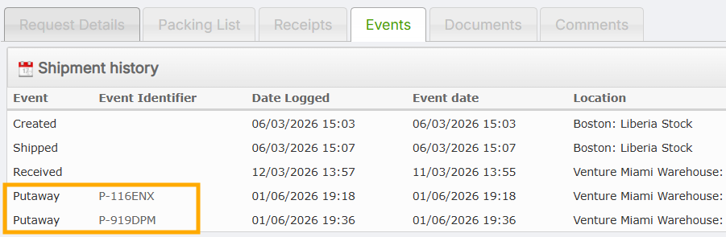
Putaway Transactions under the Events Tab
Since multiple Putaway transactions can occur for items in shipment, each Putaway is tracked in the Events tab along with its unique identifier.

Track Rollbacks!
Rollbacks of Receipts and Shipments in OpenBoxes are important features for data correction. However, rollbacks can also introduce bad data and signal poor data entry or processes. As a superuser or a support contact, it is important to identify when rollbacks occur. For this reason, we are now tracking rollbacks as Events.
Previously, we could not tell if a Shipment had been rolled back and shipped again, but now we can!
For example, in the screenshot below, you can see the events of Created, Shipped, and Received, along with the corresponding dates and the user’s name.
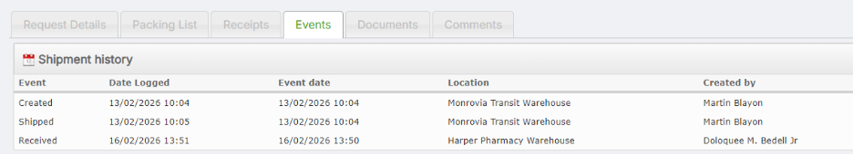
Initial Event Log with original Shipped and Received Events
For the above shipment, let’s say I need to roll back the receipt and the shipment to update the quantity of an item. When I roll back the receipt and the shipment, these actions are logged as events: Received – Rollback and Shipped – Rollback (see screenshot below).
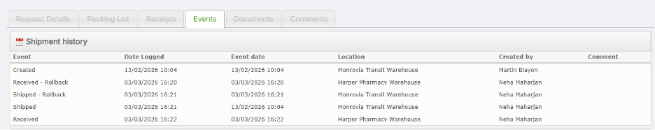
New Events logged after Rollback
Notice that the original events of Received and Shipped are no longer visible. When I continue to Ship and Receive the Shipment again, these are logged as new events with the corresponding dates.
If you are troubleshooting a shipment and want to understand what actions have been taken, check out the Events tab!

See Most Recent Event on Shipment
In addition to the above improvements (Track Rollbacks and Putaways), we are now adding the Most Recent Event field on the Details Column of the Shipment View Page for an easier view of the last action taken for the shipment.
Users can see this field for: Inbound Shipments, Outbound Shipments, and Purchase Order Shipments.
Events for Shipments can be the Status (example: Picked, Shipped) or a Customs Entry (example: Arrived at Port). To make it easy to identify what the most recent event for the Shipment was, we are now displaying this field on the Left side of the Shipment View Page.
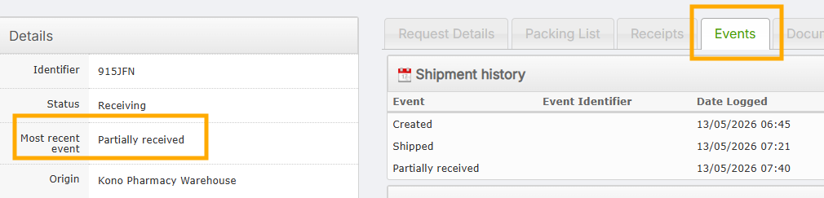
Most Recent Event in a Shipment
As you can see from the screenshot above, the Most Recent Event for the shipment is Partially Received. It will also display other events of Created, Shipped, Rollbacks, Custom Entry, and Putaway.

RETURN AND STOCK MOVEMENT FIXES

Removed Reload button on Add Items Page for Shipments
For Inbound and Outbound Shipments, we have removed the “Reload” button on Add Items page. There is no data to reload on the Add Items page, however, when used, it erased information.

Download Delivery Note for Outbound Returns
Requested by the Sierra Leone and Compañeros sen Salud teams, you can now download Delivery Notes for Outbound Returns from Depots.
Simply go to the Documents option to see the “Delivery Note” option to download.
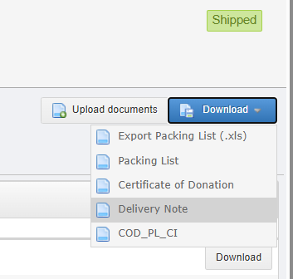
Delivery Note for Outbound Return

Allow Change of Destination for Outbound Returns
Previously, it was possible to change the destination of regular stock movements after shipment, but it was not possible for outbound returns. Now users can change the destination of outbound returns in the same way they can for other outbound stock movements.

UI Improvements in Outbound Return
We have introduced some user interface improvements to Outbound Return pages. See below for updates in each page:

Add Items Page
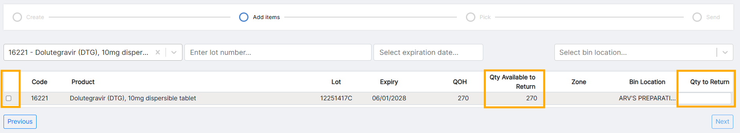
Updated Outbound Return [Add Items] Page
- Aligned all the Quantity columns to Right
- Aligned “Product” column header to Left
- Aligned “Qty to Return” header to Center
- Changed “Quantity Available” header to “Qty Available” to make it fully visible
- Reduce space for Left Checkbox column

Pick Page
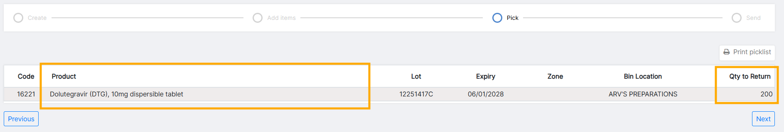
Updated Outbound Return [Pick] Page
- Reordered columns to match the Add Items Page
- Renamed “Product Code” column header to “Product”
- Expanded width for “Product” column
- Aligned “Qty to Return” column to Right

Send Page
Updated Outbound Return [Send] Page

- Table Columns are aligned to match the previous Add Items and Pick pages.

UI Improvements in Inbound Return
Similar to Outbound Return, we have updated the Add Items and Send Pages for Inbound Return.

Add Items
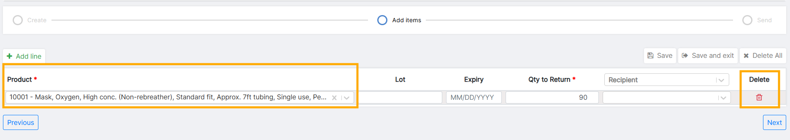
Updated Inbound Return [Add Items] Page
- Reduced width of “Expiry” column
- Fixed overlap between “Delete All” and “Save & Exit” button
- Changed “Delete” button to Red Dustbin/Trashcan icon.
- Fixed misalignment between header and data on “Recipient” and “Delete” fields
- Expanded width of “Product” column

Send Page
Updated Inbound Return [Send] Page
- Fixed misaligned column headers
- Changed “Product Code” header to “Product” and resized Column width
- Updated width of “Expiry Date” column to fit date
- Expanded “Product name” column width

[Bug Fix] Outbound Returns and Receiving Bins
Items in the Receiving Bin (R-Shipment ID) can also be returned. However, the Bin Location filter was not displaying the Receiving Bins. This has now been fixed.
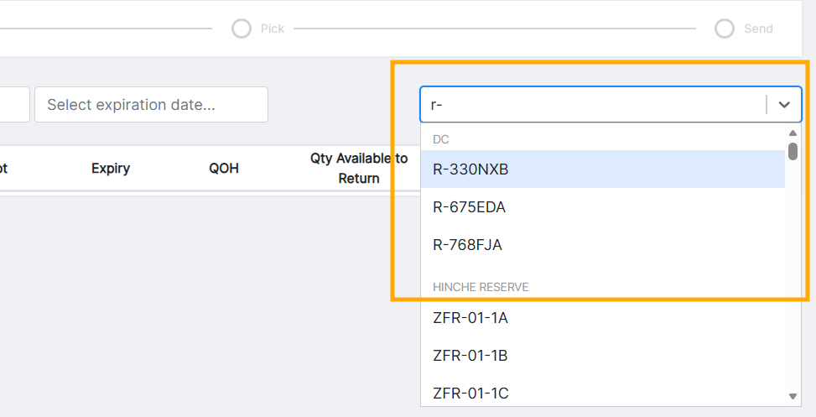
Receiving Bins Visible for Outbound Return

[Bug Fix] Unable to Rollback Receipts of Returns
After receiving Return Shipments, user was unable to roll back the Receipts. However, Receipts should be allowed to be rolled back for returns in the same way as other stock movements. This has now been fixed.

[Bug Fix] View Inbound Returns on Inbound List Page
Previously, we were unable to view Inbound Returns on the Inbound List Page. But now you can. View all your incoming shipments on the List Page!
Learn more about Inbound Returns here: Inbound Returns.

[Bug Fix] Outgoing Stock Movements Indicator Showing Shipped Returns
The “Outgoing Stock Movements” Dashboard Indicator shows any pending Outbound Stock Movements that have not yet been shipped. However, this indicator was counting Outbound Returns in “Partially Received” status although it was already shipped. We have corrected this error for the Indicator to only show the number of Outbound Stock Movements that are truly in progress.
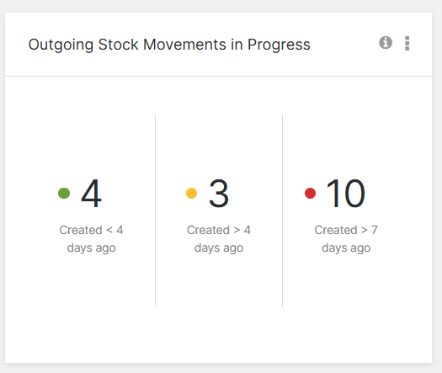
Dashboard Indicator

[Bug Fix] Expiration Date Validation for Purchase Order Shipments
For Inbound Shipments, if the user enters a different Expiration Date for a Lot number already existing in the system, OpenBoxes validates with the user to check the expiration date as this change updates the date in the system. This was not occurring when Shipping Purchase Orders – and is now resolved.
This validation will also appear if you go back and forth between pages and re-enter different Expiration Date for existing Lot numbers.
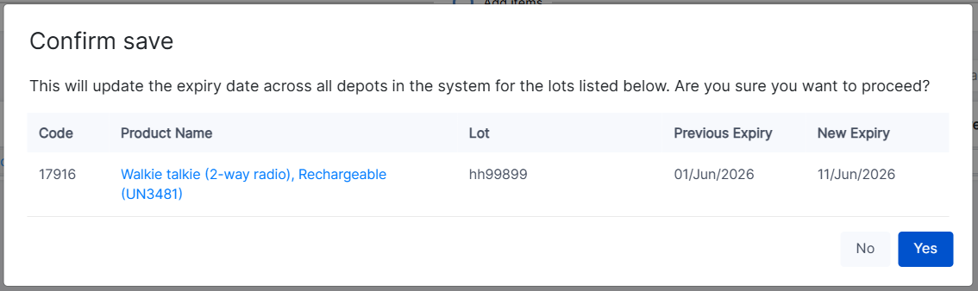
Expiration Date Validation
Recording correct Expirations Dates is important for proper inventory management, distribution, and recalls.

[Bug Fix] Inbound Movement List: Status Filters
An Inbound Stock Movement can have one of these four statuses: Pending, Shipped, Receiving, or Received. We have now removed a “Created” status since an Inbound Stock Movement cannot be in that status.
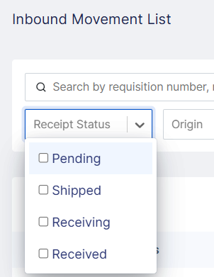
Available Status Filters for Inbound Stock Movements

[Bug Fix] Restored Verifying Filter for Outbound List Page
For Locations that require Approvals for E-Requests, we accidentally removed the “Verifying” status filter. We have now restored the filter.
When an E-Request proceeds into Outbound, it goes directly from Approved > Picking stage, however, if the warehouse starts an Outbound through “Create an Outbound” feature, it goes through Created > Verifying > Picking. So, you can filter by “Verifying” status again!
For more status information, read this article: Stock Movements Status Summary.

OUTBOUND SHIPMENT IMPROVEMENTS

Search by Lot Number and Bin in Pack page of Outbound Shipment
As requested by the Boston Logistic Users, users can now use the Search Box in the PACK page to search by Lot Number and Bin Location. The existing search allowed search by Product Code only.
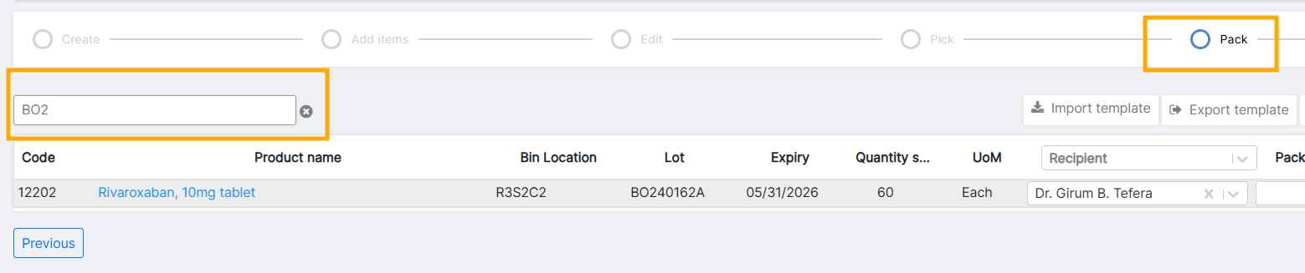
Search by Lot Number
This is only relevant for sites that have PACK levels turned on.

Import Pack Levels for Shipment Items
Per another request by the Boston Logistics Team, we have introduced the ability to assign Pack Levels to Shipment Items using Import! This will make assigning easy if users want to assign different Packs to multiple different items.
Happy Packing!
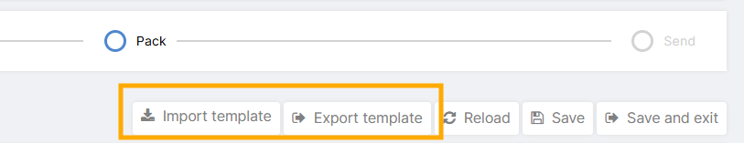
Import and Export buttons
Learn more about Importing Pack Levels here: Outbound shipment page by page - Pack.

E-REQUEST UI IMPROVEMENT
You will find cosmetic improvements when creating E-Request to make data more visible and readable.
- All quantity columns are now aligned right.
- Delete button is now replaced with Red Dustbin/Trashcan icon.
- The width of “Needed Qty” column is lesser.
- We expanded the width of “Demand per Month” column to make entire header visible.
- Expanded width of the “Comment” column
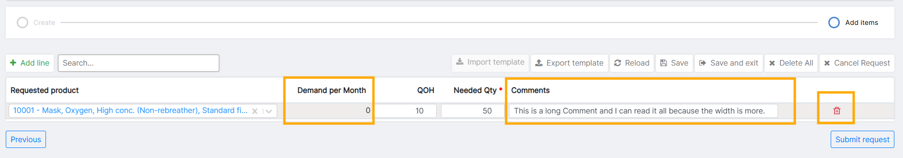
Updated E-Request Page

MANAGING PRODUCTS AND PRODUCT SOURCES

Disabled Product Category Creations via Product Import
In Release 0.9.7, we introduced the ability to restrict assignment of Parent Product Category to Products.
To align with this change, we are now disabling the creation of Product Categories through Product Creation Import. Until now, Product Categories could be created when creating Products via import, but this led to bad data when there were typos in the Category name and assignment of Products to the newly created Category.
As a change requested by Product Managers, we are now disabling creation of Categories when creating Products via Import. Only existing Product Categories can be entered into the Import file for Product Creation.
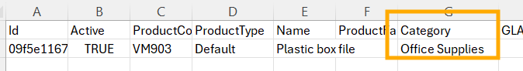
Category Column Emphasis on Product Creation Import File
Always reach out to your OpenBoxes Admin or the cross-site Item Master for new product creation. You can submit a request for product creation for cross-site Item Master through the Helpdesk.

[Bug Fix] Product Merge Permissions
A regression was introduced during one of the previous releases, where users with only Superuser permissions could merge products. We have now fixed this.
Users must have the Product Manager permission along with Superuser permission to merge products.
Product Merge cannot be reversed and requires multiple checks, such as whether the product is in stock at other locations, whether the product is in a shipment destined to another location, etc. Hence, please submit a Product Merge request to the cross-site Item Master so all the checks can be done properly and other sites are not affected.
You can raise a Product Merge request through this page: International Operations Helpdesk - Raise a request.
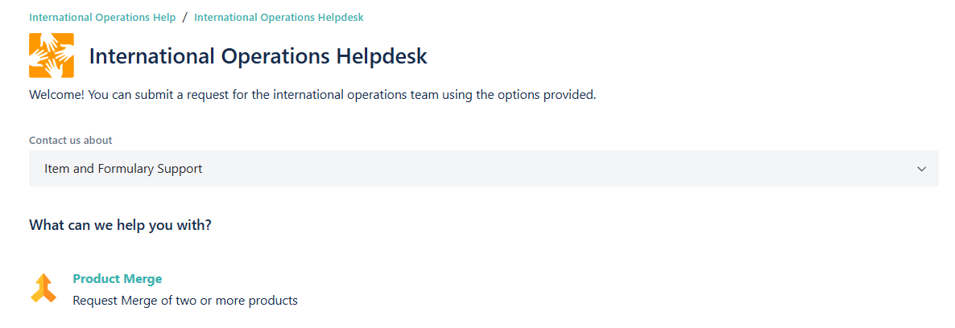
International Operations Helpdesk

See the Product Codes to be Merged
This section is for Product Managers.
At the final stage of a Product Merge, you will now see the Product Codes instead of the Product Ids.
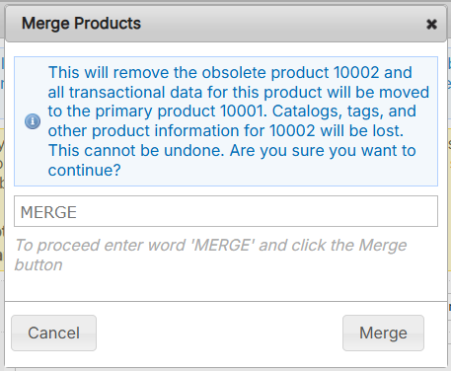
Product Codes displayed for Final Merge Confirmation

Delete Product Source with Preference Type
Previously, if a Product Source had a Preference Type, it could not be deleted. This was annoying from a data management perspective. Now if you delete a product source with preference types, those preference types will automatically be removed from the source as part of the deletion process.
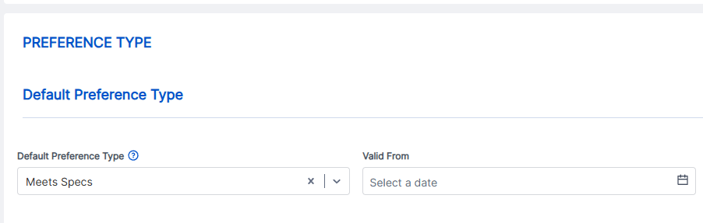
Preference Type of Product Source

PURCHASE ORDER FIXES

UI Improvements in PO Shipment Page w/ Split Line
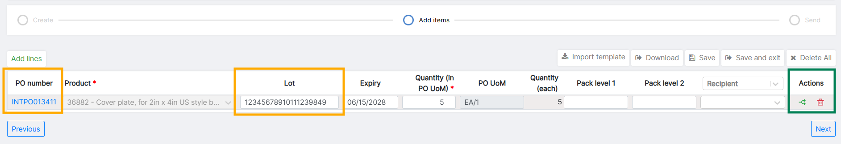
Updated PO Shipment Page
As a part of a series of UI changes in Shipment pages, we have updated the Purchase Order Shipment page as well to make the contents more readable. You will find:
- All Table Headers are fully visible
- No Table Headers are wrapped across 3 lines
- All number columns are Right aligned
- “Delete” button is now Red Trashcan icon.
- See PO # for all Lines
- Lot # shows up to 15 characters
- Split a PO Line by clicking on Green Split icon under Actions column

Improved Error Message for PO Import
When a PO import fails in Openboxes, the error message can be very helpful in determining why the import failed and fix them, especially if there are numerous lines in the Import file. For this reason, we improved the error message OpenBoxes shows for failed PO Imports.
You should now see clearly why the Import failed. See example in the screenshot below:
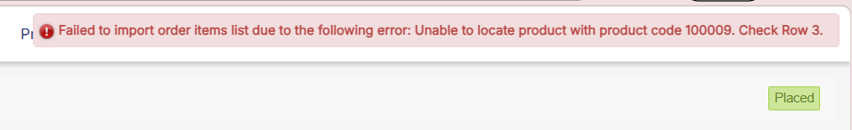
Error Message when PO Import fails
Note: The Error Message only displays one error at a time.

[Bug Fix] Edit Purchase Order Lines with Inactive Budget Code
Sometimes users have to go back and edit Purchase Order Lines that have Budget Codes that are no longer active.
However, it was not possible to edit these lines because they had inactive Budget Codes. We have now updated this to allow already saved lines with inactive Budget Codes to be edited.

[Bug Fix] Allow PO Qty Edits with Prepayment Invoice
If an item has already been invoiced, users cannot edit the item qty in the related Purchase Order to below the invoiced quantity. This is true only if a Final Invoice is present for the item. However there was a bug that was preventing edit of quantity if an item had an associated prepayment invoice.
Now, users will still be able to change the Line item qty if there is a Prepayment Invoice. The validation message shown below will not occur if the item has a prepayment invoice.
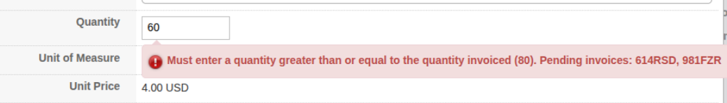
Error Message not allowing User to Edit PO Line Qty

MANAGING ORGANIZATIONS AND LOCATIONS
This section is relevant to Admins and Superusers who manage Locations in OpenBoxes.

[Bug Fix] Wrong organization auto filled when creating new supplier
When creating a new Supplier, Openboxes automatically fills in the organization based on the name of the supplier. There was a bug where, if the user entered a location number for the supplier, OpenBoxes would attempt to autofill the organization based on the location number and would select the wrong organization. This is now fixed and the organization will be selected or created based on the supplier name only.

[Bug Fix] Duplicate Organizations created via Import
When importing Locations, if multiple lines have the same new Organization, OB created multiple different Organizations instead of one new Organization. This is now fixed.
If the Location Import file contains multiple lines with one new Organization, Openboxes will only create one new Organization to get assigned to the corresponding locations.
See this article for Organization information: Manage Organizations.

Fixed Organization Code Auto generation Logic
Previously, OpenBoxes would autogenerate a 3-digit organization code based on the name of the organization. The intention was to have users easily identify the organization based on the code. However, the small number of digits and the fact that many of our suppliers have similar names lead to OpenBoxes consistently generating duplicate codes and then being unable to save the organization. Now, OpenBoxes will still generate a 3-digit code based on the name, but will add a randomly generated string afterward to prevent duplicates.

Enter Custom Code when creating an Organization
OpenBoxes now allows users to designate their own Code to Organizations. Previously, the Organization Create Page did not have a Code field to enter. This can be used when users want their Organization Codes to follow a series or pattern.
Users can still leave it blank for OpenBoxes to auto-generate the code.
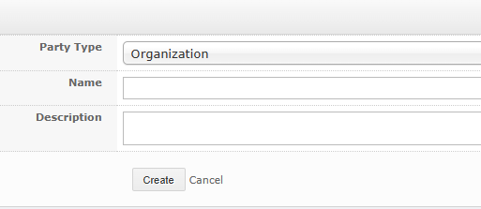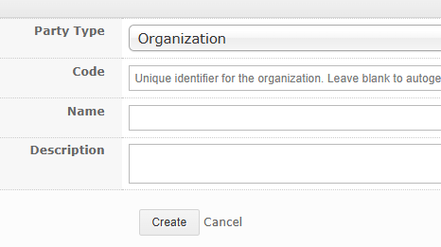
[Left] Old Organization Create Page
[Right] Updated Organization Create Page

Organization Name to display as “Code – Name”
Organization Codes are easy identifiers of Organization, especially if multiple Organizations have similar names. For suppliers, it can also tell if the supplier is a country specific supplier. For example, US-0186 is the Organization Code for International Supplier that the Boston Procurement Team sources from, whereas LE-0004 is a local Lesotho Supplier.
Because of the above-mentioned points, Organization names will now be displayed as “Organization Code – Organization Name” in all pages. If the page contains columns for both Organization Code and Organization Name, these will remain the same (such as the Organization List Page).
For example, in the Product Source List page, the Supplier Renaissance Tile & bath, Inc. will be displayed as “US-C7051-Renaissance Tile & bath, Inc”.
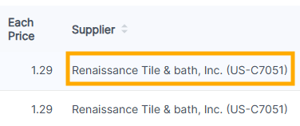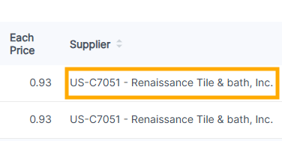
[Left] Old Supplier Name
[Right] Updated Supplier Name

Location Group for Dynamic Location Creation
New locations can be created directly in Outbound Shipments (we refer to this as dynamic creation). Locations created like this will now be assigned to the Location Group of the Origin destination. For example, in the screenshot below, a new Location created dynamically will be assigned the same Location Group of “Venture Miami Warehouse: Liberia Stock”. This ensures that newly created locations are visible within shipment menus.
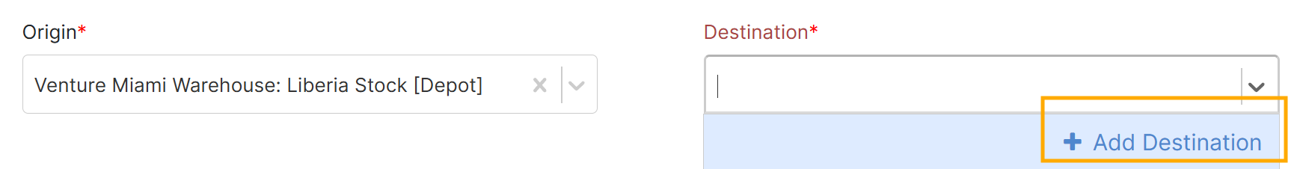
Add Destination option for Dynamic Creation
To learn more about Location Groups, please see this document: Location Groups.

CYCLE COUNT

[Bug Fix] Cycle Count starting for Wrong Product
The IMB team informed us that in a certain scenario, OpenBoxes was initiating Cycle Count for the incorrect product(s). This occurred if a user started Cycle Count immediately after completing Cycle Count for other product(s) with no discrepancies.
This is now resolved.

FILTER RENAMED
A filter in the ALL PRODUCTS tab for Cycle Count has been renamed from “Last Counted Date” to “Last Counted Before,” to better reflect the logic of the filter. The filter has always shown items that were counted before the selected date. The new name reflects this logic.
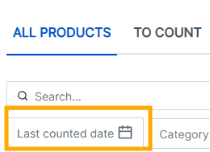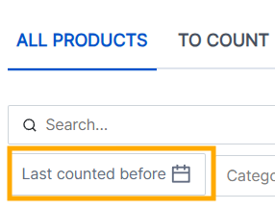
[Left] Old Description for Filter
[Right] Updated Description for Filter

ADMINS CAN NO LONGER MODIFY TRANSACTIONS
In efforts to reduce accidents and have better permission controls, we are limiting the ability to directly modify transactions from the transaction view page only to Superusers.
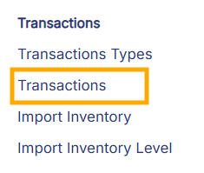
Transaction Menu

OTHER BUG FIXES
- Transfer Order Link: In the Stock History of a Product, the link of Item Transfers led to a Purchase Order View Page instead of the Stock Transfer View Page. This is now resolved.
Transfer Order Link in Stock History

- Removed Old Links in Demand tab of Stock History: Under the Demand tab in Stock History, the old link for Requisitions was still available. However, this is an old view of shipments and is no longer in use. Hence, we have removed the link from the Demand tab.

- Filter broken on list pages: There was a bug on several older list pages where if the user filtered the list, then moved to the second page of results, the filter resets to show all records. This is now resolved. If you have a filter applied and navigate to a different page of the filtered results, the filters will remain applied to only show applicable results. The following list pages have been fixed:
- organization list
- tag list
- user list
- person list
- budget code list
- document list
- inventory level list
- localization list
- location list
- product association list
- attribute list

