Release 0.9.2 🎉

# WHAT TO EXPECT?

The OpenBoxes team understands that E-Requests is one of our most sought-after features, and we are constantly trying to improve the feature. In this release, you will find that we have made significant changes to how statuses for E-Requests are displayed and ensured that the status aligns with the E-Request step. In addition, we have made improvements to the audit box for shipments of E-Requests.

Another major change is related to entering backdated shipment information into OpenBoxes. There are multiple scenarios where users might have to ship a shipment at the warehouse before they enter it into OpenBoxes. So, the OpenBoxes team is thrilled to share a solution to verify carefully that your physical shipment information (often recorded on paper) matches what you enter into OpenBoxes. You will also find other feature improvements in this release.

As always, if you encounter errors in the system or have any questions, please contact the OpenBoxes team via email at [openboxes@pih.org](mailto:openboxes@pih.org).

Table of Contents

WHAT TO EXPECT? 1

NEW FEATURES 3

Backdating Shipments 3

Update Pick in Outbound Shipments 3

Dashboard Indicators for Backdated Shipments 3

IMPROVEMENTS 4

Electronic Requests (E-Requests) 4

Status Updates for E-Requests 4

Only Approved/Submitted E-Requests to display in the Outbounds List 5

Requestor View for E-Requests: Status Update 5

Audit Box for E-Request Shipments 6

Align Statuses between the List Page and View Page 6

Updates to Localization 7

Known Bugs 8

Duplicate Shipment ID: 8

# NEW FEATURES

## Update Pick for Completed Shipments

The OpenBoxes team realizes the need for an efficient way for users to enter backdated shipments. There can be instances where you might have to ship a shipment or pick items for a shipment at the warehouse before entering it into OpenBoxes. So, the OpenBoxes team is thrilled to share with you a solution to verify carefully that your physical shipment information (often recorded on paper) matches what you enter into OpenBoxes. This will keep OpenBoxes inventory in sync with the actual inventory.

The new feature allows you to efficiently update your pick for outbound shipments to match the actual shipment. In addition, you can also use our NEW dashboard indicators to track how many shipments and items you and your team backdated.

### Update Pick in Outbound Shipments

We are introducing a **Clear Pick** button on the Pick Page of Outbound Shipment. This allows you to remove the pick that OpenBoxes automatically populates during the Outbound process.

If you have already picked items for your shipment or have already shipped your shipment, you do not want to continue with the auto-pick done by OpenBoxes. Hence, you can **Clear Pick,** andupdate the shipment with the correct Lot number and Bin location selections.

You can update the pick in two ways: manually pick for each item OR do an Import.

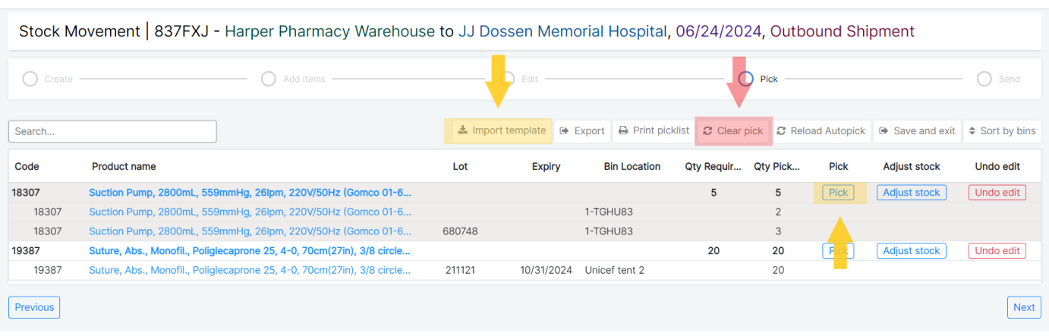

Find out more about this new feature in this article: [Updating Pick for Shipments (Clear Pick)](https://help.openboxes.com/article/477-pick-for-backdated-shipments-clear-pick).

### Dashboard Indicators for Backdated Shipments

Along with the Clear Pick button, we are introducing new Dashboard Indicators specifically for Backdated Shipments! Find these new Indicators to [Unarchive and save to your Dashboard](https://help.openboxes.com/article/7-dashboard):

* Backdated Outbound Shipments
* Backdated Inbound Shipments
* Items with backdated Shipments since last Stock Count

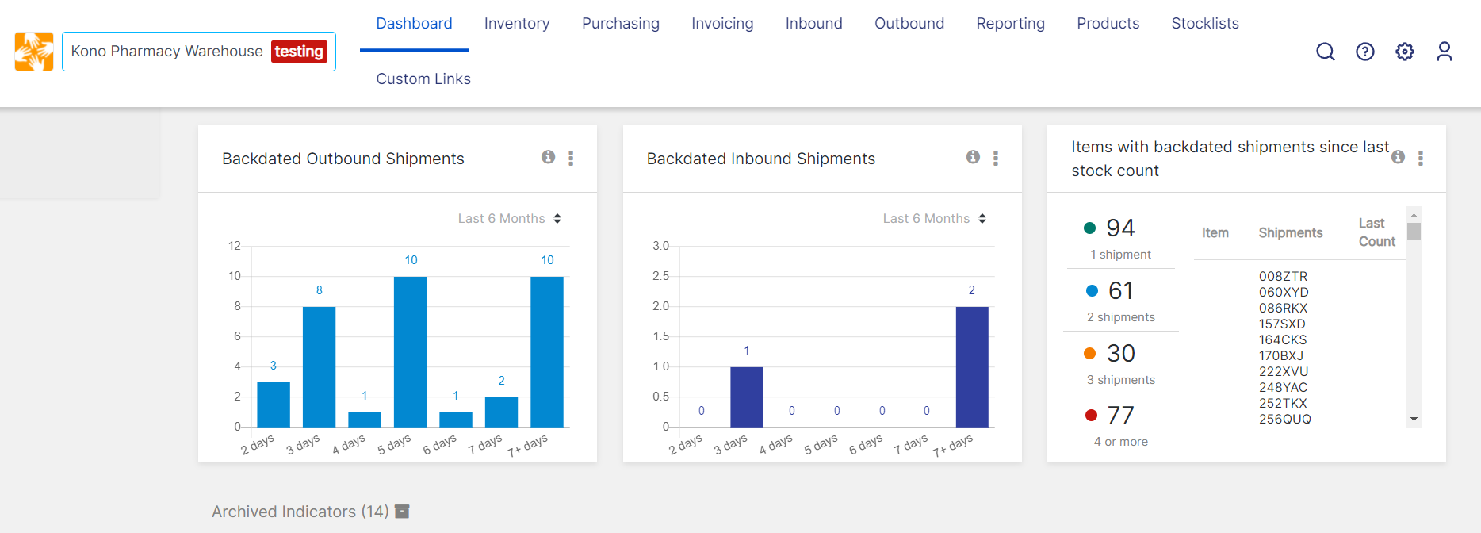

New Dashboard Indicators

These Dashboard Indicators will help track how many shipments you and your team have backdated and examine what might be causing the need to backdate shipments. In addition, you now have insight if the warehouse should do an inventory count for items that are present in multiple backdated shipments. The more an item is present in a backdated shipment, the more likely that the inventory in inaccurate in OpenBoxes.

Learn more about these new Dashboard indicators here: [Dashboard.](https://help.openboxes.com/article/7-dashboard)

# IMPROVEMENTS

## Electronic Requests (E-Requests)

Several users have reported that the overall status of an E-Request does not match the status of individual items in the E-Request. Other users from fulfilling Depots have also requested that they only see E-Requests on their list once they can act on them. Hence, we have made some updates based on your requests along with some other changes!

### Status Updates for E-Requests

* E-Requests without Approvals: For E-Requests that do not require Approvals, individual items will display as **Pending** until the requestor submits the E-Request to the fulfilling depot.

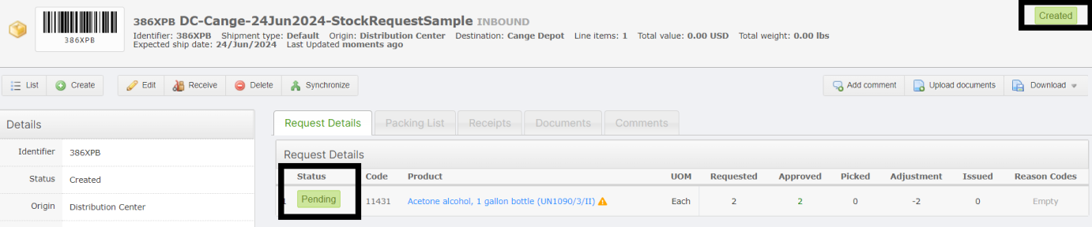

Status for E-Requests without Approvals

* E-Requests with Approvals: For locations that support Approvals, the status of each item in an E-Request will remain **Pending** until an Approver approves the E-Request. Once the Approver approvers, the individual items will display as approved.

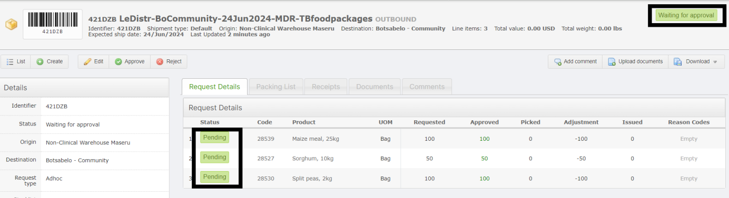

Status for E-Request with Approvals

### Only Approved/Submitted E-Requests to display in the Outbounds List

For fulfilling Depots, the Outbound List Page will only show E-Requests they can act on. Depot users will no longer see E-Requests that Requestors are still working on, that have been rejected or are pending approval.

Now, there is a summarized view of all the statuses for transactions that are possible in OpenBoxes.

Do take a look here: [Stock Movements Status Summary](https://help.openboxes.com/article/476-stock-movements-status-summary).

### Requestor View for E-Requests: Status Update

The Requestor’s view was not the most accurate – which we have worked on. Here are the updated statuses that Requestors will now see in their Dashboard:

* **Pending**: Requestor has not submitted the E-Request to the Approver or Fulfilling Depot
* **Approved**: *Only for E-Requests with Approvals.* The requestor has submitted the E-Request for Approval.
* **In Progress**: The fulfilling Depot has started their work on the E-Request and reached the Picking step.
* **Shipped**: The fulfilling Depot has shipped the E-Request.

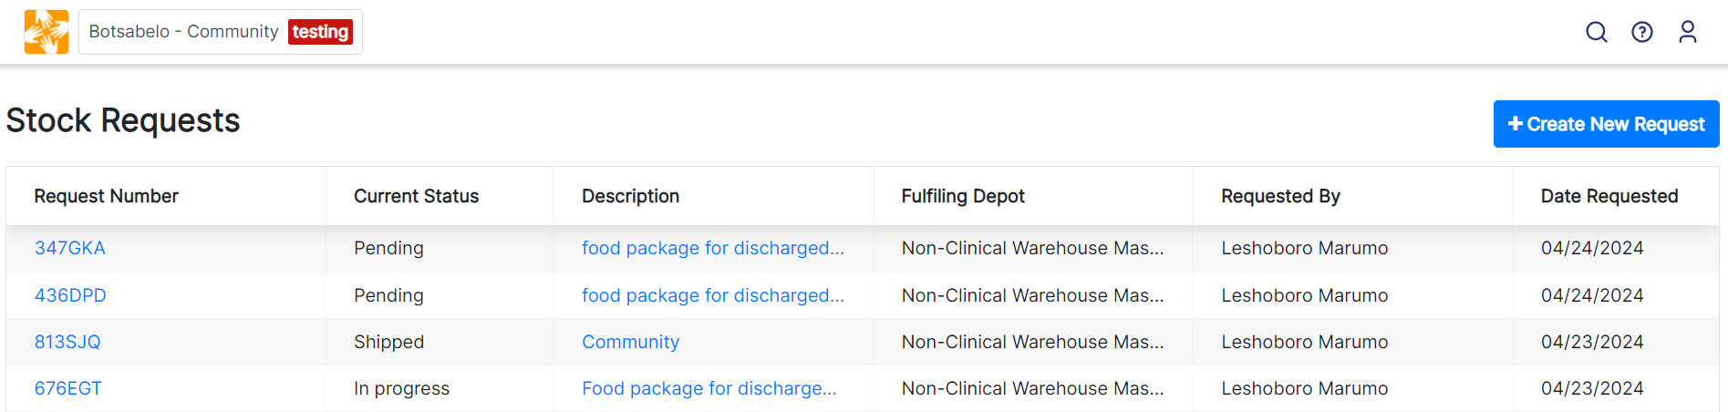

Requestor Dashboard

### Audit Box for E-Request Shipments

Every stock movement in OpenBoxes has an audit box on the bottom left to track who took what actions on which date. For E-Requests, the audit box showed incorrect information in the **Shipped By** field with the Requestor as the one who shipped the shipment – which is not possible.

As for a regular Outbound Movement, an E-Request will also show the actual user from the fulfilling Depot who shipped the shipment instead of the Requestor who requested the items.

If a Stock Movement is rolled back, the Shipped By field will clear.

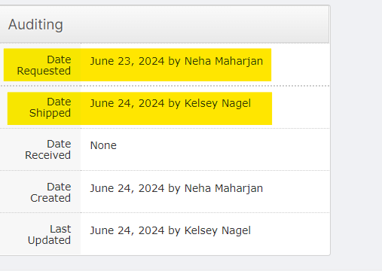

Audit Box Screenshot

For all future E-Requests, you will see the change described above. For all the past E-Request that had the incorrect Shipper information, we have changed the “Shipped by” user from the Requestor to the user who last updated the transaction (user in the “Last Updated” field).

## Align Statuses between the List Page and View Page

We have received multiple reports, including from Sierra Leone and Lesotho users, that the statuses of stock movements did not match those on the List Page and the View Page.

***EXAMPLE****: an Inbound Shipment to Kono Pharmacy Warehouse from Freetown Transition Warehouse was displayed as Received in the Inbound List Page but displayed as Issued on the View Page for Kono Pharmacy Users. This inconsistency of the statuses between the two pages can cause confusion among the users.*

Therefore, we have done some intensive work to ensure that the statuses of stock movements match those on the List Page and the View Page, for Inbound movements, Outbound movements, and Returns.

Please see this article, [Stock Movement Statuses Summary](https://help.openboxes.com/article/476-stock-movements-status-summary), to view the complete list of statuses you will now see in OpenBoxes. You will find extensive and detailed information on the expected statuses for each step of a stock movement.

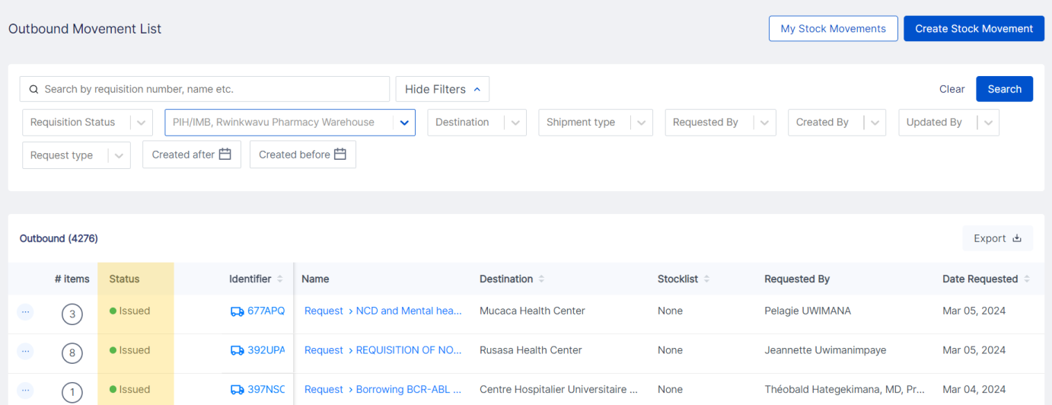

List Page Statuses

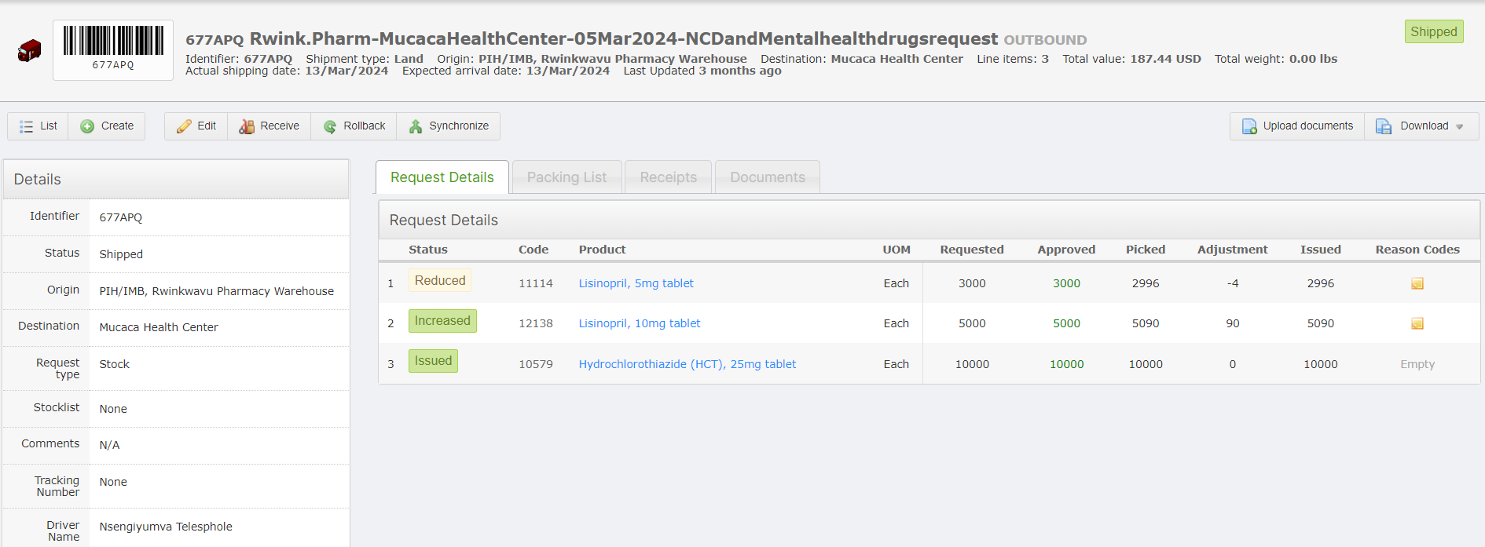

Status on View Page

## Updates to Localization

As you may remember, we did some significant translation work in the 0.8.21 and 0.8.22 releases. We’ve made a lot of progress in translating OpenBoxes pages into French and also introduced the Product Name Synonyms feature to translate Product Names for different locales!

With Compañeros En Salud or CES (a sister organization of Partners in Health in Mexico) implementing OpenBoxes in August, we have continued the localization effort in Spanish for CES.

Here’s a summarized list of changes or validations we have done for our CES users in the Spanish locale:

* Ensure Product Name synonyms are displayed in OB pages as decided: Purchase Orders, Inbound and Outbound workflows, Putaway workflow, Stock Transfers, and Return workflows.
* Enable Product search by synonym in workflows.
* Ensure number format with correct separators as 1,000.00.
* Standardize date as DD/Month/YYYY across OpenBoxes pages.
* Enable PO Import and Export in Spanish

# KNOWN BUGS

Duplicate Shipment ID: Openboxes sometimes assigns the same ID number to more than one shipment. This causes issues in receiving the shipments. If you see the below error, it is because the shipment ID is a duplicate.

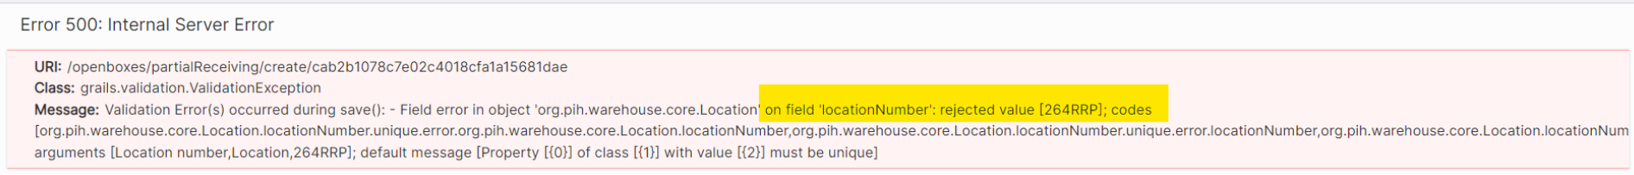

In these cases, please email [openboxes@pih.org](mailto:openboxes@pih.org) so we can change the ID for one of the duplicates.